海淀区高三年级第二学期期末练习
英 语
2013.05

第一节单项填空(共15小题;每小题1分，共15分）
21.Dan Brown , _____author of The Da Vinci Code，is _____very famous American writer.
A. a； the B. the； the C. the； a D_{a} a； a
22.The Boston Marathon bombings killed 3 people ， including a Chinese citizen Shenyang.
A. in B. from C. across D. to
23.A hearty laugh relieves physical tension, _____your muscles relaxed for over half an hour.
A. to leave B. left C. leaving D. leave
24.—Hurry up! Can’t you drive faster ，Jack?
——No. If I got _____speeding ticket ，my dad would take away my car.
A. other B. the other C. each other D. another
25.With hundreds of attractions, Beijing is a city _____ makes a lasting impression on its
visitors.
A. which B. where C. what D. when
26.The house is dirty because it since they moved out.
A. doesn’t clean B. isn’t cleaned C. hasn’t cleaned D. hasn’t been cleaned
27. _____H7N9 is a deadly virus, it is still safe to eat thoroughly-cooked chicken.
A. Until B. While C. If D. Since
28.——Lily is going to make a presentation in class this afternoon.
—Oh, really? I _____it was Michael’s turn.
A. think B. have thought C. thought D. am thinking
29.Life is a journey _____with hardships, joys and special moments.
A. filled B. to fill C. filling D. having filled
30.Besides the content of a book, _____the editor also cares about is the number of readers.
A. who B. why C. how D. what
31.—Could you please have my car ready today?
—Sure, the damage is not that serious, so it _____be ready by 5: 00 pm.
A. should B. could C. might D. need
32.Remember to give your parents my regards when you _____home.
A. phoned B. phone C. will phone D. have phoned
33.The organizers promise wins the first prize a chance to go abroad。
A. who B. whom C. whoever D. whomever
34.It is reported that the Voice of China Season II ______to air on Zhejiang TV this coming summer vacation
A. schedules B. is scheduled C. had scheduled D, had been scheduled
35.The parcel was a whole week late. How I wish I air mail instead.
. A; had chosen B would choose C, chose D. choose

第二节完形填空（共20小题；每小题l, 5分，共30分）
A Faithful Father
. My husband ,kissed me goodbye ，stroked, the baby’s cheek and then rushed out of the door ，into his busy day. With the cold of the morning fading, I fed my baby and it fell fast asleep. Usually I would place it in bed and quickly have the house somewhat in 36______ ,
This morning ，however, I stayed seated ,just 37_____,with the baby in my arms ,The thoughts ran into 38______ of the mornings with my husband, a father rushing out of the door to meet the obligations of life. It was only a small jump to thoughts of my own 39______
My mother passed away when I was ten, and as I looked 40 ______I could see how much of a family man my dad was. He went to work every morning and 41______ to his family every evening. He 42______ food, clothing, warmth ，and protection. He was a faithful father.
Setting the baby down ,I dialed the 43 ______ number. I had just realized the 44 ______ of the ordinary—the daily life going on around us that we often took for granted, and that it needed to be 45______
“Hi ，Dad. ” I said, 46______ back tears.
“Hey, Bud- How are you? ” 47______ was in his voice.:
“ Fine, Fm just calling to say. ,, thank you. ” I got it out before my throat 48______ too much for me to speak.
"What for?”
— For getting up and going to work every morning of ray life. Now that I have my' own 49______ and I see my husband doing the same ，I just wanted to thank you for being 50______ ”
There was 51______ for a moment as my dad composed himself ，and with a small . .52______ in his voice he said, “You’re welcome, Bud. ”
I don’t remember much of the rest of the call, 53______ that moment of revelation (显露） about my father, I will never forget. There are those who are known for their heroic 54 ______，and also
those who are known for their fortunes and fame ，but it is the 55 ______everyday fathers who are the true heroes. I’m thankful that my father was one of them.
36.A, use B. line C order D. fashion
37.A. thinking B. dreaming C. imagining D. praying
38. A. conversations | B. struggles | C. incidents | D. memories
39. A. baby | B. husband | C. mother | D. father
40. A. out | B away | C. back | D. around
41. A. moved | B. returned | C. escaped | D. walked
42. A. provided | B. collected | C. sought | D. bought
43. A. popular | B • relative | C. regular | D. familiar
44. A. difference | B. significance | C. balance | D. absence
45. A. recognized | B. arranged | C. reduced | D. achieved
46. A. sending | B. pushing | C. holding | D. putting
47. A. Sympathy | B。Stress | C. Doubt | D. Concern
48. A. cleared | B. hurt | C ached | D. tightened
49. A. child | B. duty | C. plan | D. career
50. A. inspiring | B. faithful | C. considerate | D. admirable
51. A. peace | B. calm | C. silence | D. rest
52. A. tremble | B. hesitation | C. passion | D. sigh
53. A. and | B. but | C. or | D. nor
54. A. ideas | B. deeds | C. remarks | D. words
55. A. outstanding | B. patient | C. ordinary | D. honest

第三部分：阅读理解（共两节₅ 40分）

A
One day, I received a call from a colleague. He was about to give a student a zero for his answer to a physical problem ，while the student claimed a perfect score. I was elected as their arbiter( 仲裁人).I read the examination problem： “Show how it is possible to determine the height of a tall building with the aid of a barometer(气压计).” The student had answered： “Take the barometer to the top of the building，attach a long rope to it，lower it to the street，and then bring it up, measuring the length of the rope. The length of it is the height of the building. ”
The student had really answered the question completely ，but the answer didn’t confirm his competence in physics. I suggested the student try again. I gave him six minutes to answer the question, warning that the answer should show some knowledge of physics. Five minutes later, he said he had many answers and clashed off one, which read： “Take the barometer to the top of the building and lean over the edge of the roof. Drop the barometer, timing its fall with a stopwatch. Then, use the physical formula (公式）to calculate the height of the building. ”
At this point, my colleague had to accept it, and then the student made almost full marks. I couldn’t help asking the student what the other answers were. He listed many others ，and then added₅ “Probably the best is to take the barometer to the. administrator and said to him，' Sir, here is a fine barometer. If you tell me the height of the building, I will give it to you.，”
Then, I asked the student if he really did not know the conventional answer to this question. He admitted that he did ，but said that he was fed up with high school and college instructors trying to teach him how to think.
The name of the student was Bohr who later was famous all over ,the world. He won the Nobel Prize for Physics in 1922.
56.The student got a zero at the beginning because_______.
A. the teacher wasn’t satisfied with him
B. his answer wasn't complete or correct
C. the teacher clicln⁵t fully understand his answer
D. his answer didn’t show his knowledge of physics
57.We know from the passage that______
A. the student knew the expected answer
B. the administrator told Bohr the height
C. the author preferred Bohr s last answer
D. the teacher was a very stubborn person
58.We can learn from the passage that______.
A. instructors can teach students how to think
B. arbiters can help students to get high scores
C. students should be given more freedom in thinking
D. teachers should make students use physical formulas
59. What was Bohr’s attitude toward his schooling?
A. Optimistic. B. Critical. C. Approving. D. Ambiguous.

B
Your Car Is Ready for Take-off
The flying car has been talked about for many years，but now it appears that the idea is about to become a reality.
An international company has built a two-seater plane that, at the touch of a button ，transforms into a car perfectly suitable for driving on public roads. It has been designed so that the wings fold up automatically； and it takes just 15 seconds to switch between flying and driving. With its wings fully open and the propeller(螺旋桨）spinning, it can take off from any airfield.
Flying cars are quicker than traditional ones for travelling from city to city，and they can run on ordinary fuel. Another big advantage is that they are cool ，like something you would see in an action film. At the moment ₉ however, the flying car’s wheels are illegal to leave the ground. That is not because of technical reasons or problems with the design. It is because the various road and aircraft authorities simply cannot agree on whether it is a car or a plane.
“The government and the authorities have never thought seriously about a flying car, says Alan Price ，the president of the company that has developed it. “I wanted a car that could fly and drive ，but it is difficult to find an organization prepared to insure the vehicle against accidents.
Nevertheless ? the company hopes to produce and deliver its first flying car soon. The company already has orders for 40 of them. The majority the potential customers are older and some are retired。There have even been orders from some people who have no pilot's license.
The flying car will cost around $ 200.000. “For an airplane ， that’s a very reasonable price， but for a car, It's quite expensive，” explains Alan. “But it just is not possible to make a $ 10，000 flying car yet. ”
This latest means of transport will not become a mass-market item in the near future，but in the long term it has the potential to change the way you travel. It will become no more expensive than driving your car on the motorway. Travel time could be reduced by more than half.
So the next time you are told to fasten your seat belt, it may be to prepare for take-off.
60.We know from the passage that the flying car______
A. has to run on special fuel B. will replace traditional planes
C. is popular with the rich D. can shift between two forms
61.The flying car is presently forbidden to take off because______.
A. many people think driving it not very safe
B. it’s hard to decide whether it's a car or a plane
C. the government and the authorities don’t accept it
D. there are still some technical problems to be solved
62.We can learn from the passage that______.
A. few people will be able to afford a flying car
B. flying cars may share the market in the future
C. traffic jams will disappear because of flying cars
D. driving a flying car doesn’t require a pilot’s license

C
The early lack of exposure to science ，technology，engineering and mathematics (STEM) can be harmful to achieving gender (性别）balance in these fields. It begins when we are young and continues throughout our time in high school.
While at home，girls generally don’t get to experience the level of exposure or encouragement in STEM fields that their male counterparts do. It is often subtle ，but it’s the first hurdle that faces and confuses so many women. Boys ，on the other hand, get on their path ，and are encouraged to do so， generally earlier than girls. For example ，boys are more often given science sets as toys ，which spark an interest in these subjects.
In school ₃ boys are often pushed to take the more challenging math and science classes. So if we want to attract the best and brightest minds into the fields that will advance us as a people ? a country，and a planet，we can no longer look to only half of the population. Young girls cannot possibly consider opportunities they do not know exist. If girls are not exposed to certain subject and career paths，they are highly unlikely to choose to follow them in college.
Our bias(偏见)toward girls₉ either from families or from schools ，is so rooted in our culture that we often don’t even recognize it. Although the situation Has changed greatly in the past 20 or 30 years，there is still a sense that girls aren't as good at math ₉ for instance ₉ even though there is almost no evidence to support such a belief.
It is important that as a society we deal with gender stereotypes long before young people are faced with a decision to declare or choose a major in college. Without making efforts to break them， we are limiting the potentials of our youth，both male and female. Providing the necessary resources， exposure , and encouragement would help young women understand that their gender shouldn’t determine the career path they choose, and that pursuing a STEM career does not make them less feminine.
63.According to the passage ? not many girls grow to enter STEM fields because______.
A. girls are not as good at STEM as boys
B. girls do not like to take science classes
C. girls get fewer chances to know about STEM
D. girls seldom survive the high pressure positions
64.The underlined word “it” in Para. 4 refers to______
A. our bias B. our culture C. the situation D. a sense
65.The main purpose of the passage is to______.
A. show women’s potentials in STEM fields
B. praise women’s contributions to STEM fields
C. describe the present gender bias in STEM fields
D. call for more involvement of women in STEM fields
66.Which of the following shows the structure of the passage? 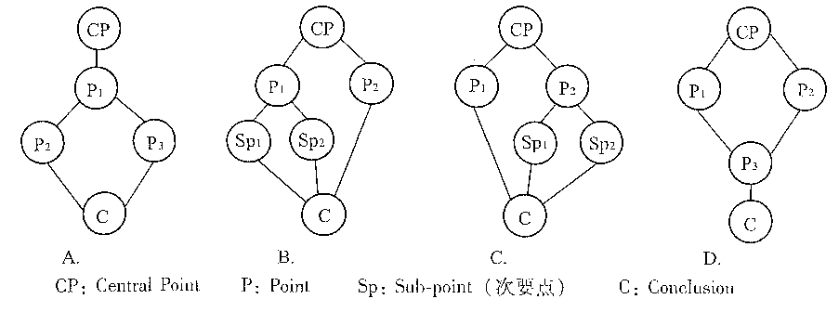

D
Online shoppers would rather receive an offer for a product or service than make their own offer ₃ according to a study led by a Michigan State University scholar that has implications for the fast-growing e-commerce industry. The findings may come as a surprise given that shopping online is an anonymous(匿名的）process that seemingly can give consumers more confidence to drive a hard bargain,said Don Conlon ，Professor of Management in MSU’s Broad College of Business.
But the study found that participants who made their own offers were less successful in sealing the deal and ，when they were successful? worried they overpaid Many shoppers found the process of researching an offer to be a hassle. “ Americans are very busy，and it’s less time-consuming to be the one receiving the offer rather than the one proposing the offer ” Conlon said. ^{u} People tend to be happier when they’re in the receiver role. ”
Online spending in the United States is expected to jump 45 percent in the next four years， from $ 226 billion this year to $ 327 billion in 2017，according to Forrester Research Inc. Nevertheless, researches into this prosperous market remain largely focused on the strategies of companies, rather than those o£ shoppers. Conlon’s study is ，obviously, a rare exception.
Conlon got the idea for the study after considering the difference between two popular sites for hotels and airline flights, priceline.com, which takes bids, and hotwire.com ，which provides offers. Using these two models ，Conlon and his fellow researchers conducted a series of experiments with more than 850 people who were charged with booking a fictional hotel room and acquiring a fictional antique car. Not only did participants prefer to receive bids, Conlon said ，but they also secured more deals in that receiver role. Further ，when they had to make the bids ，they were left more mentally taxed and regretful.
From an industry perspective，putting customers in the receiver role may help fill more hotel rooms and airplane seats. “If you’re a business with a lot of products₃ ” Conlon said，“you may want to be the one making the offers. ” However, when selling single items, such as an antique car， accepting bids may be a better option since that typically drives up the price, he said.
67.What can we learn from Para. 1?
A. The result of the study gives customers more confidence.
B. Scholars aren’t surprised at the findings of the study.
C. Online shoppers don’t bargain as much as expected.
D. E-commerce industry drives more hard bargains.
68.It can be concluded from Conlon’s experiments that______.
A. online shopping is time-consuming B .given prices help promote online sales
C. online businesses provide a lot of products D. receiving offers makes online shoppers regretful
69.The underlined word “taxed” in Para. 4 probably means______.
A. burdened B. numbed C. relieved D. challenged
70. The passage is mainly about______.[来源:学科网]
A. the big advantages of online shopping B. he rapid development of online shopping
C. online shoppers’ preference for taking offers D. online companies strategies to improve service

第二节（共5小题；每小题2分，共10分）
Does a Dog Help a Teen with Low Self-esteem?
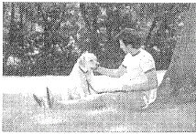
A dog is known as man’s best friend for good reason. Loyal and affectionate ,a dog companion can enrich its owner’s life in many ways, 71_____ Many teenagers suffer from periods of low self-esteem (自尊）as they try to navigate the wavy waters of adolescence and deal with all of its associated highs and lows.
A teenager who lacks self-esteem may feel isolated from his peers and unable to tell his parents about personal issues. The company of a dog can be a huge comfort and ease feelings of loneliness and awkwardness. A dog offers genuine unconditional love. 72_____
All dogs need exercise，so taking his clog for a walk is the perfect opportunity for a teenager to get outdoors and benefit from fresh air and physical activity. Exercise allows people to take control of their bodies，which is often the first step toward regaining control of other aspects of their life，says mental health specialist Dr. Alan Cohen. 73 Exercise releases chemicals called endorphins (内排肽）into the brain? which create positive responses in the body ，including improved selfesteem.
Dogs can help teenagers be more sociable and make new friends, suggests HELPGUIDE. 74_____ A dog is a great ice-breaker ，avoiding awkward social situations and putting the teenager at ease with people he meets. The more confident the teen becomes when out and about with his clog ，the more his self-esteem will improve.
75_____ If a teenager is suffering from depression or developing dangerous habits such as alcohol and drug abuse ，more extreme action may be required. In these cases ，professional help should be sought and all treatment plans considered. Parents who suspect that their teen’s low selfesteem is a sign of a far more serious problem should ask a suitably qualified health professional for advice.
A. In some cases, having a dog will not help with a teenager’s low self-esteem.
B. It simply accepts its owner for who he is and doesn’t judge, question or criticize.
C. Pets offer an unconditional love that can be very helpful to people with depression.
D. You don’t have to worry about hurting your pet’s feelings or getting advice you don’t want.
E. In particular, someone with low self-esteem may find a pet dog to be extremely beneficial.
F. A teen may meet his peers while walking his dog in the park or taking part in a dog training class.
G. Many forms of exercise besides walking can be enjoyed with a dog, such as cycling, jogging and throwing a ball.

第四部分:书面表达（共两节, 35分）
第一节情景作文（20分）
假设你是红星中学高三（1)班的学生李华，上周你接待了美国交换生Mike。为帮助他了 解中国传统文化，你为他安排了一系列的活动。请根据图片的先后顺序，将主要活动记述下 来，向校报投稿。
注意：1.文章的开头已为你写好。
2.词数不少于60。
参考词汇：人力车rickshaw
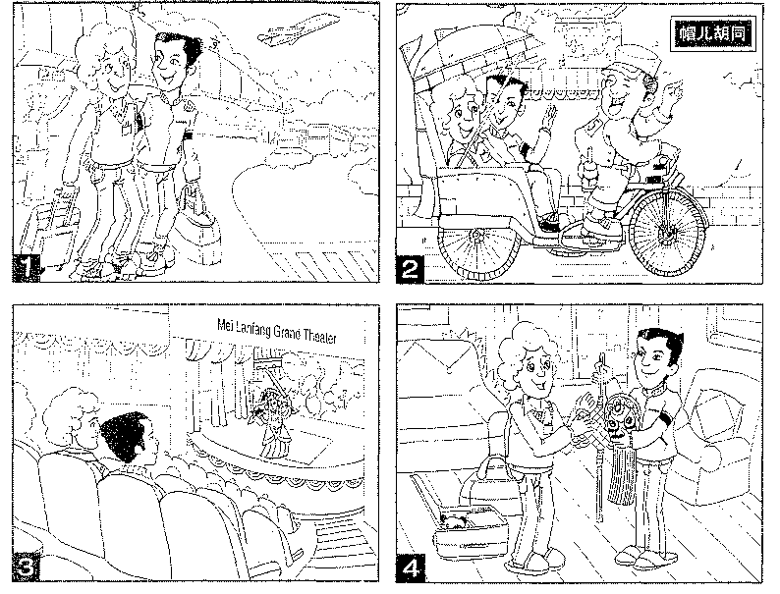
Last week, ____________________________________________________________________________________________________________________________________________________________________________________________________________________________________________________________________________________________________________

第二节开放作文（15分） 请根据下面提示，写一篇短文。词数不少于50。
You are discussing the following picture with your English friend Jim. Now you are telling him how you understand the picture and what makes you think so
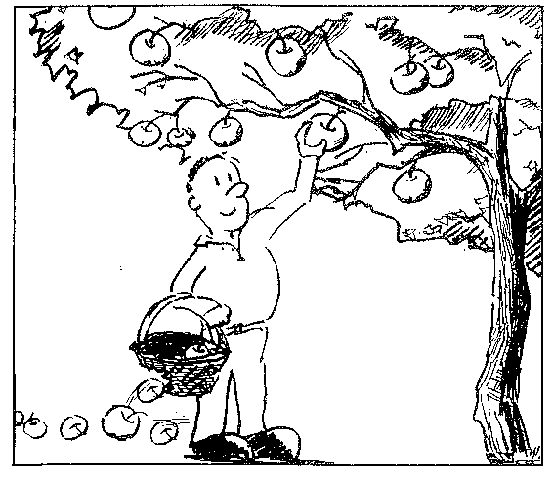

海淀区高三年级第二学期期末练习
英 语
参考答案及评分标准 2013.05
第一部分：听力理解（共三节，30分）
第一节（共5小题；每小题1.5分，共7.5分）
1. A 2. C 3. C 4. B 5. A
第二节（共10小题；每小题1.5分，共15分）
6. A 7. C 8. C 9. B 10. A 11. B 12. A 13. B 14. C 15. B
第三节（共5小题；每小题1.5分，共7.5分）
★每小题超过一个词不计分； ★拼写错误不计分； ★月份、姓名首字母必需大写，否则不计分，其余单词大小写错误扣0.5分。
16.Apply/Applying 17. Gonzalez 18. Summer 19. February 20. 623-382-1485/6233821485
第一节 单项填空（共15小题；每小题1分，共15分）
21. C 22. B 23. C 24. D 25. A 26. D 27. B 28. C 29. A 30. D
31. A 32. B 33. C 34. B 35. A
第二节 完形填空（共20小题；每小题1.5分，共30分）
36. C 37. A 38. D 39. D 40. C 41. B 42. A 43. D 44. B 45. A
46. C 47. D 48. D 49. A 50. B 51. C 52. A 53. B 54. B 55. C
第三部分：阅读理解（共两节，40分）
第一节 （共15小题；每小题2分，共30分）
56. D 57. A 58. C 59. B 60. D 61. B 62. B 63. C 64. A 65. D
66. D 67. C 68. B 69. A 70. C
第二节（共5小题；每小题2分，共10分）
71. E 72. B 73. G 74. F 75. A
第四部分：书面表达（共两节，35分）
第一节 情景作文（20分）
二、内容要点：
1．接机 2. 游胡同 3. 看京剧 4. 送礼物
三、One possible version:
Last week, I received an exchange student Mike from the US. The first day, I went to pick him up at the Capital Airport and we chatted happily along the way. In order to get him to know Chinese culture, I prepared a series of activities. For example, on the second day, we paid a visit to the famous Maoer Hutong, where we had an interesting rickshaw tour. Mike felt very excited about the driver’s vivid introduction to the history of Hutongs. The following day, I took him to MeiLanfang Grand Theatre to watch Beijing Opera. Although he could understand few words, he was still amazed to see the colorful costumes and the unique way of performing. When it was time for him to return to the US, I sent him some gifts with Chinese elements, such as a Beijing Opera mask and a Chinese knot. He was very grateful for what I had done and said he was really impressed by the diversified Chinese culture.
From this experience, I felt proud of being a Chinese and felt it my duty to introduce Chinese culture to the world.
第二节 开放作文（15分）
One possible version:
Jim, look at this funny picture. From my perspective, this picture warns us against working blindly. The boy is obviously busy picking apples from a tree. However, he loses most of them from the hole in the basket as he takes no notice of it. In life, we often keep making efforts blindly like the boy in the picture, not knowing how much we actually gain. For example, many students often busy themselves dealing with homework and test papers every day, but forget to check if they have really learned anything. So, I think we should open our eyes and make every bit of our efforts count. Only in this way can we really work effectively and keep the “apples” inside our “basket”. Do you agree, Jim?

可以接受的立意:
1. 盲目做事不看结果，最终收获甚微;
2. 做事前应该准备充分才能确保收获;
3. 做事情要具有合适的工具；
4. 不仅关注所得，也要关注所失；
……

