北京市丰台区2013年初三二模试卷（英语）

四、单项填空（共13分，每小题1分）
从下面各题所给的A、B、C、D四个选项中，选择可以填入空白处的最佳选项。
( )22. John is my friend. I often help _________ with his Physics.
A. he B. his C. him D. himself
( )23.— Are you free _______ Wednesday evening?
— I’m afraid not. I have to look after my sister.
A. in B. at C. for D. on
( )24. There is ________ to eat at home; we have to buy some in the supermarket.
A .anything B nothing C. something D. everything
( )25. — Which season do you like __________, spring or autumn?
— Spring, because everything is full of energy.
A. good B. better C. best D. well
( )26. — _______ you play tennis?
— No, I can’t. I am good at playing badminton.
A. Can B. May C. Must D. Should
( )27. Albert! It’s time for you to go to bed, ___________ you will feel tired tomorrow.
A. or B. but C. so D. and
( )28. The students _______ their classroom when the visitors arrived.
A. is cleaning B. are cleaning C. was cleaning D. were cleaning
( )29. — What did you do on Mother’s Day?
— I ________ the house and cooked dinner for my mother.
A. clean B. cleaned C. will clean D. am cleaning
( )30. — _______ do you have an English party?
— Once a month.
A. How old B. How far C. How often D. How long
( )31. The teacher tells us _________ to school on time every day.
A. come B. came C. coming D. to come
( )32. — Your Chinese is pretty good, Tom.
— Thanks a lot. I _________ it for three years.
A. learn B. learned C. will learn D. have learned
( )33. A sports meeting __________in our school next week.
A. will be held B. hold C. held D. holds
( )34. Could you tell me ______________ during the coming holiday?
A. what will Tom do B. what did Tom do C. what Tom will do D. what Tom did

五、完形填空（共12分，每小题1分）
From the age of eight, I had dreamed of becoming a member of the Students Union. I had always admired my school 35 for taking responsibility for all of us. I dreamed of being a leader too.
Years flew by, and soon I was able to take part in the elections (选举), hoping I would win. But the first time I stood, almost 36 voted for me. I decided that I had been stupid to think I had a chance. I wasn’t pretty. Girls across the school hardly knew me. I just did not have what it took to win a school election. I was 37 .
As I cried in my room that evening, I suddenly took a deep breath and decided I wouldn’t stop dreaming. I decided that I would 38 for election again in my final year at school – and I would win.
I recognized that my competitors had a lot of things in their favor. What were the points that would 39 in my favor? I had good grades, and I was friendly and helpful. And my biggest strength was the faith I had in myself. I would not allow my 40 appearance to hold me back from putting my best foot forward. That evening, I began making my 41 a whole year in advance.
I realized that girls would have to get to know me and 42 that I had the ability to represent them. I loved making friends and I liked being helpful, so I decided that perhaps I could use these qualities to my advantage. In order to learn how to 43 a great election speech, I also attended a course on effective public speaking.
The day after the election, the principal announced I had won the second highest number of votes. The students 44 . The joy on the faces of all my friends showed me that my victory was also theirs. 45 , I realized that I had achieved much more than I had dreamed of. I had made many new friends and had helped people along the way. I had won the election and love of my schoolmates and they knew me as somebody who would stand by them. I was able to put a smile on their faces and 46 their day.
( )35. A. member B. teacher C. leader D. headmaster
( )36.A. someone B. anyone C. everyone D. no one
( )37. A. sad B. surprised C. angry D. crazy
( )38. A. pay B. stand C. speak D. wait
( )39. A. work B. use C. make D. take
( )40. A. young B. personal C. special D. plain
( )41. A. plans B. designs C. projects D. decisions
( )42. A. recognized B. understood C. found D. thought
( )43. A. prepare B. give C. have D. attend
( )44. A. praised B. cheered C. cried D. gathered
( )45. A. Gradually B. Immediately C. Suddenly D. Impatiently
( )46. A. call up B. build up C. clear up D. brighten up

阅读理解（共44分）
六、阅读下列短文，根据短文内容，从短文后各题所给的A、B、C、D四个选项中，选择最佳选项。（共26分，每小题2分）
A
Every school has notice boards. Let’s see what is on the notice board of an American school.
School Policy
- Fighting, saying bad words and all other bad behaviors will not be allowed.

- Hand in a note or telephone to school if your child will be absent for the day.

③ Parents and visitors need to check in at the office when entering the school.
Report Card
Report card about your school life and work will be given to your parents. Look at the marking key for your school work.

Goes beyond grade level standards 3
Meets grade level standards 2
Does not meet grade level standards 1

Class Announcement
Testing Dates:
The math test is June 12.
The science test is June 15.

Parents Meeting:
The next parents meeting is on Friday, June 22 at 7:00 p.m. in the meeting hall.
After-school Program
The after-school programs will be open from 3:30 to 6:00 p.m. every day.
3:30 - 4:30 Homework & Reading
4:30 - 6:00 Activities

If you have any questions, feel free to call the school at 524 - 9752.

( )47. According to School Policy, visitors have to when entering the school.
A. hand in a note B. call at 524-9752 C. check in at the office D. telephone to the school
( )48. From , parents can get information on the parents meeting.
A. School Policy B. Report Card C. After-school Program D. Class Announcement
( )49. Report Card shows parents .
A. certain school rules B. after-school activities
C. plans for classes and tests D. children’s school life and work
B
A school bus is one that is used to take children to and from school.
In the USA, about 450,000 school buses take more than 25 million children to and from school. The yellow school bus is a US icon (象征). Yellow became the color of school buses in the USA in 1939. Dr. Frank got the good idea. He said it was easy for people to see yellow buses and the black letters on them in early morning or late afternoon. That would make children safer.
There are not many school buses in Britain, and they are not yellow. They have trackers (追踪器) on them, so kids are being tracked while they travel to and from school by bus. The trackers let parents know where the school bus is and whether their kids are on the bus.
Kindergarten is a difficult time for some kids. It’s the first time for them to go away from their parents. To make kids love their school, Japanese kindergartens and schools have colorful buses. The buses can easily make children want to take them--and then, go to school. Even some parents want to take them, too!
School buses are becoming more and more popular in China now. It saves a lot of time for students to take a school bus. It’s said that there will be 5,000 yellow school buses on the road by the end of this year in Beijing.
( )50. According to Dr. Frank, school buses are safer for the students.
A. yellow B. black C. white D. colorful
( )51. Children in Japan may easily by taking colorful school buses.
A. save time B. love their school C. play games D. do their homework
( )52. The author is mainly talking about .
A. school buses B. school life C. popular colors D. students’ safety

C
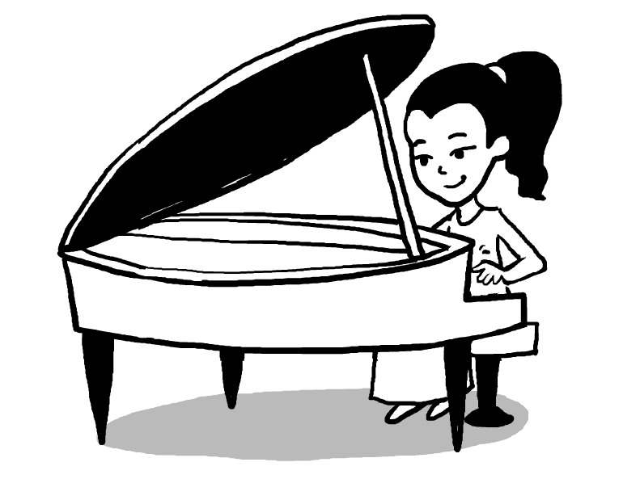
Are you listening to pop songs but not learning to play a musical instrument? The idea of practicing the piano or violin every day under your parents’ watchful eye is bad enough, not to mention all the playtime you’ll lose.
But you would change your mind if you knew that musical training could make you smarter, especially if you start young, according to The New York Times.
In fact, the study of the benefits (益处) of music has been going on for years. Back in 1993, Nature magazine reported an experiment showing that college students who listened to 10 minutes of Mozart music before taking an IQ test scored better. This is what’s now known as the “Mozart effect”.
Although scientists later found that it wasn’t IQ that had been improved, but temporary (短时的) reasoning ability, this study still got them thinking – if simply listening to music can bring good effects, what would actually playing an instrument do to brain development?
Now researchers at Northwestern University, US, have got the answer. They studied a group of college students – some of them had received musical training in their school years while others had not.
Looking at their brain waves, researchers discovered that they responded differently when hearing complex sounds – those who had learned music before were better at picking out single pitches (音高) from a noisy background. And this was true even if the lessons had ended years ago.
This ability to single out certain sounds is connected to language-based learning – for example, reading.
“To learn to read, you need to have good working memory, the ability to disambiguate (分辨) speech sounds, make sound-to-meaning connections,” professor Nina Kraus from Northwestern University told The New York Times.
“Each one of these things really seems to be strengthened ... [when] playing a musical instrument.”
But the researchers also said that there is no one best way to apply these findings. Different instruments, different teaching methods, different schedules – parents need to find what works best for the child, and children should try to enjoy themselves and their lessons. After all, music is about pleasure, instead of being just a tool.
( )53. Musical training can improve the ability to ______.
A. enjoy the noisy background B. make different speech sounds
C. learn language-based learning D. connect sounds with the pictures
( )54. We can infer from the passage that ______.
A. listening to Mozart’s music can improve one’s IQ temporarily
B. musical training at a young age can bring us a great advantage
C. students who can play musical instruments are better at reasoning
D. we must learn the skill of playing a musical instrument nowadays
( )55. The article is mainly about ______.
A. the connection between musical training and getting good grades
B. the effects of musical training on the development of human brain
C. a new discovery about the longtime benefits of early music lessons
D. the efforts at making full use of the brain through musical training
D
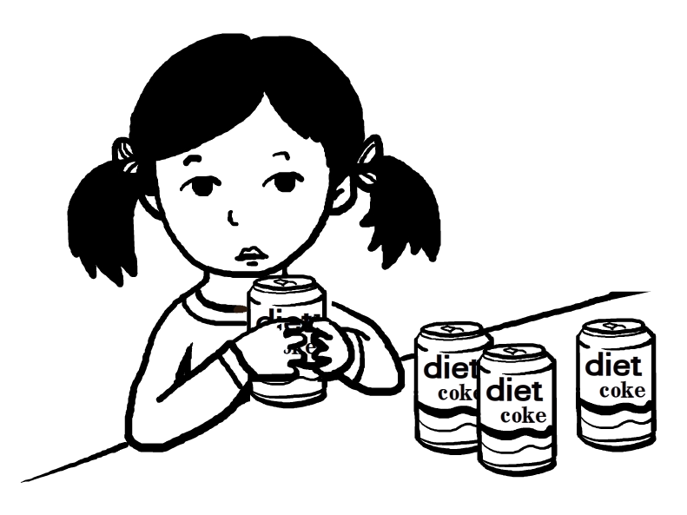
Diet drinks may taste good, but they might not bring happiness. A new study finds that people who drink diet sodas or fruit drinks are more likely to be diagnosed (诊断) with depression.
The study doesn’t show that diet drinks cause depression and the researchers stress their findings don’t provide an explanation. They looked at more than 263,900 U.S. adults ages 50 to 71 who answered questions about their beverage（饮料）consumption（摄入量） between the years 1995 and 1996. About 10 years later (from 2004 to 2006), the same people were asked if a doctor had diagnosed them with depression since the year 2000.
People who regularly drank four or more cans of any type of soda a day were 30 percent more likely to have received a diagnosis of depression than people who did not drink soda, said Dr. Honglei Chen of the National Institutes of Health, who led the study. The risk of depression was especially high for people who drank diet soda — a 31 percent increased risk compared to a 22 percent increased risk for those who drank regular soda, the researchers said.
Those who drank four or more cans of diet fruit drinks were 51 percent more likely to be diagnosed with depression compared to those who did not drink diet fruit drinks.
By contrast, people who drank four or more cups of coffee a day were 10 percent less likely to have been diagnosed with depression compared to non-coffee drinkers.
The study only found an association, and did not determine（确定）whether diet soda or fruit drinks caused depression. Although the researchers took into account factors that could affect the results, such as age, sex, education, smoking status, physical activity, body mass index (BMI) and energy intake, it’s possible other circumstances, such as a family history of depression or stressful life events, could explain the association.
A family history of depression and stressful life events are some of the biggest predictors of depression, said Emma Robertson-Blackmore, assistant professor of psychiatry at the University of Rochester Medical Center, who was not involved in the study. In addition, older people are more likely to experience stressful life events, including the death of a loved one, job changes or illnesses, Robertson-Blackmore said.
However, the findings agree with those of a few previous studies that found a link between frequent consumption of sweetened beverages and a higher prevalence (流行程度) of depression, the researchers said. (Diet sodas and fruit drinks are sweetened, but their sweeteners contain no calories.)
“More research is needed to confirm these findings, and people with depression should continue to take depression medications prescribed by their doctors,”said Chen.
( )56. People who drink four or more _______ every day are the most likely to feel depressed.
A. cups of coffee B. cans of fruit drinks C. cans of diet soda D. cans of regular soda
( )57. The underlined phrase “took into account” means ___________.
A. checked out B. went through C. drew a conclusion D. paid attention to
( )58. What can we learn from Dr. Honglei Chen’s study?
A. Diet drinks taste good but they don’t always bring happiness.
B. Drinking a lot of diet drinks regularly will lead to depression.
C. There is a close connection between diet drinks and depression.
D. Stressful life events can explain why people may feel depressed.
( )59. What is the purpose of the writer writing the article?
A. To find out why diet drinking leads to depression.
B. To present findings on diet drinking and depression.
C. To warn us against drinking diet soda or fruit drinks.
D. To suggest a healthy way of drinking for a better life.

七、阅读短文，根据短文内容，从短文后的五个选项中选出能填入空白处的最佳选项。选项中有一项为多余选项。（共8分，每小题2分）
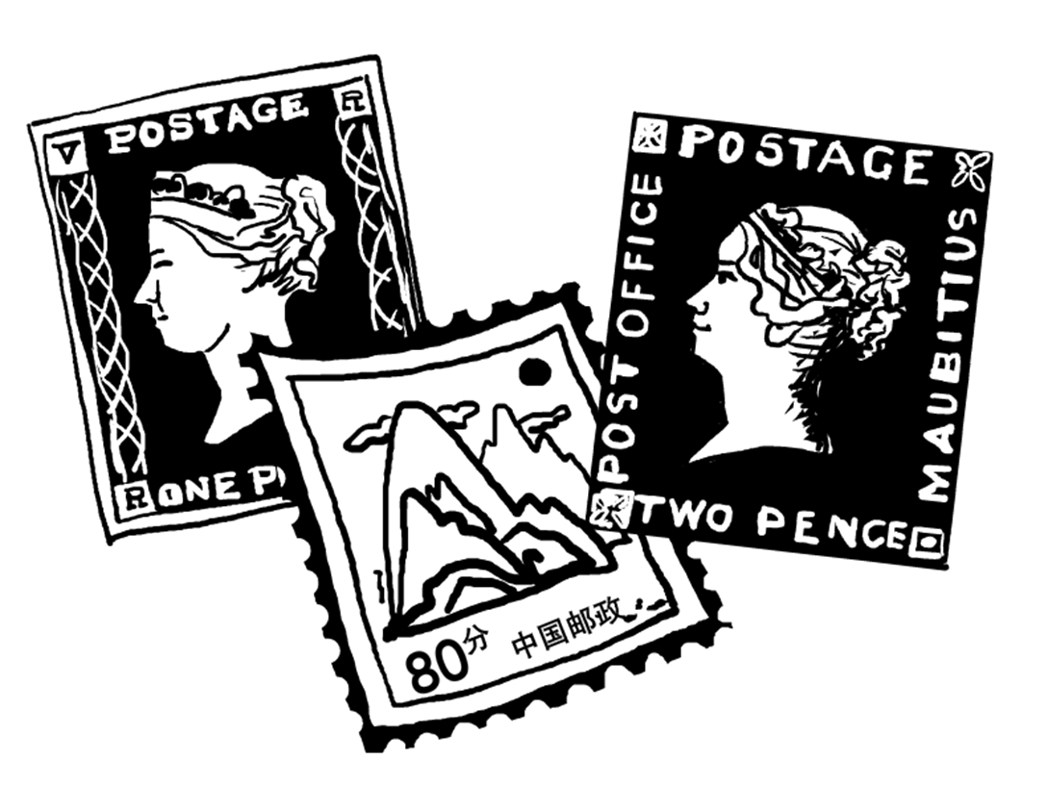
Before the invention of the postage stamp, it was difficult to send a letter to another country. The sender paid for the letter to travel in his or her own country. 60 If a letter crossed several countries, the problem was worse.
Rowland Hill, a British teacher, had the idea of postage stamp with glue on the back. The British post office made the first stamps in 1840. There were the Penny Black and the Two Pence Blue. A person bought a stamp and put it on a letter. 61 When people received letters, they didn’t have to pay anything. The postage was prepaid.
Postage stamps became popular in Great Britain immediately. Other countries started making their own postage stamps very quickly. But some countries didn’t want to accept letters with stamps from others. 62 Each country in the UPU agreed to accept letters with prepaid postage from other members. And now almost every country in the world is a member of this organization. 63
Today post offices in every country sell beautiful stamps. Collecting stamps is one of the most popular hobbies in the world, and every stamp collector knows about the Penny Black and the Two pence Blue.
A. The post office delivered the letter. B. It takes care of any international mail problem.
C. The invention of the postage stamp was popular.
D. Then the person in the other country paid for the rest of the trip.
E. Finally, in 1874, a German organized the Universal Postal Union (UPU).

八、阅读短文，根据短文内容回答问题。（共10分，每小题2分）
Team spirit means the willingness of people to work together and help each other as part of a team. With this spirit, people try hard to make their team the best of all. Everyone has experienced team spirit one way or another, whether they were part of a team or saw a group of people cheer for their favourite player.
There are different kinds of team spirit. One kind is the connection between a team of people because their efforts and cooperation (合作) are necessary in reaching a particular goal. Another kind is when a group of people support a person or a team. Another is people’s natural love for and pride in their country, when a whole nation cheers for its country in competitions.
Team spirit creates various good effects. It creates friendship and trust between people who may not get along when they don’t have such team spirit. There may also be bad effects. Too great team spirit may cause arguments or fights with other team members.
Some people don’t understand team spirit properly. They think team spirit means having to become an official member of an organization, team or fan club. In fact, team spirit can be built between friends, coworkers or even between two people sitting next to each other. You don’t have to be wearing the team spirit clothes. Anyone can show team spirit just by showing support for the goal.
64. What does team spirit mean?

65. When can we see people’s natural love for their country?

66. What good effects does team spirit create?

67. Where can team spirit be built?

68. What are the main points about team spirit in this passage?

书面表达（共25分）
九、完成句子（共10分，每小题2分）根据中文意思完成句子。
69.今天下午没课，为什么不出去玩玩呢？
We don’t have class this afternoon. __________________ go out to have fun?
70. Justin 今天没有来上学。她怎么了？Justin isn’t at school today. ________________ with her?
71. 周日，我阿姨或表姐会和我一起去游乐园。
______________ my aunt ____________ my cousin will go to the amusement park with me on Sunday.
72. 他太累了，追不上其他人。He is __________________________________ others.
73. 我一直坚持每天用一个小时阅读各种各样的英语读物。
__________________________________________________ English materials everyday.

十、文段表达（15分）
根据中文和英文提示，写一封意思连贯、符合逻辑、不少于60词的回信。信的开头和结尾已给出，其词数不计入所完成的回信内。请不要写出你的校名和姓名。
假设你叫李华，是美国中学生彼得的笔友，你收到了他的来信。请给彼得写一封回信，回答他的问题，
介绍园博会的举办给北京的环境带来的变化，并谈谈你的感受和打算。
Hi! Li Hua,
I am going to Beijing next month because I have heard that the Ninth International Garden Expo is open in Beijing. I have also heard that there are great changes in Beijing. The city is getting more beautiful and the people are getting friendlier. Is it right? Can you tell me something more about it?
I’m looking forward to hearing from you soon．
Yours,
Peter
Hi! Peter,
I’m glad to know you are coming to Beijing．

If you have more questions, please ask me．
Yours,
Li Hua

