北京市东城区2013年初三二模试卷（英语）

四、单项填空（共13分，每小题1分）
( )22. ______ saw John at the shopping center last night. He said hello to us.
A. We B. They C. He D. She
( )23. Peter is very tired, ______ he doesn’t want to go to bed.
A. or B. but C. so D. and
( )24. — Must I wait here until three o’clock?
— No, you ______．You can leave now.
A. needn’t B. mustn’t C. can’t D. shouldn’t
( )25. Dave’s father gave him ______ money for the school trip.
A. few B. many C. some D. any
( )26. ______ did you slow down? We are already late for the meeting.
A. How B. When C. Why D. Where
( )27. The baby ______ a bottle of milk every morning.
A. was drinking B. drinks C. drank D. is drinking
( )28. Of all the months in the year, December is ______.
A. the coldest B. coldest C. colder D. cold
( )29. — What were you doing when the light went off?
— I ______ with my sister on the phone.
A. talk B. talked C. am talking D. was talking
( )30. Don’t disturb the professor. He is busy ______ his lessons.
A. prepare B. prepares C. preparing D. to prepare
( )31. In the English class, I raised my hand and ______ the teacher a question.
A. had asked B. have asked C. ask D. asked
( )32. Antony and Tom are good friends. They ______ each other for ten years.
A. knew B. know C. have known D. had known
( )33. It took 16 years to build the Big Ben tower and it ______ in 1859.
A. is finished B. was finished C. has finished D. had finished
( )34. — Could you tell me ______?
— At 2:00. Hurry! There are only ten minutes left.
A. what time we set off B. what time we will set off
C. what time did we set off D. what time will we set off

五、完形填空（共12分，每小题1分）
Four of my friends and I gathered at our favourite restaurant for Anna’s birthday party. We were all having a good time when suddenly Julia said, “Hey! Let’s go to 35 house and party on!”
“I’m not sure if it’s a good idea,” I said. I looked to the others for support (支持), but it seemed they were 36 going to Julia’s house, for they didn’t know 37 to say “no” to Julia. Julia always tries to bully (欺负) the rest of us. She knew that we would all get into trouble with our parents if we left the restaurant. But that didn’t 38 her.
“Don’t forget Anna’s mother will bring the birthday cake at 8:30,” I said, “We should wait 39 Anna’s mother arrives!”
“Don’t be silly. She’ll find us,” Julia said, laughing, like it was no big deal.
“My mother is coming here to pick me up,” I lied, not wanting to tell her I knew my mother wouldn’t 40 me to go.
“Stay here by yourself,” Julia said, “The rest of us are going.” Then she began calling me names.
I felt tears coming to my eyes, so I ran to the bathroom. I felt so childish, crying alone. It’s really 41 to go against your friends, especially when you’re hoping to be popular with them. A moment later, Amanda came in and said, “Julia is just that 42 . I agree with you. If we get out right now, maybe we can persuade (劝说) the others to stay.”
“I’m staying here with Susan,” Amanda said as soon as we 43 to the table. Then she said something I hadn’t 44 . “If I leave, I’ll get into trouble with my parents, so let’s take Susan’s 45 .”
Anna looked happy again as she said, “My mother wouldn’t agree, either. I’ll stay with you two.”
“Okay, I’ll stay, too,” Ellie added.
“Well, I’m not going alone. I have to stay! Oh!” Julia said.
I was surprised it was so 46 . None of the girls left and I knew it was because Amanda sided with me.
I guess it’s true that there’s strength in numbers. Friends can influence each other, for good or bad.
( )35. A. her B. your C. my D. their
( )36. A. trying B. considering C. imagining D. suggesting
( )37. A. how B. when C. who D. why
( )38. A. help B. stop C. please D. touch
( )39. A. because B. if C. after D. until
( )40. A. allow B. tell C. force D. invite
( )41. A. brave B. hard C. necessary D. strange
( )42. A. role B. state C. shape D. way
( )43. A. traveled B. referred C. returned D. pointed
( )44. A. described B. checked C. expected D. completed
( )45. A. advice B. offer C. answer D. plan
( )46. A. natural B. direct C. wise D. simple

阅读理解（共44分）
六、阅读下列短文，根据短文内容，从短文后各题所给的A、B、C、D四个选项中，选择最佳选项。（共26分，每小题2分）
A
Holiday Activities for Kids
Clay Craft (陶艺)at Art Center
This two-hour workshop teaches children to make gifts
using clay. For children aged 6 to 12.
When: Jul. 19 (1-3 pm) (Friday)
Price: $20
Go to www.skills.org/clay for more information.
Fun Cooking at Little Cook School
Children aged 6 to 10 can learn to make healthy hamburgers. Children aged 10 to 12 can learn to make delicious cake.
When: Every Wednesday (2-5 pm) in the month of Aug.
Price: $35
Wonder Dance Class at Emma Workshop
Learn to dance with excellent teachers. A four-week dance
course for those aged 10 to 12.
When: Jul. 11 (3-5 pm) every Thursday
Price: $60 for four lessons
For details, go to http://emmaworkshop.blog.com.
( )47. Children can learn to make clay gifts on ______.
A. Jul. 11 B. Jul. 19 C. Aug. 11 D. Aug. 19
( )48. At Emma Workshop, children can ______.
A. have a big dinner B. make special gifts C. make hamburgers D. learn to dance
( )49. How many activities can an eight-year-old child take part in?
A. 4. B. 3. C. 2. D. 1.
B
Imagine you are walking to school when suddenly you notice a wallet in the street. After picking it up, you realize that it’s full of $10, $20, and $50 bills. They add up to $500! What would you do?
Would you hand the wallet over to your headmaster as soon as you arrive at school? That’s just what Kemoy Gourzang did.
“I have lost money before,” Kemoy, a 10-year-old boy, told the reporter, “I knew if I had lost my wallet, I would have wanted it back.”
Joy-Ann Morgan, the headmaster, immediately called the owner of the wallet, using the ID inside. The man did not realize he had lost it. Morgan said he was happy to learn that an honest kid had found it.
“This is what we want to teach our students,” Morgan explained.
Kemoy has learned that doing the right thing pays off. His school district gave him a “Good Citizen” prize in honor of what he did. A person who has good citizenship is responsible and does the right thing. Kemoy has also received gifts from complete strangers, money, gift cards, and even a pair of sports shoes.
As for the owner of the wallet, he thanked Kemoy when he went to the school to get his wallet back. He also gave the student $100 as a reward. “He told me I was the most honest person he had ever met,” Kemoy said, “It makes me really happy.”
( )50. How much money was there in the wallet?
A. $10. B. $20. C. $50. D. $500.
( )51. What did Kemoy do after he picked the wallet up?
A. He handed it over to the headmaster.
B. He told his friends about the money.
C. He called the owner of the wallet.
D. He asked a reporter for help.
( )52. Kemoy received ______ for what he did from the school district.
A. a pair of sports shoes B. a gift card
C. a “Good Citizen” prize D. a $100 bill
C
What do three hearts, eight arms, and one huge brain add up to? An octopus—a sea animal that can do amazing things.
Octopuses are very smart. They can learn new things just like humans. They’ve even learned a few skills to get themselves out of dangerous situations. Octopuses don’t have teeth or sharp (锋利的) claws to protect themselves. Instead, they use more clever ways to fool their enemies. Octopuses like to hide themselves in the sand on the bottom of the ocean floor. It can change the color of its skin to match the sand. And this color change happens in less than a minute.
Some octopuses like to stay near rocks in shallow water. They can make themselves fit into small spaces between the rocks to get out of reach of their enemies. Another way an octopus can hide is by shooting ink. The ink forms a cloud that hides the octopus. By the time the ink clears, the octopus has swum away or hidden.
If an octopus is in danger, it can make itself look like a sea snake. It will hide itself in the sand, leaving two arms outside. It will change the color of those arms to match a sea snake. But what if there’s no time to hide? It can break off one of its arms. The arm will then change colors and keep moving around in the water to take the enemy’s attention away while the octopus swims away to safety. Don’t worry though. The arm will grow back.
A kind of octopus is called the blue-ringed octopus. It is tiny. But the enemies know to stay away because it is very poisonous and can kill animals much larger than itself, including humans.
So the next time you see an octopus in the aquarium, remember that inside that oversized head is a very large brain, making it a clever addition to the sea.
( )53. The octopus breaks off one of its arms to ______.
A. fit into small spaces B. swim much faster C. get time to run away D. shoot more ink
( )54. Which of the following is true according to the passage?
A. The octopus has sharp teeth to catch food.
B. The octopus uses its arms to kill the enemy.
C. The octopus changes color to fool the sea snake.
D. The octopus can make itself look like another animal.
( )55. The passage is mainly about ______.
A. how careful the octopus is to hide itself
B. how clever the octopus is to protect itself
C. how happy the octopus is to live in water
D. how brave the octopus is to face dangers
D
You eat to stay fit and keep your body working, right? Then reading is food for your mind and soul. Reading informs you of what’s happening around. Reading encourages you to think and imagine, think out of the box and imagine the impossible.
In the past, people just read books, only books. Today, we have books online, which makes reading easy. The web, our new storehouse of information is just a click away. But this in no way has stolen the magic of reading books, the sound of their pages’ flutter (翻页) and their smell… You can lie in bed with a book, but with a computer you possibly can’t. No matter how you read, reading is important.
Remember those bedtime stories? We read fun facts about animals, plants and the universe. We ask “whys” and “hows”. In books, we find their answers. Children who are introduced to reading at an early age are seen to have a better understanding of phonics (语音学). They master language skills easily, have a richer vocabulary and have greater reading abilities. Children, who grow up reading good books, mostly stand out. The way they think and act is very different from those who have never been introduced to reading. Reading not only adds to their knowledge but also shapes their personalities. Reading has a great influence on one’s life. Teenagers are easily influenced by whatever they read. If inspirational stories and life experiences are read in one’s teens, they can change a person for the better. They stay with him and keep encouraging him to achieve his goals and choose the right against the wrong.
The more you read, the more creative and imaginative you will become. Reading develops vocabulary, improves language skills and sharpens your problem-solving abilities. It leads to a better understanding of self. Reading gives you knowledge, it makes you more confident. The more you read about others’ lives and experiences, a better decision-maker you will become.
Reading about the importance of reading should lead you to read more, and more, and more. So choose a book you like and don’t stop reading until you reach the end. And even after that read as much as you can.
( )56. Which of the following is true?
A. Children should start reading at a young age. B. Parents should tell their children stories every day.
C. Teenagers should think and act differently from others.
D. Students should find answers to their questions in books.
( )57. The underlined sentence in Paragraph 2 means ______.
A. reading books is no longer a pleasure to people
B. reading books is less interesting than reading online
C. reading online can’t take the place of reading books
D. reading online can’t be difficult for people
( )58. What can we infer from the passage?
A. More teenagers read online now. B. What teenagers read builds their future.
C. What children should learn first is phonics. D. More practice makes reading easier.
( )59. What’s the best title for the passage?
A. Why Is Reading Important? B. What Should Teenagers Read?
C. How Is Reading Ability Improved? D. When Should Children Start Reading?

七、阅读短文，根据短文内容，从短文后的五个选项中选出能填入空白处的最佳选项。选项中有一项为多余选项。（共8分，每小题2分）
Once upon a time, there was a group of frogs. 60 . The goal was to reach the top of a very high tower. A big crowd (群) came to see the race and cheered on the players.
The race began…
Honestly, no one in the crowd really believed that the frogs would reach the top of the tower. “Oh, too difficult. 61 ,” one frog in the crowd shouted.
“Not a chance that they will succeed. The tower is too high!” another one continued.
The frogs began falling down, one by one, except for those who were climbing higher. The crowd continued to shout, “It is too difficult! No one will make it!” 62 .
But one continued higher and higher and higher. This one wouldn’t give up!
In the end, everyone else had given up climbing the tower except for one. 63 . Then all of the other frogs wanted to know how he managed to do it.
One frog asked him why he could reach the goal successfully. It turned out that the winner was DEAF!

A. They planned to have a race B. More frogs got tired and gave up
C. They will never make it to the top D. He was the only one that reached the top
E. Some frogs were climbing faster and faster

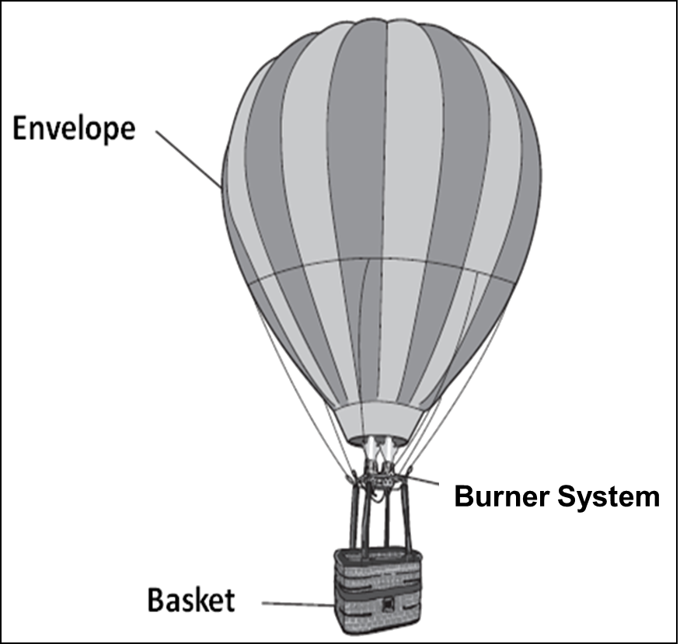
八、阅读短文，根据短文内容回答问题。（共10分，每小题2分）
On 19th September 1783, Pilatre De Rozier, a scientist, sent the first hot air balloon. The passengers were three animals and the balloon stayed in the air for about 15 minutes before hitting back to the ground.
The first manned（载人的）flight was about 2 months later, with a balloon made by 2 French brothers. The balloon flew for a period of 20 minutes.
Sailing through the sky in the balloon, high above buildings and trees, you can’t feel or hear the wind because you’re traveling in the same direction and at the same speed as it is.
A hot air balloon has three main parts: the balloon, called an envelope; a basket, where passengers ride; and a burner system, which supplies the hot air.
Most balloon envelopes are made of strong, lightweight nylon（尼龙）. They are different in size and shape, but they have to be really, really big to lift even one person. Most weigh more than an adult man.
The basket is usually made of wicker（柳条）, which is strong but not too hard. It needs to bend a bit for a soft landing, just like a good jumper bends her legs instead of keeping them straight when she lands.
The hot air balloon works on the theory that hot air rises faster than cooler air. When the burner system is turned on, it makes a noisy sound, but once the balloon is flying, the burner can be turned off. The air in the envelope will then cool, and the balloon will slowly go down unless the pilot starts the burner system again.
To control a hot air balloon, a pilot adds hot air to it to go up or lets the air out to go down until he finds a wind blowing in the direction he wants to fly. But no matter which way the wind blows, the passengers have an amazing bird’s-eye view of the world.
64. Who were the passengers on the first hot air balloon?

65. Did the first manned balloon fly for 20 minutes?

66. Why is the basket usually made of wicker?

67. How does a pilot control the hot air balloon?

68. What are the main points in this passage?

书面表达（共25分）
九、完成句子（共10分，每小题2分）
69. 要下雨了。你最好带把伞。
It is going to rain. take an umbrella with you.
70. 我和妈妈都不喜欢红色，所以选择了蓝色的。
like red, so we chose the blue one.
71. 他尽可能小心地做了这个化学实验。
He did the chemical experiment he could.
72. 坚持努力，你的梦想会实现的。
and your dream will come true.
73. 李女士很关心村子里的人。她花了很多时间和精力帮助他们改善生活。
Miss Li cared much about the people in the village. She their life.
十、文段表达（15分）
根据中文大意和英文提示词语，写出意思连贯、符合逻辑、不少于60词的短文。所给的英文提示词语仅供选用。请不要写出你的校名和姓名。
74. 我们周围有很多值得尊敬的人，家长，老师，朋友……你最尊敬的人是谁呢？
某英文报纸以“我最尊敬的人（The person I respect most）”为题进行征文，请你投稿。介绍一下你最尊敬的人是谁，你为什么尊敬他/她，你从他/她身上学到了什么。
提示词语：important, learn, help…

The person I respect most

