北京市通州区2013年初中毕业统一检测
英 语
2013年5月
考  生  须  知 | 1. 本试卷分为听力理解、语言知识运用、阅读理解和书面表达四部分，共8页。  2. 本试卷满分100分，考试时间120分钟。  3. 考试结束，请将本试卷和答题卡交回。  4. 请将姓名、校名填写在答题纸密封线外指定的位置上。
听力理解（共20分）



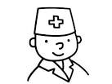
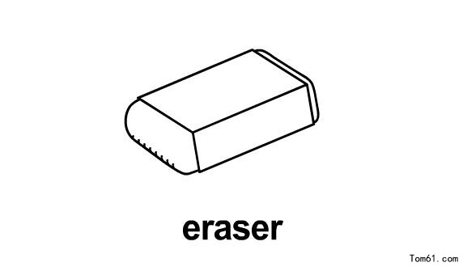
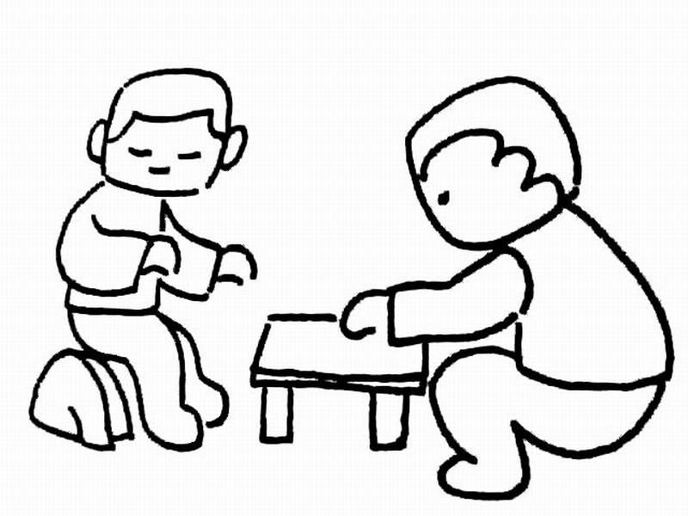



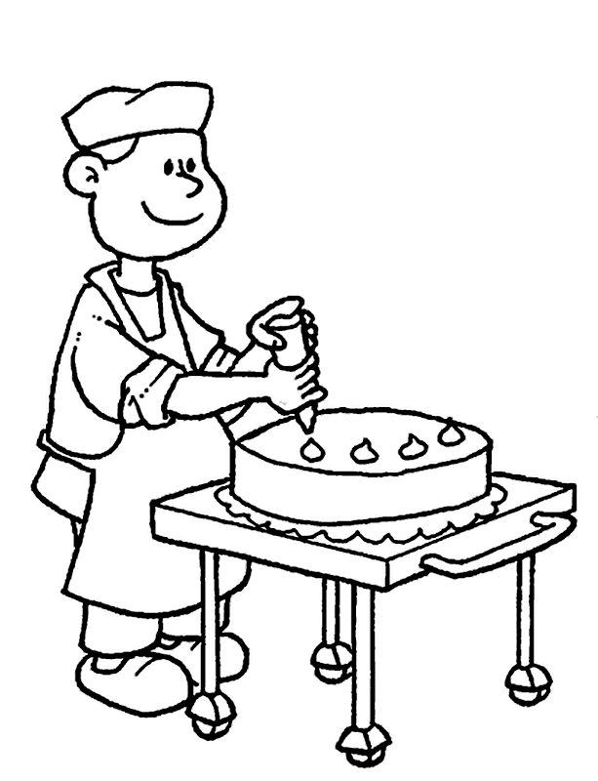
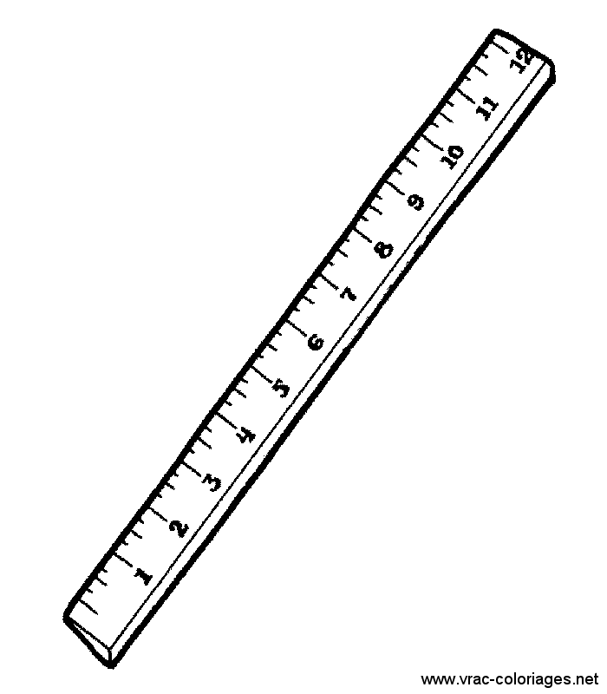

一、听对话，从下面各题所给的A、B、C三幅图片中选择与对话内容相符的图片。每段对话读两遍。（共4分，每小题1分）
1.

A B C
2.

A B C[来源:学.科.网]
3.

A B C
4.

A B C
二、听对话或独白，根据对话或独白的内容，从下面各题所给的A、B、C三个选项中选择最佳选项。每段对话或独白读两遍。（共10分，每小题1分）
请听一段对话，完成第5至第6小题。
5. What time is it now?
A. 5:00. B. 6:00. C. 7:00.
6. What’s the relationship between the speakers?
A. Teacher and student. B. Husband and wife. C. Doctor and patient.
请听一段对话，完成第7至第8小题。
7. Who did Lucy look after yesterday?
A. Her brother. B. Her father. C. Her uncle.
8. How long has Tom been in the hospital?
A. Two days. B. Three days. C. Four days.
请听一段对话，完成第9至第11小题。
9. Where is Grace going to work?
A. In the camp. B. At the store. C. In the school.
10. What is Alex going to do in the camp?
A. Work with his father. B. Learn how to sell. C. Do some sports.
11. What does Alex think of the camping?
A. It’s great. B. It’s useful. C. It’s crazy.
请听一段独白，完成第12至第14小题。
12. How did the speaker get his idea?
A. He looked for information on the Internet.
B. He asked his friends and classmates for help.
C. His teachers and parents told him about it.
13. What can we learn from the talk?
A. Team games need little time to prepare.
B. Lazy kids like to have a longer break.
C. Kids used to have more outdoor time.
14. What’s the speaker doing?
A. Making a suggestion.
B. Introducing his school life.
C. Asking kids to work hard.
三、听对话，根据所听到的对话内容和提示词语，记录关键信息。对话读两遍。（共6分，每小题1.5分）
Research Notes about Computer Use
Name: 15 Brown
Age: 16
How to use it: look for information
17 news
When to use it: every 18

语言知识运用（共22分）
四、单项填空（共12分，每小题1分）
从下面各题所给的A、B、C、D四个选项中，选择可以填入空白处的最佳选项。
19. Miss Gao is our English teacher. She gives ____ a lot of help.
A. we B. us C. our D. ours
20. Fiona goes to bed ____ 9 o’clock every day.
A. of B. in C. on D. at
21. I can’t carry your bag. It is much ____ than mine.
A. heavy B. heavier C. heaviest D. the heaviest
22. — ____ is your mother?
— She is in the kitchen.
A. Where B. What C. When D. How
23. — Do you like this shirt?
— Yes, ____ I don’t like the color.
A. but B. and C. or D. so
24. — Must I go there right now, mum?
— No, you ____. You can go there tomorrow.
A. shouldn’t B. can’t C. mustn’t D. needn’t
25. Frank asked his father ____ a new bike for him and his father said OK.
A. buy B. to buy C. buying D. bought
26. In 2000, we ____ to the Great Wall and had a good time there.
A. go B. went C. will go D. have gone
27. When the teacher came into the classroom, the students ____ in groups.
A. work B. have worked C. were working D. are working
28. The boys ____ a football match tomorrow morning.
A. are having B. will have C. had D. have had
29. Mr. Li ____ to give a talk in our school yesterday.
A. invites B. is invited C. was invited D. invited
30. — Can you tell me ____ last year?
— In Shanghai.
A. where does she work B. where she works
C. where did she work D. where she worked
五、完形填空（共10分，每小题1分）
阅读下面的短文，掌握其大意，然后从短文后各题所给的A、B、C、D四个选项中，选择最佳选项。
My name is Ben Mansury. I’m fifteen years old and study in a middle school. In school, I never join in any group discussion or stage (舞台) program. So, I never knew what stage nervousness was.
Our community (社区) has a weekly “Students Ideas” program. About two years ago, I received a(n) 31 from the chairman of our community. He invited me to the “Students Ideas” talk the next morning to speak to the group.
The time between his call to the next morning was like several weeks for me. The whole night, I could not sleep. Many 32 were coming. One of them was to call the chairman, with regret, and tell him that I could not come. But finally, I thought, if I missed this 33 , the community would never invite me again to any of their programs. So, I decided to go.
I reached the hall in time. When my turn came and I started, my heartbeat increased and my mouth went dry. I wasn’t even able to 34 the words on the paper properly. I had no idea where I was standing and what I was talking. That was the day when I 35 my biggest weakness: public speaking.
After I finished, I met with the chairman and 36 what happened to me. He said that this happens to everyone. It is very 37 . He suggested that I should come again the next week.
I 38 a talk carefully. This time when I gave the talk, I was somewhat comfortable but not confident (自信的). Afterwards, I met with the chairman again and told him about the improvement I 39 I had made. He was kind enough to invite me again.
For around one month, I practiced a lot for my talk. This time I was feeling comfortable and both the chairman and my neighbors thought I did a good job.
I learned that everything is 40 if we take the first step, as the saying goes: A journey of thousand miles begins with first step.
31. A. letter B. call C. card D. email
32. A. topics B. regrets C. thoughts D. words
33. A. man B. group C. stage D. chance
34. A. read B. spell C. see D. recite
35. A. had B. forgot C. realized D. improved
36. A. asked B. checked C. explained D. wondered
37. A. useful B. successful C. difficult D. common
38. A. wrote B. prepared C. gave D. finished
39. A. knew B. felt C. believed D. hoped
40. A. easy B. great C. helpful D. possible
阅读理解（共36分）
六、阅读下列材料，根据其内容，从材料后各题所给的A、B、C、D四个选项中，选择最佳选项。（共20分，每小题2分）
A
This is part of a book’s table of contents.
Chapter One: North America
The Fox and the Raccoon ..... 1
Song of the Mountains ......... 4
Little Feather Meets Bear ..... 7
Chapter Two: South America
Kuma and the Big River......... 10
The Smallest Monkey ............ 12[来源:学|科|网Z|X|X|K]
Three Tree Frogs ................... 15
Chapter Three: Africa
Marumbi Saves the Day....... 18
The Jumping Fish ................ 22
Father Lion and His Son ...... 25
41. Chapter One is about ____.
A. North America B. South America C. Africa D. Asia
42. If you want to read The Smallest Monkey, you can turn to page ____.
A. 4 B. 7 C. 12 D. 25
43. If you are reading page 22, which story are you reading?
A. Song of the Mountains. B. Kuma and the Big River.
C. Three Tree Frogs. D. The Jumping Fish.
B
Dolores Huerta has worked hard most of her life to help other people. She has helped change things so that farm workers can have a better life.
Dolores grew up in California. She was a good student and liked school. After she finished high school, she went to college and studied to be a teacher. After she became a teacher, Dolores noticed that many of her students were not getting enough food to eat. Some of them wore very old clothes. Dolores wondered how she could help them.
Dolores decided to stop teaching so that she could spend more time helping the farm workers and their families. One thing she wanted to do was to get more pay for farm workers so they could buy their children the things they needed.
Dolores knew that many farm workers moved often from one place to another to help pick different kinds of fruits and vegetables. She began talking and writing about these workers. Even people who lived far from California read what Dolores wrote.
Getting higher pay for the farm workers was not easy. Dolores worked hard to make sure that farm workers got good pay for their work. She knew that nothing would change unless people made new laws to help the workers. Through all her hard work, new laws were made that gave farm workers good pay.
Dolores Huerta has worked for more than 30 years in many different ways to make life better for working people. She has shown how much one person can change things.
44. Dolores became a ____ after she left college.
A. farmer B. teacher C. worker D. lawyer
45. Dolores gave up her first job because ____.
A. she found it was too boring for her B. the work condition was too bad
C. she wanted to do more for others D. she got little pay for her work
46. How did Dolores help farm workers?
A. She gave them food and clothes. B. She helped them teach their children.
C. She helped them got more pay. D. She made new laws for them.
C
The high school diploma (文凭) is losing its value quickly, as a growing number of students graduate (毕业) from school without the math and reading skills that colleges and companies require, according to a new report.
The high school graduation exams that most states (州) require students to pass before they graduate remain far too easy. Most of the exams generally test eighth-or ninth-grade level work.
Today, even high school graduates who are going to have blue-collar (蓝领) jobs need to study the math, research and writing courses. But in high school, only students who are going to college are now required to take these courses.
“If you want a good job with a good pay, it’s a high-skill job,” said Michael Cohen, a leading member of the America Diploma Project.
The project suggests that all graduates master a wide range (范围) of skills. “A high school diploma should mean something to a company and university,” said Ohio Gov. Bob Taft, who is Achieve’s co-chairman.
In Taft’s state, about 30% students who go directly to college from high school have to take remedial classes of English or math, he said. It’s easy to see that the present high-school graduating standards are not preparing students for college education.
And with high-skilled jobs increasingly headed overseas to places like India and Ireland, states need to act, he said.
To prove why math and reading skills matter, the report includes real-life examples of problems students meet in college and that workers must solve each day on the job. 
Some states are taking actions to upgrade the high school diploma. In Texas, all high school students, starting with the 2008 graduating class, will have to take the college-prep curriculum (大学预备课程) - unless a parent agrees to an easier course load. Other states are planning similar moves.
The report includes examples of reading and math skills that high-school students should have. Project leaders say they hope parents will use those examples to judge (评定) the coursework at their kids’ high schools.
47. Why is the high school diploma losing its value quickly?
A. Because the number of high school students is growing fast.
B. Because high school students fail to reach the standards.
C. Because the graduation tests are easier than it should be.
D. Because difficult courses are not required in high schools.
48. Remedial classes in Paragraph 6 mean classes____.
A. for good learners to study quickly and better
B. for slower learners weak in the subject
C. for learners to be taught one by one
D. for learners to reach a higher standard
49. What can we learn from the passage?
A. Colleges require higher math and reading skills than companies.
B. It is easier for companies to find high-skilled workers in India.
C. Math and reading skills help little for workers to solve daily problems.
D. Parents ask high schools to offer college-prep curriculum in Texas.
50. What can be the best title for the passage?
A. High School Diploma Means Little
B. Give Students More High-skill Jobs
C. Math and Reading Skills Really Matter
D. Judge Coursework at High Schools
七、阅读短文，根据短文内容，从短文后的五个选项中选出能填入空白处的最佳选项。选项中有一项为多余选项。（共8分，每小题2分）
When I was about 13, I had an enemy, a girl who liked to point out my shortcomings (缺点). Sometimes she said I was lazy. Sometimes she said I wasn’t a good student. 51 . I tried to put up with (忍受) her as long as I could. At last, I became very angry. 52 .
My father listened to me quietly, and then he asked, “Are the things she said true or not? Go and make a list of everything she said and mark the points that are true. Pay no attention to the other things she said.”
I returned to my room and I did as my father told me. To my surprise, I found that about half the things were true. 53 . He refused to take the list. “That’s just for you,” he said. “When something said about you is true, you’ll find it will be helpful to you. Listen to them all, but hear the truth and do what you think is right.”
Many years have passed. 54 . In our life we often meet with some trouble and we often go to someone and ask for advice. For some advice you will treasure (珍惜) all your life!
A. I brought the list back to my father
B. The situation often appears in my mind
C. My mum didn’t like me
D. I ran to my father
E. Sometimes she said I talked too much
八、阅读与表达（共8分，每小题2分）
阅读短文，根据其内容回答问题。
People are very social animals. We need to talk with and do things with other people. We often understand ourselves better when we discuss our ideas and activities with other people. We need to make meaningful connections with friends and family. These connections help us forget our failures and worries. We can focus (集中) on things that are important: the people we care about.[来源:学科网]
Your community is the area near your home. It’s where you work, play and go to school. It is the neighborhood where your family makes connections with other people. It’s the places you feel like you belong (属于) to.
Communities grow and change over time. Families move from one city to another because of work or family situations. Older people often move to smaller homes or vacation areas after their children have grown up. Their children move out to start families of their own. New families move in when others leave.
Basic services, such as police, fire, post office, health and public schools are in almost every community. Businesses provide services to the community, too. Stores sell things that people need. Restaurants sell prepared food. Offices provide lots kinds of skilled work.
The job of the city government is to listen to the people of the community and help them connect. Some people may move on, but the community remains.
55. Are people very social animals?
56. What can these connections help us forget?
57. Why do older people move to smaller homes or vacation areas?
58. What does the passage tell us?

书面表达（共22分）
九、完成句子（共10分，每小题2分）根据中文意思完成句子。
59. 今天有雨，你最好带把伞。It’s going to rain today. You ____ take an umbrella.
60. 我的爸爸和妈妈都喜欢读书。Both my father and mother ____.
61. 别说话了，上课的时间到了。Stop talking. ________ class.
62. 我的电脑出问题了，你能帮我修一修吗？
____ my computer. Can you help me repair it?
63. 对于学生来说，花大量的时间进行英语阅读是有必要的。
____ a lot of time reading English.
十、文段表达（共12分）
64. 假设你叫林洋，收到了你的笔友Susan的一封信，请你给她写一封回信。在信中回答她的问题，提出你的建议，并就此事谈谈你的看法。
Dear Lin Yang,
I have a problem these days. My mother doesn’t allow me to watch TV even on weekends. She says as a middle school student, my job is to study. After I finish my homework, she says, I should read books and watching TV is bad for me. But I think I need a rest and watching TV helps me learn a lot too.
Do you have the same problem? What do you think of my mother’s decision? What should I do?
Yours,
Susan

通州区初三年级毕业考试
英语试卷答案及评分参考
2013. 05
听力理解 (共20分)
一、听对话，选择与对话内容相符的图片。（共4分，每小题1分）
1. B 2. A 3. C 4. A
二、听对话或独白，选择最佳选项。（共10分，每小题1分）
5. C 6. B 7. A 8. C 9. B 10. C 11. A 12. A 13. C 14. A
三、听对话记录关键信息。（共6分，每小题1.5分）
15. Allan 16. twelve/12 17. read 18. Sunday (本题大小写不扣分)
知识运用 （共22分）
四、单项填空（共12分，每小题1分）
19. B 20. D 21. B 22. A 23. A 24. D 25. B 26. B 27. C 28. B 29. C 30. D
五、完形填空（共10分，每小题1分）
31. B 32. C 33. D 34. A 35. C 36. C 37. D 38. B 39. B 40. D
阅读理解（共36分）
六、阅读短文，选择最佳选项。（共20分，每小题2分）
41. A 42. C 43. D 44. B 45. C
46. C 47. C 48. B 49. B 50. A
七、阅读短文，还原句子。（共8分，每小题2分）
51. E 52. D 53. A 54. B
八、阅读短文，回答问题。（共8分，每小题2分）本题大小写不扣分
55. Yes, (they are).
56. These connections (can) help us forget our failures and worries. (意思对即可)
57. Because their children move out to start families of their own. (意思对即可)
58. Why we have communities and what community is.
书面表达 （22分）[来源:学&科&网]
九、完成句子（共10分，每小题2分）本题大小写不扣分
59. had better
1 1
60. like reading
1 1
61. It is time for/to have
0.5 0.5 0.5 0.5
62. There is something wrong with
0.5 0.5 0.5 0.5
63. It is necessary for students to spend
0.5 0.5 0.5 0.5
十、文段表达（共12分）
64. One possible version:
I don’t have this problem. My mother allows me to watch TV after I have finished my homework.
I think your mother shouldn’t do like this. As a student, study is our main job, but it is not all of our life. We also need a rest and enjoy ourselves. Watching TV is a good way for us to relax. Besides, some TV programs are good for our study.
I think you should talk about it with your mum. Look for some information on the Internet to help you. You can also ask your father for help.
书面表达评分标准：
第一档：（12~10分）
完全符合题目要求，观点正确, 要点齐全，字数60词以上。句式多样，词汇丰富。语言准确，语意连贯，表达清楚，具有逻辑性。
第二档：（9~7分）
基本符合题目要求，观点正确, 要点齐全，字数60词以上。语法结构和词汇基本满足文章需要。语言基本通顺，语意基本连贯，表达基本清楚。虽然有少量语言错误，但不影响整体理解。
第三档：（6~4分）
部分内容符合题目要求，要点不齐全。语法结构和词汇错误较多，语言不通顺，表达不够清楚，影响整体理解。
第四档：（3~0分）
与题目有关内容不多，只是简单拼凑词语，所写内容难以理解。

听力录音材料:
一、听对话，从下面各题所给的A、B、C三幅图片中选择与对话内容相符的图片。
1. M: Can I use your ruler?
W: OK, here you are.
2. W: What are you doing Mike?
M: I’m watching TV.
3. W: What’s your favorite animal?
M: My favorite animal is the tiger.
4. W: What does your father do?
M: He is a doctor.
二、听对话或独白，根据对话或独白的内容，从下面各题所给的A、B、C三个选项中选择最佳选项。
请听一段对话，完成第5至第6小题。
W: John, what time is it now?
M: It’s 7 o’clock.
W: Oh, it’s time for dinner, but I don’t want to cook today.
M: Let’s eat in the restaurant around the corner.
W: That’s great!
请听一段对话，完成第7至第8小题。[来源:学|科|网]
M: Lucy, why didn’t you come to the party yesterday?
W: I had to look after my brother at the hospital.
M: What’s wrong with Tom?
W: He hurt his right arm.
M: How long has he been in the hospital?
W: Four days.
M: I hope he’ll get better soon.
请听一段对话，完成第9至第11小题。
M: What are you going to do this summer, Grace?
W: I’m going to work with my father at the store.
M: Have you ever worked?
W: No, but I can learn. What are you going to do this summer, Alex?
M: I’m going to camp. I’ve gone to camp for four summers.
W: I’ve never gone to camp. What do you do there?
M: We do many things. In the morning, we go swimming and boating. In the afternoon, we play basketball or tennis. We sit around a campfire at night. We sing or tell stories.
W: That sounds great.
M: Sure, it is.
请听一段独白，完成第12至第14小题。
M:
Recently, our school cut the period of the break down from 30 minutes a day to 20 minutes. This is terrible! My friends and I like to make up different games to play during the break. It takes a few minutes just to work out what we want to play and divide into teams. How can we finish a whole game in just 15 minutes?
I have a better idea. How about making the break longer instead of shorter? After I have done careful research on the Internet, I think we should make the break two hours — every day!
I don’t want a two-hour break because I am lazy or just want to have fun. Studies show that people learn better when they have a break once in a while. Studying takes a lot of hard work. After a while, your brain just gets tired. What’s more, kids don’t have as much time to play together as they used to. Our parents and teachers are always telling us about how they ran around outside for hours every day when they were little. Our parents won’t let us do that! They make us stay in the room. Isn’t that sad? If we had two hours of break, we could learn all of the cool games our parents played when they were kids. We would have more to talk to our parents, too!
三、听对话，根据所听到的对话内容和提示词语，记录关键信息。
W: Excuse me. My name’s Molly. I work for a market research company. Do you have a few minutes to answer some questions?
M: Yeah, sure.
W: Thanks. OK, what’s your name?
M: I’m Allan Brown. A-L-L-A-N, Allan. B-R-O-W-N, Brown.
W: How old are you?
M: I’m 12.
W: OK… Do you have a computer?
M: Yes, I have one.
W: How do you use it?
M: I look for information on the internet. It’s good for my study. And I like reading news on the Internet. I really can learn a lot.
W: How often do you use it?
M: I use it every Sunday.
W: OK. Thank you.

