密云县2011-2012学年第二学期高三一模
英语试卷 2012.4

注意事项：
1、本试卷分第Ⅰ卷(选择题)和第Ⅱ卷（非选择题）两部分, 共150分,考试时间120分钟。
2、试题所有答案必须填涂或书写在答题卡上，在试卷上做答无效。未在对应的答题区域做答或超出答题区域做答均不得分。
第一部分：听力理解（共三节，每小题1.5分，共20小题, 共30分）
第一节: 听下面五段对话。每段对话后有一道小题。从每题所给的A、B、C 三个选项中选出最佳选项。听完每段对话后，你将有10秒钟时间来回答有关小题和阅读下一小题。每段对话你将听一遍。
What does the woman want?
A. Pears. B. Apples. C. Bananas.
2. What time is it now?
A. 10:15. B. 10:30. C. 10:45.
3. What’s the possible relationship between the two speakers?
A. Mother and son. B. Brother and sister. C. Doctor and patient.
4. What is the weather like now?
A. Snowy. B. Cloudy. C. Fine.
5. What will the man and Mike do on the first day?
A. Stay at home. B. Visit the Great Wall. C. Go to the Summer Palace.
第二节
听下面4段对话或独白。每段对话或独白后有几道小题，从每小题所给的A、B、C三个选项中选出最佳选项。听每段对话或独白前，你将有5秒钟的时间阅读每小题。听完后，每小题将给出5秒钟的作答时间。每段对话或独白你将听两遍。
听第6段材料，回答第6至7小题。
6. How much does the woman have to pay?
A. Fifty dollars. B. Sixty-five dollars. C. One hundred dollars.
7. Where does this conversation take place?
A. In a store. B. In a restaurant. C. In a hotel.
听第7段材料，回答第8至10题。
8. What’s wrong with the man?
A. He has a headache. B. He has a toothache. C. He has a stomachache.
9. What did the man have this morning?
A. Some bread and two eggs. B. Some bread and a glass of milk.
C. Some bread, two eggs and a glass of milk.
10. What will the woman do next?
A. Prepare for her exam. B. Give her mom a phone call. C. Go to the hospital with the man.
听第8段材料，回答第11至13题。
11. What does the man want?
A. An English dictionary. B. A German dictionary. C. A French dictionary.
12. What do we know about the man?
A. He learns very fast. B. He is good at English C. He knows at least four languages.
13. What does the woman think of English and French?
A. English is much easier than French. B. French is more important than English.
C. English and French have a lot in common.
听第9段材料，回答第14至15题。
14. What is the girl under the tree doing?
A. Reading a book. B. Having a good rest. C. Talking with her friend.
15. What can we learn about the man and the girl from the dialogue?
A. They are classmates. B. They are brother and sister. C. They live in the same building.
第三节
听下面一段对话，根据题目要求在相应题号后的横线上写下回答第16至20题的相关信息。听对话前，你将有20秒钟的时间读题，听完后你将有60秒钟的作答时间。这段对话你将听两遍。请把16-20小题答案写在答题纸上。
Lost Property Report Form
Passenger’s name: | 16
Telephone number: | 17
Description of lost property: | the Beauty of Nature, a travel book with a lot of 18
Remarks: | in the 19 room  around 20 yesterday
第二部分：知识运用（共两节，45分）
第一节：单项选择 （共15小题，每小题1分，共15分）
从每题所给的A、B、C、D、四个选项中，选出可以填入空白处的最佳选项，并在答题卡上将该项涂黑。
例：It’s so nice to hear from her again. , we last met more than thirty years ago.
A. What’s more | B. That’s to say | C. In other words | D. Believe it or not
答案是D。
21. —Oh, must you? Stay a bit longer, it’s been such ______ fun having you.
—Thanks , anyway. I’ve got ______early start tomorrow morning.
A. /; the | B. a; an | C. /; an | D. the; an
22. It’s quite ______me why such things have been allowed to happen.
A. above | B. beyond | C. over | D. by
23. —How long do you suppose it may take ______ he arrives at the center of the city?
—No more than half an hour.
A. when | B. before | C. after | D. that
24. As______, the 2010 World Expo is to be held in Shanghai from May 1 next year to October 31.
A. being planned | B. to be planned | C. planned | D. planning
25. When it comes to ______responsible for our rubbish, the best way to deal with it is by recycling.
A. be | B. take | C. being | D. taking
26. Many students in this school make ____a rule to come to the evening classes even on Saturdays.
A. this | B. that | C. it | D. them
27. If I ______ get the money, I would set up a Hope school for the children in the poor areas.
A. were to | B. will | C. would | D. /
28. I’ve come to realize the simple truth: only after you lose something, ______how to cherish it.
A. do you know | B. you will know | C. will you know | D. can you know
29. —Is the meeting to be held tomorrow afternoon?
—Yes. When you arrive, I ______ in reception for you
A. wait | B. am waiting | C. will be waiting | D. am going to wait
30. They couldn’t say what it was _____troubled them.
A. that | B. which | C. what | D. who
31. I ______ in a foreign trade company for five years. Still, I don’t regret having given up the well-paid post.
A. worked | B. have worked | C. was working | D. had worked
32. The computer programs are a puzzle to me. The more I think of them, the more questions I think of______.
A. ask | B. asked | C. being asked | D. to ask
33. ______has been planned is sure to change as one puts it into practice.
A. Whatever | B. It | C. Which | D. That
34. Learning strategies, ______the teachers attach importance, haven’t yet drawn enough attention of students.
A. which | B. to which | C. that | D. on which
35. ______ the gold medal at the 2010 Winter Olympics, Shen Xue and Zhao Hongbo said they would hold a national exhibition tour for Chinese fans.
A. After they win | B. To win | C. Having won | D. Winning
第二节： 完形填空（共20小题，每小题1.5分，共30分）
阅读下面短文，从短文后所给各题的四个选项（A、B、C和D）中，选出可以填入空白处的最佳选项，并在答题卡上将该项涂黑。
The art of living is to know when to hold fast and when to let go．With life moving along, I have come to 36 it the hard way．
I began my 37 life when I was 18．Since then, I 38 each minute to achieve my goals．I always thought whatever I desired, it could all be 39 . Luckily I got a good job, got married happily and had our 3 clever children．I had just 40 the wonders of life．Then I came to the point where I had to gather my 41 to accept so many unpleasant facts．My children left me one after 42 just like me in my teens．My parents 43 one day．I suffered a serious heart attack and had to be in 44 in the hospital．It was hard for me to face the blows in a row．
One morning I had to have some medical tests．The medical 45 was located in a building at the 46 end of the hospital, so I had to be wheeled across the 47 ．As I entered the yard, the 48 hit me．Just the light of the sun, 49 how beautiful it was! I looked around to see whether anyone else was 50 the sun's golden light．But everyone was hurrying with eyes fixed on the 51 . Then I 52 how often I also had been addicted to the petty （琐事）of each day and ignored the beauty life gave us, which we realized 53 when there was no more．
This is not a（n） 54 lesson to learn because it is the second side of life．We should hold fast to life and learn how to let go as well．Let's be aware that life itself is precious although we must accept our 55 at times．
36．A．consider B．learn C．question D．see
37．A．free B．fast C．comfortable D．independent
38．A．planned B．spared C．seized D．let go
39．A．available B．valuable C．suitable D．acceptable
40．A．created B．sought C．tasted D．found
41．A．curiosity B．courage C．mind D．patience
42．A．one B．others C．the others D．another
43．A．broke down B．broke out C．passed away D．passed by
44．A．care B．comfort C．trouble D．peace
45．A．test B．class C．equipment D．treatment
46．A．next B．nearby C．middle D．opposite
47．A．yard B．passage C．entrance D．building
48．A．doctor B．nurse C．sunlight D．machine
49．A．yet B．so C．because D．though
50．A．searching B．enjoying C．avoiding D．hating
51．A．sky B．watch C．sunlight D．ground
52．A．remembered B．recognized C．admitted D．supposed
53．A．even B．exactly C．only D．hardly
54．A．hard B．general C．effective D．easy
55．A．losses B．possessions C．damage D．health

第三部分：阅读理解 （共两节，40分）
（共15小题；每小题2分，共30分）
阅读下列短文，从每题所给的A、B、C、D的各选项中，选出最佳选项。
A
As China made another giant leap into space with the Shenzhou VII spaceship launch on Thursday carrying a crew that is scheduled to make the nation’s first space walk, the word “taikonaut” appeared in media reports around the world. It’s appearing in dictionaries, too.
The word is a mixture of the Chinese term “taikong”（space）and the Greek expression “naut” (traveler), or astronaut, according to the Concise Oxford English Dictionary.
“The fact that taikonaut has been listed in popular dictionaries like Oxford and Longman shows that the word has been recognized by quite a number of English speakers. It can be seen as another sign of China’s growing global influence,” and “This new word shows that China has more to export to the world than just kungfu and Chinese food,”said Chen Lin, a linguistics professor at the Beijing Foreign Studies University.
Taikonaut was invented in 1988 when China started to train astronauts. It became well known in 2003 when China sent its first spaceman Yang Liwei to space in Shenszhou V spacecraft.
Two years later, the Shenzhou VI took off from China’s Jiuquan Launch Center for a five-day mission carrying taikonauts Fei Junlong and Nie Haisheng.
During the Shenzhou VII mission, one of the three taikonauts (Zhai Zhigang, Liu Boming and Jing Haipeng) on board made China’s first space walk, in a China-made space suit named Feitian. That walk made China the third nation after Russia and the United States to stroll in space.
“Now, China is not only recognized as a nation with a long and fascinating history, but also a leading technological power,” Chen said.
56. This passage is probably taken from the following media EXCEPT ______.
A. A guide book | B. China Daily | C. BBC | D. Beijing Weekly
57. What does the underlined sentence mean in the last paragraph?
A. China is a great country with advanced technologies as well as a long and extremely attractive history.
B. China is a great power because of its long and extremely interesting history.
C. China was in the leading position in technology in the past.
D. China is regarded as a great power because of its advanced technologies.
58. What would be the best title for this passage?
A. Taikonaut was invented by Chinese.
B. Taikonaut has been listed in popular dictionaries.
C. Many Chinese words were adopted by users of English.
D. Taikonaut, a sign of China’s growing global influence.

B
Operation Green Sweep
For Teens Currently in 6th to 12th Grades
Operation Green Sweep is a volunteer program for teens who want to earn community service hours by helping to clean up our city parks and community centers. Teens will clean up various local parks, remove light rubbish and learn a thing or two about our parks and surrounding environment.
Fridays, April 17 to May 29, 2010
3:30 to 5:00 pm
Meet at the Teen Center, 2203 Central Avenue, Room 170
Cost: $45—covers the uniform shirt, training guidebook and transportation
Note: If you miss more than two days, you may be dropped from the program without earning your hours. Please bring a snack, wear work clothes (no skirts or open-toed shoes) and sunscreen.
Teens are expected to arrive at the meeting place on time, learn communication skills and learn to plan ahead. All volunteers must meet at the Veteran’s Memorial Building to receive their tasks. Do not be late because transportation is provided to take teens to their selected sites.
Save your receipts. There is a $5 service charge per receipt to reprint receipts.
In the event if a class is cancelled by us, full refunds (退款) will be given. There will be a $15 administration fee for cancellations put forward by participants.
59. Operation Green Sweep is intended for those who ________.
A. are willing to serve the community
B. are interested in playing in the parks
C. hope to learn how to plant various flowers
D. expect to work in parks after graduation
60.What do we know about the program Operation Green Sweep?
A. Teens should pay $45 for transportation.
B. It lasts from 3:30 to 5:00 pm every day.
C. Teens will go to their working places themselves.
D. Teens can learn communication skills.
61. To join in the program, teens are asked to ______
A. bring their own uniform shirt  C. promise to serve the community all life | B. pay $45 for it  D. wear skirts and open-toed shoes
62. If you give up the activity, how much money is left for you?
A. $45 B. $5 | C. $30 D. $15
C
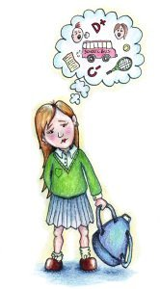
School phobia is a type of illness which causes students to be afraid to go to school. This condition is most commonly seen in children, typically between the ages of 8-13, and it can be very upsetting, especially if it is allowed to progress. Symptoms include stomach aches, tiredness, shaking, a racing heart and frequent trips to the toilet.
This common phobia is associated with a wide variety of causes. Most commonly it is the result of separation anxiety, but it can also be caused by different kinds of stress. A child who has recently moved, suffered a loss, or gone through a divorce may develop school phobia, and phobias can also develop in response to bullying (欺侮), an unrecognised learning disability, and poor self-image. Understanding the cause of a school phobia is an important step in providing treatment.
A child with school phobia usually refuses to go to school, or protests violently. He or she may become physically ill when ordered to school, or pretend to be sick to avoid going. When the child arrives at school, he or she may run away, or develop behavioural problems in class and on the playground. When school is discussed, the child can become impatient, upset or angry.
Many techniques can be used to manage school phobia, but research suggests that much more effective treatment is required for school phobia to prevent problems developing in later life. Children with this condition usually benefit from seeing a psychologist or doctor who can help the child and provide assistance to help parents and school officials support the child. As soon as a school phobia is identified, parents should take action too. Like other phobias, school phobia gets worse the longer it is left untreated, and it can interfere with a child's success in school. Adjustments can be made at home and in the classroom to help. If bullying is a cause, for example, the bullying situation should be solved. A teacher can meet the child at the door and take him or her to class, and provide support so that the child feels a friendly adult is always available.
Changes at home can include supportive language from parents, along with support like assistance with homework. If a child lacks confidence, parents may encourage the child to take up new hobbies that will help them to feel good about themselves. Parents might also talk to their children about their own fears of school and how they got over them, and their own enjoyment of school and school-like activities.
By following these methods we can help children to dispel their school phobia.
63. Which of the following topics is NOT discussed in the passage?
A. The definition of school phobia.  C. The causes of school phobia. | B. The history of school phobia.  D. The effects of school phobia.
64. What is a useful treatment for school phobia according to the passage?
A. Parents should allow their children occasional days off.
B. Teachers should be stricter with students.
C. Children should be helped to develop a sense of achievement.
D. Children should be regularly sent to psychologist.
65. The underlined word “dispel” (the last paragraph) probably means “________”.
A. accept B. realize | C. forget D. overcome
66. Which of the following statement might the author agree with?
A. School phobia is most often suffered by middle school students.
B. School phobia may have bad influence on children’s future life if neglected.
C. Children with school phobia should not be given medical treatment.
D. Most children with school phobia are pretending to be ill.
D
Archaeologists said Stonehenge, Britain’s most famous prehistoric monument, may have been an ancient pilgrimage (朝圣) site for the sick who believed its stones had healing qualities.
It has always been a mystery why bluestones, the smaller stones that form part of the circle, were transported around 155 miles from Preseli Hills in Wales to Wiltshire in southern England. Archaeologists from Bournemouth University, who carried out the dig in April—the first at Stonehenge since 1964—believe the bluestones were respected as healing stones. “It was the magical qualities of these stones which transformed the monument and made it a place of pilgrimage for the sick and injured of the Neolithic world (新石器时代),” a statement from the archeologist team said.
Geoffrey Wainwrigt, one of the experts leading the work, said that one reason which lead to the conclusion was that a number of the burials around Stonehenge showed signs of injury and disability.
The archaeologists said in the statement that radio-carbon dating (放射性碳测年法) put the construction of the circle of bluestones at between 2400 BC and 2200 BC, a few centuries later than originally thought. But they found pieces of charcoal dating from before 7000 BC, showing humans were active in the area much earlier than previously thought.
During the dig, the researchers also found Roman ceramics (陶瓷) and ancient stone hammers. “We now know, much to our surprise and delight, that Stonehenge was not just a prehistoric monument, but also a Roman and mediaeval (中世纪的) monument,” said Wainwright.
Another of the team leaders, Tim Darvill of Bournemouth University, said the bluestones appeared to be the most important to the purpose of Stonehenge although it may have had more than one function. Other theories about Stonehenge are that it was a religious site or that it acted as a calendar.
67. Faraway bluestones were transported to Wiltshire probably because they __________.
A. were of great value at the time
B. looked more beautiful than the stones there
C. looked like green diamonds
D. had the function of treatment
68. Before bluestones were transported there, Stonehenge may have been regarded only as_______.
A. a monument | B. a pilgrimage site | C. a religious image | D. a ceremony
69. The archeologist team drew the conclusion that Stonehenge may have been an ancient pilgrimage site for the sick by the fact that______.
A. many pieces of charcoal were found around Stonehenge
B. radio-carbon dating was used to check the bluestones
C. many bodies of the sick and injured were found buried around Stonehenge
D. humans were active around Stonehenge before 7000 BC
70. ______proved that Stonehenge had been not only a prehistoric monument but a Roman and mediaeval monument.
A. The location of the bluestones
B. The magical qualities of the bluestones
C. Roman ceramics and ancient stone hammers
D. Years of hard research for Wainwright

第二节（共5题；每小题2分，共10分）
根据短文内容，从短文后的选项中选出能填入空白的最佳选项。选项中有两项为多余选项。
How to Do Well in Exams
Do not underestimate(低估) the power of revision in the days and hours before an examination. The closer you are to the exam, the more chance you have of storing and getting important information. But do not overdo it. 71 . An effective daily routine can help you through an exam period, so in the days leading up to your first exam, get into the habit of being up and ready to work.
On the day of the exam, have a good breakfast, pack everything you need (pens, pencils, erasers, etc.), then make your way to the examination hall in good time. 72 .
Once in your seat, simply pause for a few seconds and collect your thoughts. Close your eyes and take in a few slow, deep breaths to help you relax. When you turn over the test paper, spend a short period reading through all the instructions and questions, paying particular attention to key verbs such as “discuss”, “compare” and “evaluate”. 73 . It is wise always to allow for 10 minutes at the end of the exam to give yourself time to go back over your answers. Once you have selected the questions you wish to deal with, begin by attempting the one you think is your strongest. 74 . Also remember to write clearly, and do not be afraid to express the unexpected: after all, examiners can get very bored marking stereotypical（陈腔滥调）answers.
Try not to look at those around you, or at the clock. If you do need something else to focus on to help collect thoughts, choose the ceiling or anything else that will not draw your attention away.
Finally, once you have finished, never hang around outside afterwards to attend the discussion by other students. 75 .
A. Do not arrive too early, though, as other people’s anxiety can spread, and you may suffer from panic.
B. When you get home, look up the new words in the paper and prepare for your next exam.
C. Getting all the information in one day is not necessary.
D. Sleep, exercise and relaxation are all just as important.
E. Map out a quick plan of points you wish to make and how much time you should spend on each question.
F. It will give you more confidence when you see a well-answered question done on paper.
G. Go and have a good rest, then prepare for your next exam.

第II卷 （共35分）
第四部分：书面表达 （共两节 35分）(请务必将作文写在答题纸指定区域内)
第一节 情景作文 （20分）
假设你准备向学校的英文月刊投稿，讲述在你校运动会期间发生在李华同学身上的感人故事。请根据下列图画，描述事情的经过并简单发表你的感想。
词数不少于60。 参考词汇：勇气杯—Courage Cup
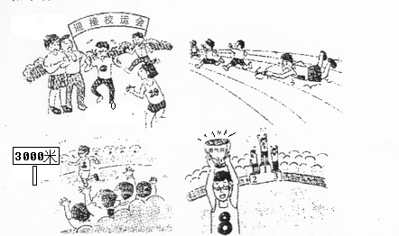

第二节：开放作文 （15分）
请根据下面提示，写一篇短文。词数不少于50字。
In an English class, you are asked to describe the following picture and explain to the class how you understand it．

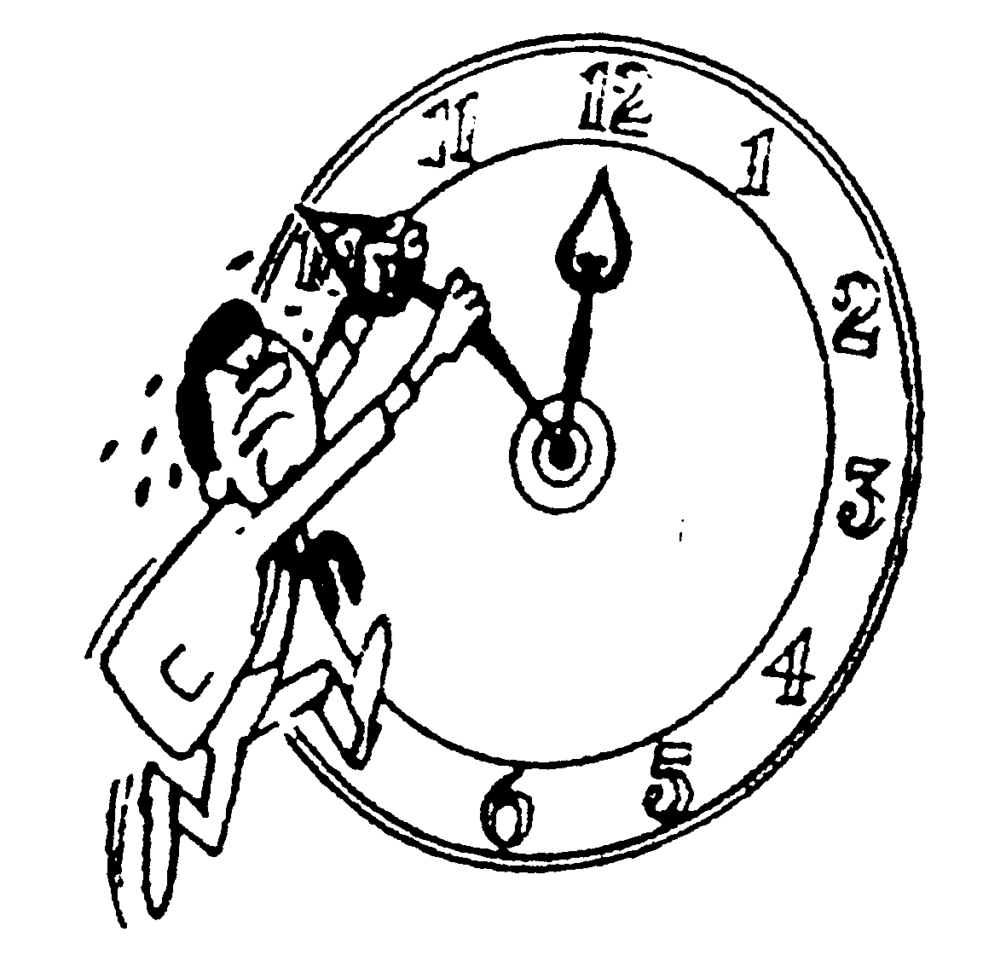

密云高三英语第一次模拟考试 参考答案 2012-4
第一部分：
听力理解第一、二节(共15小题，每小题1.5分，共22.5分)
1-5 CABCB 6-10BACCB 11-15 CBCAC
听力理解第三节：(共5小题，每小题1.5分，共7.5分)
如出现拼写错误不计分；出现大小写、单复数错误扣0.5分；如每小题超过一个词不计分。
16．Jessop 17. 585 2838 18. photos 19. waiting 20. midnight
第二部分：
第一节：单项选择（共15小题，每小题1分，共15分）
21-25. CBBCC | 26-30. CACCA | 31-35. ADABC
第二节：完形填空（共20小题，每小题1.5分，满分30分）
36-40. BDCAC | 41-45. BDCAC | 46-50．DACAB | 51-55．DACDA
第三部分：阅读（共20小题；每小题2分，共40分）
56-60. AADAD | 61-65. BCBCD | 66-70. BDACC | 71-75. DAEFG
第四部分：
第一节：情景作文（20分）
内容要点： 1.同学们为运动会做准备；李华报三千米 2. 摔倒，起来继续跑
3. 观众欢呼；李华到终点 4. 李华荣获‘勇气杯’ 5. 感想
One possible version:
With the sports meeting drawing near, many of my classmates trained hard for it, including Li Hua. Li Hua decided to take part in the 3000-metre race, saying though he was not strong enough, he would do his best to finish the race.
During the race, Li Hua tried hard to follow the others. Suddenly he fell, breaking his glasses and hurting his knees. But he wouldn’t give up. Regardless of the pain in the knees, he got up and kept on running. “Come on, Li Hua. You can make it.” Everyone on the sports field was cheering for him. Although Li Hua was the last one to cross the finishing line, he won the ‘Courage Cup’.
I was deeply touched by Li Hua’s courage and determination. I began to understand that, winning in life shouldn’t be measured by the final score; it should be based on how you play the game.
第二节：开放作文（15分）
One possible version
From the picture we can see a man is trying to stop the minute hand on the clock from moving forward. He uses all his strength so that he sweats all over. As we know, time always goes forward and we can’t slow it down or stop it. Once gone, it can’t come back to us for ever. As the saying goes, “Time and tide wait for no man.” So people should treasure and make full use of it to do something useful. As students, we are supposed to make a good plan for every day, studying hard and taking part in meaningful activities. Only in this way will we not be regretful in the future.

