海 淀 区 高 三 年 级 第 二 学 期 期 中 练 习
英 语 2012.04
注意事项：
1．考生务必将答案答在答题卡上，在试卷上作答无效。
2．答题前考生务必将答题卡上的姓名、准考证号用黑色字迹的签字笔填写。
3．答题卡上选择题必须用2B铅笔作答，将选中项涂满涂黑，黑度以盖住框内字母为准，修改时用橡皮擦除干净。非选择题必须用黑色字迹的签字笔按照题号顺序在各题目的答题区域内作答，未在对应的答题区域内作答或超出答题区域作答的均不得分。

第一部分：听力理解（共三节，30分）
第一节（共5小题；每小题1.5分，共7.5分）
听下面5段对话。每段对话后有一道小题，从每题所给的A、B、C三个选项中选出最佳选项。听完每段对话后，你将有10秒钟的时间来回答有关小题和阅读下一小题。每段对话你将听一遍。
1. What does the woman want?
A. A toothbrush. B. Some food. C. Some books.
2. When will the Chief Editor probably see the man?
A. At 9:00. B. At 10:30. C. At 11:00.
3. Where was the man yesterday afternoon?
A. At a lake. B. In a café. C. In a cinema.
4. What is the relationship between the two speakers?
A. Husband and wife.
B. Receptionist and visitor.
C. House seller and buyer.
5. Where will the man probably live next year?
A. In his house. B. In an apartment. C. In the dormitory.
第二节（共10小题；每小题1.5分，共15分）
听下面4段对话或独白。每段对话或独白后有几道小题，从每题所给的A、B、C三个选项中选出最佳选项。听每段对话或独白前，你将有5秒钟的时间阅读每小题。听完后，每小题将给出5秒钟的作答时间。每段对话或独白你将听两遍。
听第6段材料，回答第6至7题。
6. What is the woman’s article about?
A. Students’ play. B. Literature class. C. Future career.
7. What position will the man probably apply for?
A. Editor. B. Writer. C. Photographer.
听第7段材料，回答第8至9题。
8. What did the woman think of the candidate avoiding making eye contact?
A. She was impolite. B. She was nervous. C. She was unprofessional.
9. What made the candidate fail the interview?
A. Her resume. B. Her meeting manners. C. Her work experience.
听第8段材料，回答第10至12题。
10. What does the man think of Bill Gate’s home?
A. Ordinary. B. Awesome. C. Comfortable.
11. What kind of house does the man want to live in?
A. A modern cottage. B. A new cottage. C. An old cottage.
12. How would the man decorate his dream house?
A. Keep it as it was. B. Decorate it in a modern way. C. Furnish it with old furniture.
听第9段材料，回答第13至15题。
13. What should the audience do with expensive equipment first?
A. Insure it. B. Lock it up. C. Keep it home.
14. What does the speaker suggest when it is too late?
A. Calling a friend. B. Taking a taxi. C. Avoiding dark streets.
15. Who is the speaker speaking to?
A. Security guards. B. Dormitory staff. C. College students.
第三节（共5小题；每小题1.5分，共7.5分）
听下面一段对话，完成第16至第20五道小题，每小题仅填写一个词。听对话前，你将有20秒钟的时间阅读试题，听完后你将有60秒钟的作答时间。这段对话你将听两遍。
Trip Booking Form
Name | Alex Lee
Trip time | 16
Destination country | 17
Trip type | 6-day 18 trip for $ 19 per person
Site to visit | Black 20
Tel. No. | 55562239
第二部分：知识运用（共两节，45分）
第一节 单项填空（共15小题；每小题1分，共15分）
从每题所给的A、B、C、D四个选项中，选出可以填入空白处的最佳选项，并在答题卡上将该项涂黑。
21. ---What happened to Bill?
---He _____ really fast when suddenly he ran headfirst into a parked car.
A. had run B. was running C. has run D. has been running
22. ---How was your holiday?
---It couldn’t have been _____. I just stayed in the hotel because it was raining most of the time.
A. boring B. more boring C. most boring D. less boring
23. Thank you so much! But for your text message, I _____ home without my ID card this morning.
A. would have left B. would leave C. had left D. left
24. ---Do we have to wear our school uniforms tomorrow?
---I think so. We _____ the coming-of-age ceremony in the afternoon.
A. will be attending B. have attended C. attend D. attended
25. In English class, our teacher often creates an environment _____ we are given the opportunity to solve problems ourselves.
A. when B. which C. where D. that
26. Some seemingly harmless blogs might become harmful when _____ on the Internet by millions of people.
A. to read B. reading C. read D. being read
27. Friends are angels who lift us to our feet _____ our wings have trouble remembering how to fly.
A. unless B. because C. though D. when
28. Jonny, I can’t believe how much you have changed! You _____ at least one foot!
A. grow B. grew C. have grown D. are growing
29. --- I’m going to have lunch. Do you mind talking about your plan ____ lunch?
---All right. I’ll wait here in the office.
A. after B. before C. over D. until
30. ---The weatherman on the news said it might rain later on this afternoon.
---Well, I ____ take my umbrella along with me today.
A. can B. may C. could D. must
31. ---You seem busy these days.
---Yes. I’m looking for a house. It’s really not easy to find _____ with a garden.
A. this B. one C. it D. that
32. Although the Eiffel Tower _____ to last for 20 years, it is still standing today.
A. has designed B. had designed C. is designed D. was designed
33. Shooting, as ____ means of survival originally, developed into _____ sport only in the late 19th century.
A. a; a B. the; the C. a; the D. the; a

34. ______ the housing price, several measures have been adopted in the last two years.
A. Lowering B. Having lowered C. To lower D. To have lowered
35. In my point of view, the question is not _____ the world is going to have a new economic crisis, but when.
A. that B. how C. what D. whether
第二节 完形填空（共20小题；每小题1.5分，共30分）
阅读下面短文，掌握其大意，从每题所给的A、B、C、D四个选项中，选出最佳选项，并在答题卡上将该项涂黑。
When you’re a preteen, a huge problem might be that you just have to have a new rock-rap CD, 36 your parents won’t give you the money for it. I thought life was so 37 when things like this happened—until September 11, 2001.
I was in P.E. when the planes hit the World Trade Center and the Pentagon. As soon as I got home and for weeks after, I saw the disaster 38 on TV. Seeing the innocent people running for their 39 as the debris(瓦砾) started coming down the fire and smoke rose out of the 40 brought tears to my eyes. I couldn’t help imagining what the people on the 41 and in the buildings were thinking and going through, not 42 what was going on. I admired the courage of the firefighters who rushed in and risked their own lives to 43 others. It tore my heart apart to watch the 44 looks on the faces of so many people who didn’t know if their loved ones were dead or alive while 45 in all the debris.
Then it 46 me: All my life I had thought mainly of myself. I had it easy in life and had been taking it all for granted.
A feeling of coldness 47 down my back, and I cried just thinking of the possibility that it could have easily 48 to my family. My mom or dad could have been killed like that, and I would never, ever see them again. I began to evaluate what a real 49 in life was.
This disaster 50 me that awful things can happen to anyone at any time. Now when my mom or dad or sister go somewhere, even if it’s just 51 the store, I try to remember to tell them that I love them because I know there is a 52 that I may never tell them that 53 .
Not getting a new CD is not going to make or 54 my life. I can live with those kinds of problems. But losing someone I love would 55 make my life miserable. 9/11 showed me just what I am.

36. A. but | B. so | C. or | D. for
37. A. unbelievable | B. uncomfortable | C. unfair | D. uncertain
38. A. expand | B. occur | C. strike | D. unfold
39. A. lives | B. families | C. houses | D. friends
40. A. curtains | B. buildings | C. gates | D. bedrooms
41. A. seats | B. planes | C. corners | D. streets
42. A. believing | B. thinking | C. knowing | D. caring
43. A. join | B. save | C. meet | D. calm
44. A. puzzled | B. severe | C. dirty | D. desperate
45. A. hidden | B. found | C. placed | D. trapped
46. A. rewarded | B. surprised | C. hit | D. told
47. A. cooled | B. dropped | C. ran | D. passed
48. A. happened | B. compared | C. related | D. turned
49. A. relationship | B. problem | C. need | D. fate
50. A. taught | B. reminded | C. persuaded | D. informed
51. A. on | B. in | C. at | D. to
52. A. story | B. doubt | C. chance | D. plan
53. A. again | B. once | C. enough | D. ever
54. A. end | B. change | C. spare | D. break
55. A. rather | B. truly | C. probably | D. frequently

第三部分：阅读理解（共两节，40分）
第一节 （共15小题；每小题2分，共30分）
阅读下列短文，从每题所给的A、B、C、D四个选项中，选出最佳选项，并在答题卡上将该项涂黑。
A
How do you feel about watching other people work?

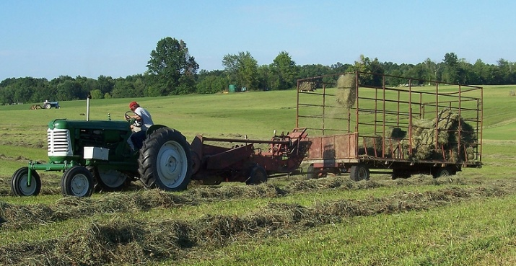
Nothing is more refreshing on a warm summer day than watching someone else work.
Right now, I’m sitting on my porch and watching young Beth baling（打捆）the big field on top of the hill. She’s been haying that field for over ten years. I know: I put her on the tractor when she was just twelve years old.
She picked a great day for baling. It’s not too hot, and there’s a nice breeze. On Monday, when she cut the field, it was so hot I thought the corn would start popping in the field. Didn’t stop her, though. She just stuck that big hat on her head, wrapped a wet handkerchief around her neck, and set to work. I remember when I would have done the same thing.
While I’m here sucking a lemonade, Beth is driving the “hay(干草) train,” a tractor pulling a baler and an old wagon. You’d think someone her size would never be able to see over the tractor. But somehow she manages. When she’s finished, her tracks are very straight.
The whole time she’s haying, that dog of hers is working just as hard, running along beside her like he’s afraid she’ll drive away without him. Beth sure knew what she was doing when she trained him.
The way the machine works is pure poetry. Each row is pushed into shape. When just enough hay is in a bale, it is wrapped up and fastened together. A second or so later, the bale comes flying out and into the old wagon. The person who invented that machine sure was some kind of genius.
That’s not to say it works perfectly. Every once in a while a bale misses the mark, especially when you are turning the machine at the end of a row. That means, of course, that you have to go back and pick up those bales and throw them into the wagon.
I can remember when Beth’s mother was her age. She looked an awful lot like Beth does now. Makes a man proud to see his daughter and granddaughter taking such good care of themselves.
Well, I suppose I should get up and fill this glass again. Not much fun sitting here with an empty glass.

56. We can learn from the passage that at some time in the past the author ______.
A. bought the tractor for Beth B. forced Beth to work at an early age
C. worked in the field like Beth D. trained the dog to help Beth work
57. In the eyes of the author, the sight of Beth baling hay is _______.
A. uncommon B. beautiful C. unforgettable D. changeable
58. Before thrown into the wagon, the hay must be _______.
A. tied up B. dried up C. cut up D. lined up
59. Who do you think is telling this story?
A. Beth’s mother. B. Beth’s father. C. Beth’s grandmother. D. Beth’s grandfather.
B
If you haven’t heard or seen anything about Road Rage in the last few months, you’ve probably been avoiding the media. There have been countless stories about this new and scary phenomenon, considered a type of aggressive driving. You have most likely encountered aggressive driving or Road Rage recently if you drive at all.
While drunk driving remains a critical problem, the facts about aggressive driving are surely as disturbing. For instance, according to the National Highway Transportation Safety Association,
41,907 people died on the highway last year. Of those deaths, the agency estimates that
about two-thirds were caused at least in part by aggressive driving behavior.
Why is this phenomenon occurring more than ever now, and why is it something that seemed almost nonexistent a few short years ago? Experts have several theories, and all are probably partially correct. One suggestion is sheer overcrowding. In the last decade, the number of cars on the roads has increased by more than 11 percent, and the number of miles driven has increased by 35 percent. However, the number of new road miles has only increased by 1 percent. That means more cars in the same amount of space，and the problem is magnified in urban areas. Also, people haveless time and more things to do. With people working and trying to fit extra chores and activities
into the day, stress levels have never been higher. Stress creates anxiety, which leads to short tempers. These factors, when combined in certain situations, can spell Road Rage.
You may think you are the last person who would drive aggressively, but you might be
surprised. For instance, have you ever yelled out loud at a slower driver, sounded the horn long
and hard at another car, or sped up to keep another driver from passing? If you recognize yourself in any of these situations, watch out!
Whether you are getting angry at other drivers, or another driver is visibly upset with you,
there are things you can do to avoid any major conflict. If you are susceptible(easily influenced) to Road Rage, the key is to discharge your emotion in a healthy way. If you are the
target of another driver’s rage, do everything possible to get away from the other driver safely,
including avoiding eye contact and getting out of their way.
60. The first sentence in Para. 1 implies that ______.
A. one may be angered by media reports and wants to avoid them
B. the media coined the term "Road Rage" only a few months ago C. Road Rage has received much media coverage in the last few months D. people not interested in the media know little about recent happenings
61. The underlined word “spell” in Para. 3 means ________.
A. relieve B. cause C. spread D. prevent
62. Which of the following characterizes aggressive driving?
A. Talking while driving. B. Driving at high speed.
C. Sounding the horn when passing. D. Shouting at another driver.
63. The last paragraph is intended to _________.
A. tell people how to deal with Road Rage
B. inform people how aggressive drivers could be
C. show people how to control themselves when angry
D. warn people against eye contact with another driver
C
Smartphone Security Blankets
Security—for the information on your smartphone, as well as for the phone itself—is a hot topic these days. The truth is that you’re packing a lot of sensitive information on your phone, and you should keep it safe.
When it comes to physical security, iPhone users would do well to download Find My iPhone, a free app (application program) from Apple that allows you to visit a website and see your (lost, stolen or misplaced) phone on a map. You can then sound an alarm, send a message that will pop up on its screen, lock the phone or erase all your data.
Android does not have an exact equivalent, but there are plenty of alternatives. A free app called Lookout offers the find-my-phone feature. The paid version allows you to wipe the data from your phone remotely.
Then there is your coffee shop’s WiFi network. Anyone with minimal technical expert skill can snoop on（窥视）people using shared wireless networks, harvesting passwords and other personal data. Lookout’s apps will caution you when you’ve logged on to an unsecure network, but cannot protect you once you’re there.
In order to protect yourself on such networks, you can use a virtual private network, or V.P.N. This turns all your activity into nonsense to anyone trying to read along with you from across the Starbucks. It also keeps websites from tracking you and, if you’re traveling, allows you to get access to sites that may be blocked in other countries.
If you have an iPhone, the simplest V.P.N. app is probably Hotspot Shield, whose distinguishing feature is said to be that it automatically kicks in each time you start browsing (浏览), as opposed to other V.P.N. apps that require you to start them up manually. This matters, because even if you decide you want a V.P.N. app, you want to spend approximately zero time thinking about it. For the most part, that was true of Hotspot Shield, though occasionally it took a while to connect or temporarily lost connection without warning. I found myself having to turn the app on and off sometimes, which involved setting my phone constantly.
If even reading about the settings on your phone drives you crazy, then it is probably best to stay away from a V.P.N. app. But if you’re the type who can’t resist checking your bank balance from your corner bar, the hassle may be preferable to the risk.
64. Which of the following can warn you against the unsecure network?
A. Android. B. V.P.N. C. Lookout. D. Find My iPhone.
65. By using V.P.N., users can _______.
A. find their lost phone on the Internet B. erase all the data from the phone remotely
C. check their bank balance now and then D. save their browsing from being tracked
66. The underlined word “that” in Para. 6 refers to the fact that _____.
A. a V.P.N. app kicks in automatically B. the user starts V.P.N. apps manually
C. the app takes a while to connect D. users spend no time thinking about it
D
Why are people interested in eating raw foods or whole foods? One reason is that eating these types of food reduces the risk of acid accumulation in your body.
Raw and whole foods are usually digested more efficiently than cooked and refined foods. When we cook foods, we destroy the natural enzymes(酶) that are part of the food in its raw form. These enzymes were intended by nature to help us digest the food. When we consume food without these natural enzymes, our bodies either digest the food improperly or allow too many nutrients to be absorbed into the bloodstream. In both instances, the result is obesity. When too many nutrients are absorbed at once, the body grows fat. Improperly digested food moves slowly through the digestive tract, where it becomes increasingly acidic. To protect its vital organs from this acidic waste, the body changes the acid into fat and stores it safely away from the organs.
Processed foods contain chemical elements, which might confuse the appetite mechanism that tells us when we’ve had enough to eat; as a result, people often overeat. Processed foods also upset the digestive cycle. The body will either identify these foods as allergens and then store them safely away from the organs as fat, or the remains of undigested food will become acidic and enter the bloodstream as acid waste, which will stick to the blood vessel walls and block the passage of vital oxygen and nutrients heading for the body’s cells. The body’s metabolism (新陈代谢) becomes inactive, and the result is weight gain and obesity.
The accumulation of acid in the digestive tract makes digestion increasingly inefficient. When that happens, even healthy foods can become acidic and the food allergies will become more common.
To stop this vicious circle in its tracks, people need to consume food and supplements that will neutralize the acid already accumulated in body. Eating the right types of raw and whole foods can help. It’s also important to restore your enzyme balance. You need to identify and avoid the foods that cause acid accumulation and consume the foods that increase enzyme production. If you truly want to change and help your body heal itself, you need to take an active approach.
67. It can be inferred from Para. 2 that _______.
A. foods with natural enzymes help people keep fit
B. we’d better be cautious about raw and whole foods
C. it is essential for people to protect their vital organs
D. giving up cooked and refined foods is a new lifestyle
68. Processed foods are unhealthy because they _______.
A. destroy body’s cells B. may lead to obesity
C. are difficult to digest D. stop body’s metabolism.
69. What is the main purpose of this passage?
A. To warn people of the problem of obesity.
B. To advocate eating more raw and whole foods.
C. To inform people of the harm of processed foods.
D. To tell the differences between raw and processed foods.
70. What is likely to be talked about following the last paragraph?
A. Different causes of acid accumulation. B. Correct ways to cook raw foods.
C. Suitable types of raw and whole foods. D. Active approaches to avoid acid.
第二节（共5小题；每小题2分，共10分）
根据短文内容，从短文后的七个选项中选出能填入空白处的最佳选项。选项中有两项为多余选项。
If you have ever been in a school play or even made believe you were a doctor, detective, or a space traveler, you know the enjoyment that acting brings. Almost all of us have the wish to play the part of someone—or something—else. 71
In the ancient world, acting was often associated with religious ceremonies and other special occasions. As far back as 2200 B.C. trained Chinese actors performed ceremonial dances in costume and makeup at harvest festivals. 72 To the dance was gradually added pantomime—the imitation of movements and gestures—as well as the wearing of masks, the singing of chants, and finally the use of dialogue.
While acting was coming into its own in the ancient Chinese classical theatre, it was doing the same in the western world, in Greece. From about 500 B.C. on, acting became a highly specialized art in Greece. Greek actors, however, still wore masks, and their motions were largely fixed by custom. 73
Modern acting, by contrast, gives the individual actor great opportunity to develop his or her personal talents for serious, comic, or musical drama. The names, faces, and styles of famous movie actors are known worldwide. 74 A special form of acting takes place in radio drama, which was highly popular before television. In radio drama the actors face an unique challenge. They are unseen by their audience. So they must rely on voice alone to make their characters real to the listeners.
75 Only forty percent of Broadway actors are employed, most of them for only part of the year. Those who become stars need not only talent, but determination. They must not be easily discouraged. Otherwise, they might give up before the opportunity for stardom presents itself.
A. The origins of acting are in the act of remembering.
B. Drama in Greece began with festivals honoring Dionysus.
C. It is believed that this was the first step in the development of acting.
D. Historical records indicate that this desire is as old as civilization itself.
E. Acting is not, as many people think, a quick, easy road to fame and riches.
F. Broadway and television provide other stages on which actors can display their talent.
G. Consequently, they had little opportunity to demonstrate their individual personalities.

第四部分：书面表达（共两节，35分）
第一节 情景作文 （20分）
假设你是红星中学高二（1）班的学生李华。下面四幅图描述了上周五你参加的一次拓展训练活动。请根据图片的先后顺序，用英语为校刊写一篇短文。词数不少于60。
参考词汇：outward bound 拓展训练
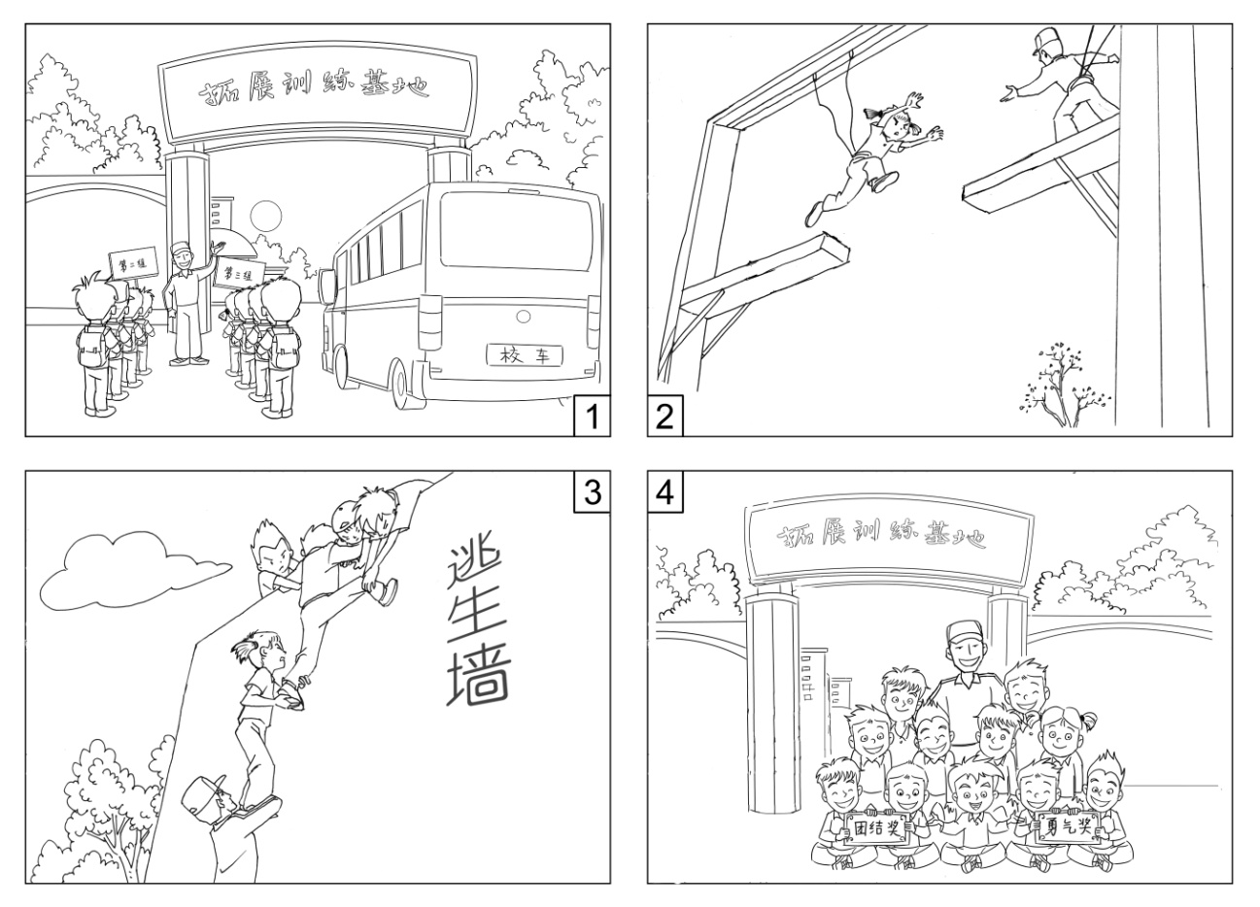

第二节 开放作文 （15分）
请根据下面提示，写一篇短文。词数不少于50。
In your spoken English class, your teacher shows you the following picture. You are asked to describe the picture and explain how you understand it.

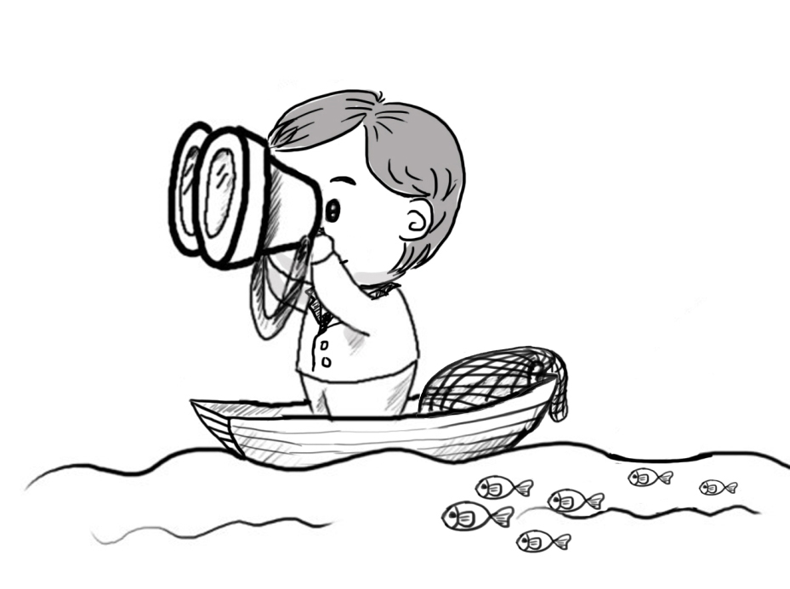

海淀区高三年级第二学期期中练习英语参考答案
2012. 04
第一部分：听力理解（共三节，30分）
第一节（共5小题；每小题1.5分，共7.5分）
1. A 2. C 3. B 4. A 5. C
第二节（共10小题；每小题1.5分，共15分）
6. A 7. C 8. B 9. B 10. B 11. C 12. A 13. A 14. B 15. C
第三节（共5小题；每小题1.5分，共7.5分）
16. August 17. Germany 18. private 19. 850 20. Forest

第二部分：知识运用（共两节，45分）
第一节 单项填空（共15小题；每小题1分，共15分）
21. B 22. B 23. A 24. A 25. C 26. C 27. D 28. C 29. A 30. D
31. B 32. D 33. A 34. C 35. D
第二节 完形填空（共20小题；每小题1.5分，共30分）
36. A 37. C 38. D 39. A 40. B 41. B 42. C 43. B 44. D 45. D
46. C 47. C 48. A 49. B 50. A 51. D 52. C 53. A 54. D 55. B

第三部分：阅读理解（共两节，40分）
第一节 （共15小题；每小题2分，共30分）
56. C 57. B 58. A 59. D 60. C 61. B 62. D 63. A 64. C 65. D
66. A 67. A 68. B 69. B 70. C
第二节（共5小题；每小题2分，共10分）
71. D 72. C 73. G 74. F 75. E

第四部分：书面表达（共两节，35分）
第一节 情景作文（20分）
一、评分原则：
1．本题总分为20分，按5个档次给分。
2．评分时，先根据文章的内容和语言质量初步确定其档次，然后以该档次的要求来衡 量，确定或调整档次，最后给分。
3．评分时应考虑：内容要点的完整性、上下文的连贯、词汇和句式的多样性及语言的准确性。
4．拼写、标点符号或书写影响内容表达时，应视其影响程度予以考虑。英、美拼写及词汇用法均可接受。
5．词数少于60，从总分中减去1分。
二、内容要点：
1．到达 2．跳断桥 3．翻越逃生墙 4．合影
三、各档次的给分范围和要求：

第一档 | 完全完成了试题规定的任务。  ·覆盖了所有内容要点；  ·运用了多样的句式和丰富的词汇；  ·语法或用词方面有个别错误，但为尽可能表达丰富的内容所致；体现了较强的语言运用能力；  ·有效地使用了语句间的连接成分，所写内容连贯、结构紧凑。  完全达到了预期的写作目的。
18分－20分
第二档 | 完全完成了试题规定的任务。  （13—16分）  ·覆盖了所有内容要点；  ·运用的句式和词汇能满足任务要求；  ·语法和用词基本准确，少许错误主要为尽可能表达丰富的内容所致；  ·使用了简单的语句间连接成分，所写内容连贯。  达到了预期的写作目的。
15分－17分
第三档 | 基本完成了试题规定的任务。  ·覆盖了内容要点；  ·运用的句式和词汇基本满足任务要求；  ·语法和用词方面有一些错误，但不影响理解。  基本达到了预期的写作目的。
12分－14分
第四档 | 未恰当完成试题规定的任务。  ·漏掉或未描述清楚主要内容；  ·所用句式和词汇有限；  ·语法或用词方面的错误影响了对所写内容的理解。  未能清楚地传达信息。
6分－11分
第五档 | 未完成试题规定的任务。  ·明显遗漏主要内容；  ·句式单调、词汇贫乏；  ·语法或用词方面错误较多，严重影响了对所写内容的理解。
1分－5分
0分 | 未能传达任何信息；所写内容与要求无关。
四、One possible version:
Last Friday, my class took part in a meaningful and challenging course—Outward Bound.
Early in the morning, we got to an Outward Bound centre on our school bus. Upon arrival, we were divided into several groups and our coach introduced the course to us. Shortly afterwards, we got involved in various activities. One of them was jumping across a broken bridge. I was afraid at first, but with the encouragement of the coach, I finally made it. What impressed me most was climbing over a wall to “escape.” We helped one another and all of us managed to “survive.” Before we left the centre, we had a photo taken to record the unforgettable experience, which gave us a good chance to build up courage and improve our sense of teamwork.

第二节 开放作文（15分）
一、评分原则：
1．本题总分为15分，按4个档次给分。
2．评分时，先根据文章的内容和语言质量初步确定其档次，然后以该档次的要求来衡
量，确定或调整档次，最后给分。
3．评分时应考虑：文章是否扣题，结构是否完整，内容是否充实、健康，思维是否活
跃，逻辑是否清晰，语言是否规范，交际是否得体。
4．拼写、标点符号或书写影响内容表达时，应视其影响程度予以考虑。英、美拼写及
词汇用法均可接受。
5．词数少于50，从总分中减去1分。
二、各档次的给分范围和要求：
第一档 | 完全完成了试题规定的任务。  ·内容充实，体现了活跃的思维和清晰的逻辑；  ·交际得体，表达时充分考虑到了交际对象的需求；  ·体现出较强的语言运用能力。  完全达到了预期的写作目的。
13分－15分
第二档 | 基本完成了试题规定的任务。  ·内容、逻辑和交际等方面基本符合要求；  ·所用语法和词汇满足了任务的要求；  ·语法或用词方面有一些错误，但不影响理解。  基本达到了预期的写作目的。
9分－12分
第三档 | 未恰当完成试题规定的任务。  ·表达未能切题；  ·所用词汇有限，语法或用词方面的错误影响了对写作内容的理解。  未能清楚地传达信息。
4分－8分
第四档 | 未完成试题规定的任务。  ·写了少量相关信息；  ·语法或用词方面错误较多，严重影响了对写作内容的理解。
1分－3分 | 未完成试题规定的任务。  ·写了少量相关信息；  ·语法或用词方面错误较多，严重影响了对写作内容的理解。
0分 | 未传达任何信息；所写内容与要求无关。
三、Possible versions
In the picture, a man on a boat is searching for some fish with a telescope. However, his efforts do not pay off, for the net is still empty. Amusingly, a school of fish is swimming just nearby, but he completely ignores them.
What the picture conveys is that we should never aim too high, neglecting the readily attainable goal. If the man stopped focusing on the distant waters and looked around, the fish near the boat would be an easy harvest for him. This is not uncommon in our daily life. When we aim to build one ridiculously large project, we complete nothing; when we aim for a small goal, we complete it. Let’s be more practical.

听力录音文本

Text1:
M: Hello, grandma! Tomorrow I will bring you some books and some cookies. Is there anything special you’d like?
W: Mm… I don’t feel like reading or eating, but buy me a toothbrush on your way here.
Text 2：
M: Do you think the Chief Editor could see me tomorrow before 9:00?
W: I am afraid he won’t be in until 10:30.
M: Is 11:00 any good then?
W: Yes, I’ll write down that time.
Text 3:
W: Did you have a good time yesterday?
M: Yes, I went fishing with my friend at a lake, but it rained at noon, so we stayed in a café before we went to the cinema at 7 p.m.
Text 4
M: What do you think of the house?
W: Well, the living room is huge, the balcony is nice, but the baby room is kind of small for our two kids.
M: You’re right. And it’s not as cheap as the last apartment we saw.
Text 5:
M: I don’t think I want to live in the dormitory next year. I need more privacy.
W: But check out the cost of renting an apartment first. How about moving back home?
M: Oh, it’s too far. Maybe I’ll still stay on campus.

Text 6
M: Well! Congratulations! How do they decide to hire you?
W: I sent them a writing sample.
M: What did you write about?
W: Actually, it was a lot of fun. I wrote about the students’ play that was performed this month.
M: Oh, I saw that play.
W: Really? I wrote about people’s reaction to it.
M: I wish I were a better writer. Working for the paper sounds like fun.
W: Well, they’re looking to add one or two more photographers to the staff.
M: You’re kidding! Maybe I’ll go over and apply.
W: If you want, I’ll walk over with you to the newspaper office and introduce you to the photographic editor.
M: That would be terrific!
Text 7
W: Well, what did you think about the last candidate?
M: She had a very impressive resume, but she seemed to lack the confidence that I think a good manager needs.
W: What made you think she wasn’t very confident?
M: Did you notice the way that she avoided making eye contact with us while she talked?
W: She was a bit nervous I guess. What else?
M: When she first walked into the room to greet us, she didn’t shake our hands or introduce herself at all. I thought that was a bit unprofessional.
W: You are right.
M: Did you also notice the way she sat in her chair during most of the interviews? It was horrible. Even worse, she didn’t seem to have any sense about people’s personal space. She didn’t keep enough distance between us during the meeting.
W: That’s true. I guess we’ll have to keep looking for a manager then.
Text 8
M: Have you ever seen Bill Gates’ home on the Internet?
W: No, what’s it like?
M: It’s got its own library, theatre, swimming pool and a guest house. The house itself has about ten different rooms. It’s absolutely amazing.
W: Would you want to live there?
M: I think the house is fantastic, but I wouldn’t want to live there. You’d have to hire one or two people to clean all the rooms. It’s too hard.
W: What’s your dream home like then?
M: My dream home is actually just a small cottage in a quiet village.
W: Would you want to buy an old cottage or a new one?
M: Old homes are great because they’ve got character, I think that’s important.
W: Is that why you wear secondhand clothes as well because they’ve got character?
M: No, that’s just because I don’t have enough money to buy new clothes all the time.
W: I see, if you lived in an old house, would you decorate it in a modern way?
M: Definitely not. I would keep it in its original state. I’d love to imagine what it would be like to live in the olden days.
Text 9
W: Good afternoon, everybody. Thank you for inviting me here to talk about safety in the dormitory and personal security.
First, a few points to bear in mind. You’ll notice the doors of your dorm have two types of locks. Make sure you double lock your door however long you are going out for. Make sure when you go out, all the windows are closed. If you have got expensive equipment in your room, first of all, insure it. So many people lose things and haven’t got insurance.
This brings me onto personal security. Wherever possible, avoid walking alone late at night, especially females. Avoid dark streets, and try to stick to the well-lit areas whenever possible. Also if you know you are going to be up late, make sure you’ve got enough money for a taxi to get home, or arrange to stay with friends for the night. It may sound absurd, but don’t forget the university actually offers free self-defense classes. I hope it’s something you’d never have to use, but it is certainly worth going to a few self-defense sessions.

Text 10
W: Good morning! Premier Travel services. This is Karen speaking.
M: Hello, this is Alex Lee. I want to plan a trip to Europe. Can you give me some advice?
W: Of course! When would you like to go on the trip?
M: In August.
W: OK, and which country would you like to go to?
M: Well, I like Sweden best but this time I’d prefer to go to Germany.
W: Got it. Would you like to join a group or plan a private trip?
M: My wife and I would prefer the private trip.
W: OK, we have a 6-day trip for $850 per person, or you can take an 8-day trip for
$1,000 per person.
M: I think 6 days is enough. Now…what sites do you recommend I see?
W: Well, the Romantic Road is one of Germany’s best scenic routes. And if you want to see the side of Germany with rolling hills, small villages and lush forests, visit Black Forest.
M: Black Forest sounds great! I’m excited about the 6-day trip!
W: Great! I’ll call you next week to confirm more details.
M: All right! My phone number is 55562239. Thanks for your help.
W: You’re welcome, goodbye!

