北京市西城区2012年初三二模试卷（英语）

第一部分 听力理解(共26分)
- 听对话，选择与对话内容相符的图片。每段对话读两遍。（共4分，每小题1分）
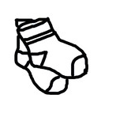
( )1.
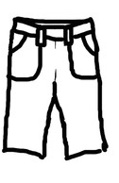
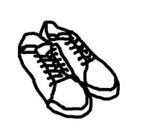

A. B. C.
( )2.
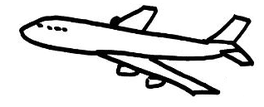
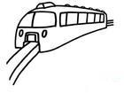
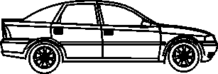

A. B. C.
( )3.
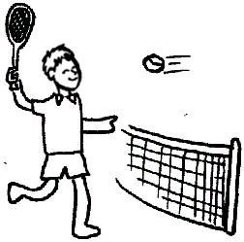
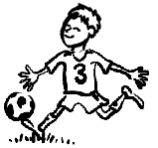
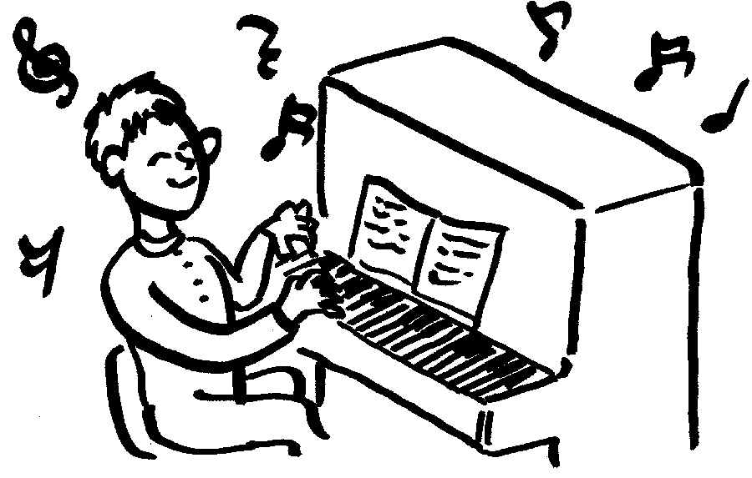

A B C
.
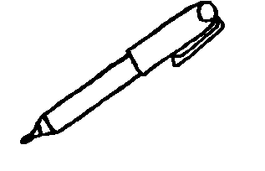
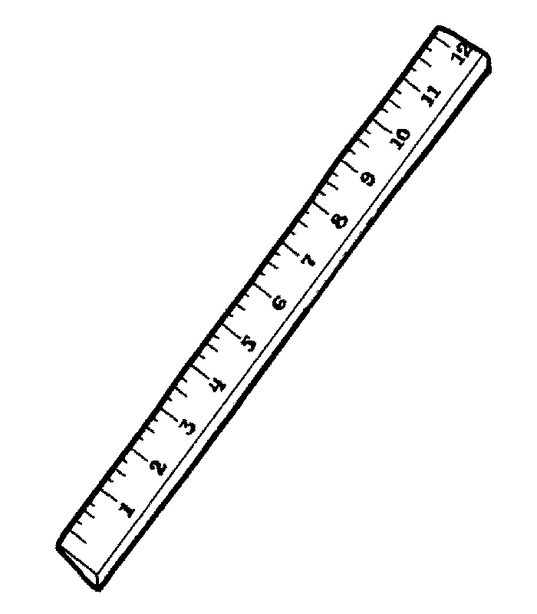
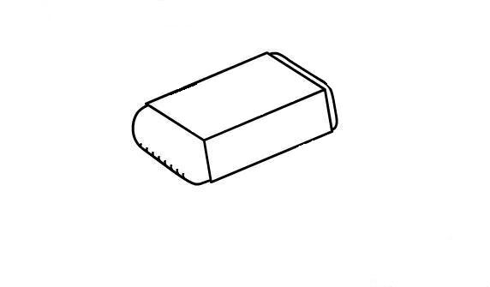
( )4.

A. B. C.
二、听对话或独白，根据对话或独白的内容，从下面各题所给的A、B、C三个选项中选择最佳选项。每段对话或独白读两遍。（共12分，每小题1分）
请听一段对话，完成第5至第6小题。
( )5. What is the boy busy doing?
A. Doing some cleaning. B. Studying for the exam. C. Taking a vacation.
( )6. What does the girl suggest?
A. Staying at home. B. Visiting his teacher. C. Having a picnic.
请听一段对话，完成第7至第8小题。
( )7. Where will the woman go?
A. The Garden Hotel. B. The taxi company. C. The airport.
( )8. How much will the woman pay?
A. $60. B. $50. C. $7.
请听一段对话，完成第9至第10小题。
( )9. What is the girl’s name?
A. Betty. B. Karen. C. Nancy.
( )10. What does the girl’s mother do?
A. A teacher. B. A housewife. C. A business woman.
请听一段对话，完成第11至第13小题。
( )11. What is there going to be in Liberty Park next week?
A. An art festival. B. A classical concert. C. A film show.
( )12. How many local artists are showing their paintings?
A. Two. B. Three. C. Four.
( )13. What can you infer from the dialogue?
A. The paintings are shown at the same place and time. B. People can see the paintings for one week.
C. The woman is interested in paintings.
请听一段独白，完成第14至第16小题。
( )14. What did the American family do on the speaker’s arrival?
A. They held a great welcome party. B. They told the speaker some funny stories.
C. They showed the speaker around the house.
( )15. What surprised the speaker?
A. The speaker was given nothing to eat. B. The family were not friendly.
C. The family prepared everything for the speaker.
( )16. What’s the lesson for the speaker?
A. Home is always the best place. B. Always directly tell Americans what you want.
C. Never stay with an American family again.
三、听独白，根据所听到的独白内容和提示词语，记录关键信息。独白读两遍。（共10分，每小题2分）
The School Trip
Place to visit | 17. the ________ Museum
When to leave | 18. at ________
Where to meet | 19. at the school ________
How much to pay | 20. ________ dollars each
What to take | 21. a pencil and a ________

知识运用（共25分）
四、单项填空（共13分，每小题1分）
( )22.— What are you reading?
— The Adventures of Tom Sawyer. ______ writer is Mark Twain.
A. It B. Its C. He D. His
( )23.— Where did you have dinner?
— ______ Lily’s house.
A. At B. To C. On D. For
( )24.The shoes are very smart, ______ they don’t fit me.
A. so B. and C. but D. or
( )25.New York is one of the ______ in the world.
A. modern city B. more modern cities
C. most modern cities D. most modern city
( )26.— Wait a minute. I have ______ to tell you.
— What is it?
A. something important B. important something
C. anything important D. important anything
( )27.— Where is Mike?
— I don’t know. But I saw him ______ football on the playground just now.
A. to play B. playing C. played D. plays
( )28.— Who ______ us a speech next week?
— Dr. Smith, a famous scientist.
A. give B. gave C. gives D. will give
( )29. — Have you seen my dictionary?
— Yes. I ______ it on your desk five minutes ago.
A. see B. saw C. sees D. will see
( )30. Don’t forget ______ the windows before you leave the classroom.
A. close B. closing C. to close D. closed
( )31. The Greens ______ breakfast when the door bell rang.
A. had B. would have C. are having D. were having
( )32. — The concert is very popular.
— Yes. So far, all the tickets ______.
A. booked B. have booked C. were booked D. have been booked
( )33. We’ll go to have a picnic next Sunday ______ the weather is fine.
A. if B. before C. unless D. until
( )34. Frank asked me ______ for the violin.
A. how much do I pay B. how much I paid
C. how much did I pay D. how much I pay

五、完形填空（共12分，每小题1分）
One day in my third grade, I brought home a very plain invitation.
“I’m not going,” I said. “She’s a 35 girl named Ruth, and Berniece and Pat aren’t going. She asked the whole class, all 36 of us.”
As Momma studied the invitation, she looked 36 sad. Then she said, “Well, you are going! I’ll pick up a present tomorrow.”
I couldn’t believe it. Momma had never made me go to a party! I was sure I’d 37 die if I had to go. But nothing could ever make Momma change her mind.
When Saturday arrived, Momma 38 me out of bed, made me wrap the pretty pink mirror she bought and drove me over to Ruth’s home.
Following Ruth up the steepest (最陡峭的), scariest stairs I’d ever seen, I finally got through the door. On the table sat the biggest cake I had ever seen. Thirty-six cups filled with homemade candy were near the cake — each one with a name on it.
“This won’t be too bad — once 39 gets here,” I decided.
“Where’s your mom?” I asked Ruth.
Looking down at the floor, she said, “Well, she’s sick.”
“Oh. Where’s your dad?”
“He’s gone.”
Then there was a 40 , except for a few bad coughs from behind a closed door. About 15 minutes passed....then 10 more. Suddenly, we 41 that no one else was coming.
How could I get out of here? As I slowly fell into self-pity, I saw Ruth’s tearful face. All at once my eight-year-old heart was filled with pity for Ruth and 42 at my 35 selfish (自私的) classmates. I spoke at the top of my voice, “Who needs them?”
Ruth’s surprised look changed to 43 agreement.
We started with the cake. I sang “Happy Birthday” 44 Ruth made a wish and blew out the candles, and then we played all the games.
In a flash it was noon and Momma arrived to pick me up. 45 Ruth repeatedly, I happily got into the car.
“I was the only one there — out of the whole class. And I couldn’t wait to tell every one of them what a great party they 46 !”
That was the day I learned that one person could really make a difference. I had made a big difference on Ruth’s ninth birthday, and Momma had made a big difference in my life.
( )35. A. popular B. lucky C. new D. happy
( )36. A. hopefully B. strangely C. absolutely D. immediately
( )37. A. just B. still C. ever D. never
( )38. A. helped B. knocked C. kicked D. rushed
( )39. A. anyone B. no one C. everyone D. someone
( )40. A. silence B. voice C. shame D. sadness
( )41. A. expected B. realized C. hoped D. explained
( )42. A. responsibility B. understanding C. interest D. anger
( )43. A. excited B. sudden C. direct D. quiet
( )44. A. since B. because C. while D. though
( )45. A. Holding B. Replying C. Praising D. Thanking
( )46. A. hated B. missed C. lost D. knew[

阅读理解（共44分）
六、阅读下列短文，根据短文内容，从短文后各题所给的A、B、C、D四个选项中，选择最佳选项。
A
Natural Wonders of the World
The Deepest Lake  in the World  Lake Baikal in Russia is the deepest lake in the world. It is 1,637 meters deep. It is also the largest freshwater lake in the world. |  | The Biggest Lake  in the World  The biggest lake in the world is the Caspian Sea. It has a surface area of 371,000 square kilometers. The Caspian Sea is salty, about 1/3 as salty as seawater.

The Hottest Desert  in the World  The hottest desert in the world is the Sahara Desert. In 1922, scientists recorded a record high temperature of 58 °C. Though it’s hot there during the day, it sometimes freezes at night. |  | The Largest Volcano (火山)  in the World  The largest volcano in the world is Mauna Loa in Hawaii. It is about  17, 000 meters high from the bottom to the top. Mauna Loa is much larger than Mt. Everest but most of Mauna Loa is underwater.
( )47. Which is the biggest lake in the world?
A. Lake Baikal. B. Caspian Sea. C. Sahara. D. Mauna Loa.
( )48. How high is the largest volcano in the world?
A. 17, 000 meters B. 371, 000 meters. C. 1, 922 meters. D. 1, 637 meters.
( )49. Sometimes, it’s ______ at night in Sahara Desert.
A. hot B. warm C. freezing D. cool
B
Teenager Callie Rogers was “jumping and screaming” when she realized she had become the National Lottery’s (彩票) youngest ever millionaire (百万富翁). The 16-year-old, from Cockermouth, Cumbria, described the moment when she realized that she had won the £1,875,000 prize on Saturday.
Callie told reporters at the meeting organized by the lottery that she was dog-sitting for a friend when the draw (抽奖) took place. She said she rushed home to check the numbers — 1, 10, 17, 23, 29, and 35 — which were based on her family birthdays. Callie was one of eight winners sharing the £15,000,000 prize. And she said she was looking forward to taking her first holiday in Australia.
She said: “Hopefully I will help my family have a better life.” But Callie, who left school in December last year, said becoming a millionaire would mean a different future. She said she was going to go traveling for two years, and then would like to become a social worker.
One of the first things she hopes to buy is a new computer for her mother. Callie, who will be 17 in December, is going to treat herself as well, and said she wanted to buy a Peugeot 206 when she learnt to drive. She said: “My brother also wants a motorbike and my sister wants a piano.”
Callie had been working since leaving school at a number of jobs, as a shop assistant, a waitress, and at the Community Center, and she was happy to take a break.
( )50. What prize did Callie win?
A. £1,875,000. B. £15,000,000. C. A holiday in Australia. D. A Peugeot 206.
( )51. Callie chose the lottery numbers according to ______.
A. her telephone number B. her family birthdays
C. the ages of her family D. her friends’ birthdays
( )52. What will Callie probably do after winning the prize?
A. She will go traveling for a year. B. She will continue her education.
C. She will buy a new computer for her grandmother.
D. She will buy the gifts that her brother and sister want.
C
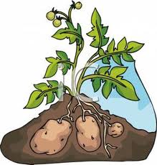
Of the many kinds of vegetables grown all over the world, which remains the favorite of both the young and old? The potato, of course. Perhaps you know them as “taters”, “spuds”, or “Idahoes”. But it’s no matter, a potato by any other name is still a potato—the world's most widely grown vegetable. As a matter of fact, if you are a normal potato eater, you will eat at least a hundred pounds of them each year.
That's only a tiny part of the total grown every year, however. Worldwide, the potato harvest (收获) every year is over six billion bags, with each bag having a hundred pounds of spuds, some of them as large as four pounds each. In the United States, farmers fill about four hundred million bags a year. That may seem like a lot of taters, but it leaves us in third place among world potato growers. Farmers in Poland (波兰) dig up just over 800 million bags a year, while the Russians lead the world with nearly 1.5 billion bags.
People eat potatoes in many ways — baked (烘烤), mashed (捣成糊状), and roasted, to name just three. However, in the United States most potatoes are eaten in the form of French fries. One fast-food chain alone sells more than $1 billion worth of fries each year. No wonder, then, that the company pays close attention to the way its fries are prepared.
Before any fry makes it to the people who eat at this popular restaurant, it must pass many separate tests. Fail any one and the French fry is thrown away. To start with, only a certain kind of Idaho potato is used to make fries. They have less water than other kinds. Once cut into “shoestring” shapes, the potatoes are partly fried in secret oils, sprayed (喷洒) with liquid sugar to brown them, steam dried at high heat, and then quickly frozen for shipment to each restaurant.
Before shipping, though, every shoestring is measured (测量). Forty percent of the fries must be between two and three inches long. Another forty percent has to be over three inches. What about the twenty percent that is left? Well, a few short fries in a bag are okay, it seems.
So, now that you realize the huge size and value of the potato crop, you can understand why most people agree that this part of the food industry is no “small potatoes.”
( )53. According to the passage, which country has the largest harvest of potatoes？
A. America. B. Russia. C. Poland. D. France.
( )54. What can be known about Americans and French fries?
A. Americans like to eat French fries at home.
B. Americans care about French fries’ size and shape.
C. Americans eat French fries less than mashed potatoes.
D. Americans prefer potatoes to be cooked in this way.
( )55. What is the main idea of this passage?
A. Potatoes are known by many names. B. The way of making French fries is interesting.
C. The potato is an important vegetable in America.
D. The various names of potatoes have a long history.
D
What does the word “patent (专利权) ” mean to you? Does it interest you? If it does, stop and think a moment about some of the commonplace things that you use every day: the telephone, radio, television, and the thousands of other things that enrich our lives today, were once only ideas in the minds of men. If it had not been possible to patent their ideas, so as to protect them from being copied, these inventions might never have been fully developed to serve human beings.
If there were no patent protection there would be little encouragement to invent, for once the secrets of an invention became known, those who did not experience the inventor's risks and expenses(花费) might well fill the market with their copies of his product and steal much of the benefit (益处) of his efforts.
The most basic values in the U. S. patent system came from England. During the rule of Queen Elizabeth I in England, the growing technology was furthered by the giving of exclusive privileges (独家特权) to people who had invented new processes (程序) or tools—a step that did much to encourage creativity. Later, an important value was added: society had everything to gain and nothing to lose by giving exclusive privileges to an inventor, because a patent for an invention was given for something new that society never had before.
George Washington signed the first patent law on April 10, 1790, and less than four months later, the first patent was given to a man named Samuel Hopkins for a chemical process, an improved method in soap making.
In 1936, the Patent Office became a separate department and it has grown into an organization of over 2,500 people who every week deal with more than 1,600 patent applications, and of those, give more than 1,000. A patent may be given for any new and useful process, machine, or planning method.
The patent system has also helped to improve the pay of the American worker to an unexpected level; he can produce and earn more by using computers or adding machines, two important patented inventions. Patented inventions also help keep prices down by encouraging competition.
Our patent laws, like the Constitution from which they grew, have stood the test of time. They have encouraged creative processes, brought great benefits to society as a whole, and enabled American technology to outstrip that of the rest of the modern world.
( )56. From the passage, what can we learn about inventors?
A. They make a lot of money. B. They fight against copiers.
C. They have a lot of experience. D. They put effort into inventions.
( )57. Why were inventors given exclusive privileges?
A. Because their inventions made leaders happy. B. Because their creativity is very important.
C. Because their inventions could enlarge society.
D. Because they were the smartest people in society.
( )58. According to the passage, the patent system is good for America because ______.
A. it helps more workers get jobs B. it provides a first-class service
C. it produces less expensive things D. it helps inventors find markets
( )59. What is the meaning of “outstrip” in the last paragraph?
A. be better than B. catch up with C. make better use of D. cost more than
七、阅读短文，根据短文内容，从短文后的五个选项中选出能填入空白处的最佳选项。
When a man was passing the elephants, he suddenly stopped, not understanding how these huge animals could be held by only a small rope tied to their front leg. No chains (链子), no cages (笼子). 60 . But for some reason, they did not.
He saw a trainer nearby and asked why these animals just stood there and didn’t try to get away. “Well,” the trainer said, “when they are very young and much smaller, we use the same size rope to tie them and, at that age, it’s enough to hold them. As they grow up, they have to come to believe they cannot break away. 61 . So they never try to break free.”
The man couldn’t believe what he was seeing. These animals could at any time break free from their ropes. 62 . They believed they couldn’t.
Many of us go through life like the elephants. We sometimes believe that we cannot do something, simply because we failed at it once before. 63 . We should never give up the struggle (抗争) in life.
A. Failure is part of learning
B. Success is not what we want
C. They believe the rope can still hold them
D. But they were stuck right where they were
E. It was clear that the elephants could break away from their ropes

八、阅读短文，根据短文内容回答问题。（共10分，每小题2分）
The idea of teamwork is very important to the success of any team. All coaches talk about working as one unit, as a team that plays as one. Teamwork and unselfishness (无私) create the strong center of a great team; without them a team cannot play well against other teams. You can have a group of superstars, but if they do not work well as one unit, they are not going to be successful. The team working as one unit is going to be successful.
Here are some things to consider when you are looking at your team:
◆ Does your team have agreed-upon goals they created as a team?
◆ Do the players openly encourage and support one another?
◆ Do they have open communication with one another, as well as the coaches?
◆ Does each player know what their role on the team is?
◆ Is there shared respect among the players and coaches?
◆ Do players use words such as “we” when referring to the team?
◆ Have they created a positive (乐观的) team image for themselves?
◆ Does the team as a whole want to improve their performance?
◆ Does each member consider themselves as a “team player” ?
A winning team has players that share common goals and a common dream. Teams come together through shared attitudes about a particular sport. They may come together for a number of different reasons, but their goals are the same — to achieve top performance and experience success. The ends may be different but the means by which one gets there is the same — teamwork.
Teamwork is something that must be on the top of the list. Every player needs to understand how important it is for them to work smoothly together if they want to be successful. Each player must be true to the whole team and be willing to act unselfishly. When challenges (挑战) come, the team needs to deal with them in a positive manner. A sense of teamwork will play an important part in this.
Just remember T.E.A.M. — Together Everyone Achieves More!
64. What can create the strong center of a great team?
___________________________________________________________________________________________
65. Which is more important to the success of a team, teamwork or superstars?
___________________________________________________________________________________________
66. How many things are considered when you are looking at your team?
___________________________________________________________________________________________
67. How does a team come together according to Paragraph 3?
___________________________________________________________________________________________
68. What is the text mainly about?
___________________________________________________________________________________________

书面表达（共25分）
九、完成句子（共10分，每小题2分）
69. 一起吃晚餐庆祝父亲节怎么样? ________________ having dinner together to celebrate “Father’s Day”?
70. 他们是好朋友，相处得很融洽。 They are good friends and they ________________ each other.
71. 我们需要一条新的规定，阻止学生们浪费粮食。We need a new rule to ______________________ food.
72. 政府更多关注药品安全是非常必要的。
________________ the government ____________________________________________ the drug safety.
73. 这位严格的老师经常警告她的学生要么按时上交作业，要么不能通过这门课。
The strict teacher often warns her students that_________________________________________________.
十、文段表达（15分）根据中文和英文提示词语,写出意思连贯、符合逻辑、不少于60词的短文。请不要写出你的真实校名和姓名。
某英文报纸以 “ A Good Sentence to Me ” 为题征文，请你投稿。请你从下面的三句话中选出你最喜欢的一句，并结合自己的经历谈谈你喜欢它的理由。
☆ The more we read, the more we will know.
☆ Helping others is one of the gifts we have to give in life.
☆ If we’re not making mistakes, then we’re not doing anything.

__________________________________________________________________________________________________________________________________________________________________________________________________________________________________________________________________________________________________________________________________________________________________________________________________________________________________________________________________________________________________________________________________________________________________
___________________________________________________________________________________________
___________________________________________________________________________________________

