05、2011年北京海淀区第一次模拟试题

知识运用（共27分）
- 单项填空（共15分，每小题1分）
从下面各题所给的A、B、C、D四个选项中，选择可以填人空白处的最佳选项。
（ ）21. Mike is my pen pal. I often help him with ____ Chinese
A. he B. his C. him D. himself
（ ）22. The train from Shanghai arrives ______ about7:00 a.m.
A. of B. in C. on D. at
（ ）23. 一______ is your grandma, Robert?
一In the dining room.
A. Who B. What C. Where D. Which
（ ）24. Jeff studied hard and got_____ grades than before.
A. good B. better C. best D. the best
（ ）25. 一_____the little kid dress herself?
一No, she can't. She is only two years old.
A. Can B. May C. Must D. Need
（ ）26. I have two hobbies. One is painting, ______ is playing guitar.
A. other B. others C. another D. the other
（ ）27. Simon and Sally _____ fishing with their classmates next weekend.
A. go B. went C. will go D. would go
（ ）28. Let’s ______ goodbye to plastic bags in order to protect the environment.
A. say B. said C. saying D. to say
（ ）29. Be confident! Everyone will succeed if he _____ in himself.
A. believe B. believes C. believed D. will believe
（ ）30. We'll ask Mr. Smith _____ the students a report on world peace tomorrow.
A. give B. given C. giving D. to give
（ ）31. Plan everything ahead, _____ you will live an easy life.
A. and B. but C. for D. or
（ ）32. Justin Bieber _____ famous all over the world when he was fifteen years old.
A. became B. becomes C. will become D. is becoming
（ ）33. Alan and I ____ friends ever since we were at school together.
A. am B. were C. will be D. have been
（ ）34. It is true that knowledge_____ instead of being taught.
A. learns B. learned C. is learned D. was learned
（ ）35. --Can you tell me______ when the teacher came into the classroom?
-- Sorry, I don't know.
A. what were the students doing B. what are the students doing
C. what the students were doing D. what the students are doing
- 完形填空（共12分，每小题1分）
阅读下面的短文，掌握其大意，然后从短文后各题所给的A、B、C、D四个选项中，选择最佳选项。
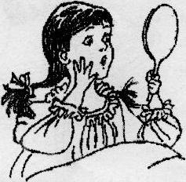
My mom told me that when I was born, I was the most beautiful baby in the world. Time passed, and I started to be a strong and happy girl.
Then, one day when I was five years old, my life 36 a lot. I had a high fever. The doctor gave me the wrong medicine, and this caused me to37 my speech. My mom couldn't believe that I could not speak. The doctor told her that the medicine brought me a lot of problems with my speech. He thought that I would 38 be able to speak well again or learn another language.
My mom, however, was a 39 .She sent me to a lot of teachers. Finally, she found the 40 teacher, Nina, to help me to make my dream come true. She was a very nice person. She encouraged me and told me that I would speak again.
The most amazing thing was that she taught me to read my41 I remember that I spent hours in front of the mirror and tried to repeat every word that I said. Imagine losing your speech and having to learn everything again. For me, it was like being 42 again. Yes, I was! I learned to talk and speak my mother language--Spanish.
Now, I am studying English. I can't believe that I am learning another language. But, I am! I am crying 43
studying here makes me feel happy, and it makes me 44 when I remember what the doctor said to my mom,
"45 will never be able to speak or learn another language."
I'll always remember the beautiful words my mom said to me when I was a child and learned to speak again. "You fought in a war, you 46 on, and then you got a beautiful medal for your success. You realized an impossible dream that people said you would never do. I will always 47you, and you will always be my hero."
Now, I'm thinking about what is going to happen to me. When I am going to take every step in my studies and in my life, I try to think about my experience and be a grateful person.
（ ）36．A. proved B. changed C．improved D．increased
（ ）37．A．have B．make C．lose D．drop
（ ）38．A．still B．never C．either D．always
（ ）39．A．fighter B．pioneer C．protector D．volunteer
（ ）40．A．real B．right C．clever D．patient
（ ）41．A．eye B．face C．heart D．mouth
（ ）42．A．born B．hurt C．raised D．trained
（ ）43．A．until B．unless C．before D．because
（ ）44．A．cry B．fly C．smile D．shake
（ ）45．A．I B．He C．She D．You
（ ）46．A．lived B．moved C．worked D．climbed
（ ）47．A．be satisfied with B．be strict with C．be careful with D．be proud of

阅读理解（共44分）
六、阅读下列短文，根据短文内容，从短文后各题所给的A、B、C、D四个选项中，选择最佳选项。（共
26分，每小题2分）
A
Cooking and Learning
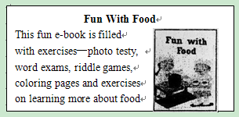
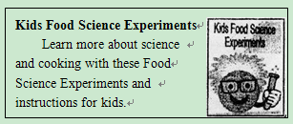
In this E-book package, we have four e-books.

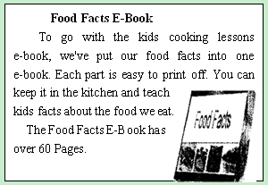
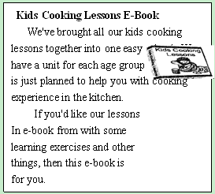

（ ）48. Kids can_______by reading Fun with Food.
A. do science experiments B. get cooking experience
C. cook well in the kitchen D. play some riddle games
（ ）49._______has over sixty pages.
A. Fun with Food B. Kids Cooking Lessons E-Book
C. Food Facts E-Book D. Kids Food Science Experiments
（ ）50.Kids Cooking Lessons E-Book is popular because_______.
A. there is a unit for each age group B. there are a lot of photo tests in it
C. kids can learn more about science D. each part is very easy to print off
B
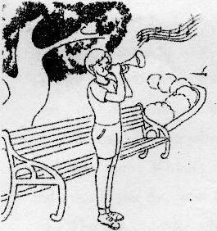
the leaves fluttered (飘扬) over John's head. He liked to watch the colors of the trees shine through the sunlight, It was the same color as his trumpet. John smiled when he thought of the music the leaves made. He looked at his watch ; his father would meet him in a few minutes for their first practice in the park.
John and his family lived in an apartment building. He began playing his trumpet in his own living room two weeks ago. Then the family next door had a new baby. To keep from waking up the baby, John was going to spend his practice time in the park. Although he enjoyed visiting the park, he didn't want to practice his music there.
John was afraid that he would embarrass himself if he played the wrong notes. And he imagined his cheeks looking like a red, blown-up balloon. He didn't want people to watch him as he practiced his music. Unluckily, his father couldn't possibly understand how embarrassing it would be!
“John, are you ready?” pulling him out of his daydream, his father sat down and began to play his trumpet.
John looked up at a golden tree. The leaves seemed to be dancing with the tune. He felt excited as he watched the people walking by and smiling at his father. He wanted to play like that! Immediately，John placed his trumpet to the mouth and blew. Soon, john was having such a great time playing with his father that he didn’t care if had played a few bad notes.
The golden tree was dancing while John was still playing. Now he and his neighbors could both be happy.
（ ）51. To keep from walking up the baby, John practiced his trumpet .
A. in the building B. in the street C. in the park D. in the room
（ ）52. John didn’t want to practice his music outside because .
A. his next door neighbor had a new baby B. his father didn’t played together with him
C. he didn’t enjoy going to the public park D. he was afraid to play some wrong notes
（ ）53. How did John feel when his father was playing?
A. Interested B. Excited C. Afraid D. Bored
（ ）54. Which of following statements is TRUE according to the passage?
A. John was sorry to wait for his father to come.
B. John was willing to be watched by many people.
C. John experienced true happiness brought by music.
D. John refused his father’s invitation to play the trumpet.
C
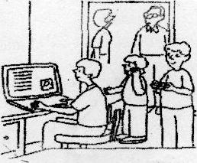
Recent research from the Pew Internet Project suggests that 90% of Americans aged from 12 to 17 use the Internet, and 51% of those teens use social networks. However, there are many possible problems with social networking sites and the teenagers who use them.
Apart from the social advantages, social networking sites can be used to record school research, develop artistic talents and experiment with other forms of subject creation. They provide a way to communicate with others who share the same interests and to get helpful advice on ongoing projects.
Along with these advantages come some dangers. For example, most social networking sites are open to all, especially MySpace, which is the most popular social network among teens in America. It means that they could be put in unpleasant and frightening situations.
A greater danger is that teens may become objects of the people with secret purposes. The secrecy of some social networking sites makes it easy for dangerous people to find young teens and invite them into dangerous conversations. It's easy for them to pretend as teens and draw children into dangerous real-world communication as well. Then further hurt might be on its way.
Another danger is identity stealing, which can happen when teens share too much information about their names, dates of birth and locations.
Therefore , it's very important to make sure teens are safe when they use social networks.
Many of the same rules that work for online chat work for these sites:
※Don't use your real name.
※Don't give out personal information to people you don't know. A last name and a town are enough for a bad guy to find where you are.
※Don't believe that people are who they say to be.
※Immediately end any communication that makes you uncomfortable mid report it to a parent.
Only if you are sure of your safety, can you enjoy the fun brought by social networking. Besides, trying to deal with all problems on your own can lead to terrible results. Remember, asking your parents or school officials for help doesn't mean you are unable to do anything but wiser than many others.
（ ）55. How many dangers of using social networks are mentioned in the passage?
A. 2. B. 3. C. 4. D. 5.
（ ）56. The writer takes MySpace as an example to show that____.
A. students could be put into unreal situations on the Internet
B. teenagers are facing unknown dangers on the social networks
C. Internet provides more social websites to American teenagers
D. social networks are very popular among teenagers in America
（ ）57. We can infer from the passage that____ .
A. the dangers are similar when chatting online and surfing social networks
B. more than half American teenagers aged from 12 to 17 use social networks
C. teens who ask for help are wiser when meeting problems on social networks
D. there are more disadvantages than advantages for teens to use social networks
D
"You don't have to be great to get started, but you have to get started to be great.” I believe it is thought normal in today's society to just let life happen to us. I also believe that we sometimes damage our well-planned thoughts about success because it is easier to just carry on as usual rather than ' try' with the possibility of failure in mind.
The main reason why most people never get moving is because they have no real idea about what they want. Without a certain result already set in your mind, it is really difficult to get going, and even if you do, your motivation (动力) may soon disappear and you give up before too long.
Why not consider what is really important in your life? Write down what excites you, what would truly make you happy and what problems you have. At the end of the week, take a careful look at the notes you have taken. You will soon begin to see a clearer picture of what direction you should be heading.
Knowledge is useless without action. You can read every book on any subject but your life will stay the same if you do not use that knowledge. This may seem clear but the reason why the self-help industry is thriving (繁荣的) is because people read and read and read but never use the information provided.
Knowledge is fantastic but it is not life changing until used. I love to read personal development material to keep a positive attitude towards my life, but l also realize that if I don't set goals to achieve, then l will always be a talk the talk person who is great at giving advice but useless at realizing it. If you have no plans of practicing what you say, then it may he best to keep your mouth closed.
Do yon want to know who you are? Don't ask. Act! Action will explain you. Whatever excuses we have for not living up to our talent, the fact is that time will always move forward. Be whatever yon want to be and whatever you can be. Always remember the only limits we have are the ones we create for ourselves. Life is not what we think, it is what we experience when we act upon the thoughts we entertain.
（ ）58. In Paragraph Two, the writer wants to ______
A. tell us what people need to get success B. show us what people set in their mind
C. inform us why people should practice D. explain why people stop going ahead
（ ）59. The underlined phrase "living up to" probably means ______.
A. matching B. showing C. wasting D. losing
（ ）60. What is the best title for the passage?
A. See a Clear Picture of Life, B. Get Started to Be Great.
C. Set Goals to Achieve D. Act upon Thoughts
七、阅读短文，根据短文内容，从短文后的五个选项中选出能填入空白处的最佳选项。选项
中有一项为多余选项。（共8分，每小题2分）
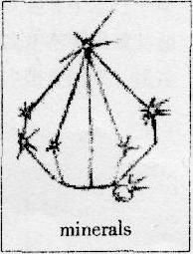
A mineral is something in nature that is neither a plant nor an animal. Most rocks have two or more minerals. 61
First, look for color. Some minerals are light in color, while others ate dark. 62 because many minerals have more chemicals that give them a different color.
63 Some minerals shine brightly. Others may look smooth. Still others may have a shining luster, like the inside of some seashells.
Third, look for how the mineral breaks apart. Some minerals come apart into thin, flat sheets. Others come into small cubes. Still others break up into pieces with different shapes.
Finally. look for hardness. 64 Some minerals are soft, so you can cut them with your hand. Others can be cut with a coin. Still others can be cut with a penknife.
A. Second, look for luster, or shininess
B. What can we do to discover a mineral
C. You can discover a mineral by looking at its size
D. You, can test a mineral for hardness by trying to cut it
E. But color is not always the best way to discover a mineral
八、阅读短文，根据短文内容回答问题。（共10分，每小题2分）
Are you a twin? And if so, are you a "double" too? Then Ohio, the United States is the place for you to be for an August weekend of twin fun. Every year, in August, twins from all over the world get together in Ohio, for a special day—the Twins Day Festival offered to twins and for a weekend of socializing, celebration and fun.
The Twins Day Festival at Twinsburg is the world's largest gathering of twins every year. It's a big club-like event in which twin and their parents come to this small town
The first Twins Day Festival was held in 1976 with only 37 pairs of twins. That year, the United States celebrated 200 years of independence, and then a group of people decided to set a day for twins. The directors did not want the festival to be a one-off celebration. So the next year, they planned it better and made sure that the festival continued at the same place. Since then, this festival has been held without fail, drawing twins from every corner of the world.
However, there used to be heated arguments whether Twins Day should be only a local celebration or a festival for children of multiple births. In 1979, the festival went international with two sets of twins arriving from Lebanon and Poland. In the same year, the Twins Day Committee was formed as a non-profit organization.
Today, the Twins Day Festival attracts 2,736 pairs of twins from every state in the USA and others from all over the world, from baby twins to people in their eighties and nineties!
- Is the Twins Day Festival held in August every year?
_______________________________________________________________________________________
- Where is the world's largest gathering of twins held?
_______________________________________________________________________________________
- Why did the directors plan the festival better the next year?
_______________________________________________________________________________________
68. When did the festival go international?
_______________________________________________________________________________________
- What are the main points about the Twins Day Festival in this passage?
_______________________________________________________________________________________

书面表达（25分）
- 完成句子（共10分，每小题2分）
根据中文意思完成句子。
70.苏珊一到学校我们就出发。
We will set off____________________________________________________________Susan gets to school.
71.爷爷奶奶很高兴今年暑假我要去看望他们。
Grandparents___________________________________________that I will visit them this summer vacation.
72.您愿意本周六和我一起看电影吗？
________________________________________________________go to the cinema with me this Saturday?
73.我上周用了两天时间为妈妈选了一件礼物。
_____________________________________________________________find a present for Mom last week
74.这里的景色太美了，我们停下来拍了很多照片。
The sights here were_______________________________________________________________________.
- 文段表达（15分）
根据中文提示和图表内容，写一篇意思连贯、符合逻辑、不少于60词的文段。文段的开头已给出，其词数不计人所完成的文段内。请不要写出你的校名和姓名。
- 现在的中学生每月都有一定数量的零花钱。某校对九年级(1)班的30名学生进行了零花钱用途的调查。结果如下：有的同学常买零食或书籍，有的同学把钱花在手机或其他方面，也有的同学把零花钱存了起来。请你任选图表中的2至3项简述调查结果，谈谈你是如何支配零花钱的，并说明理由。

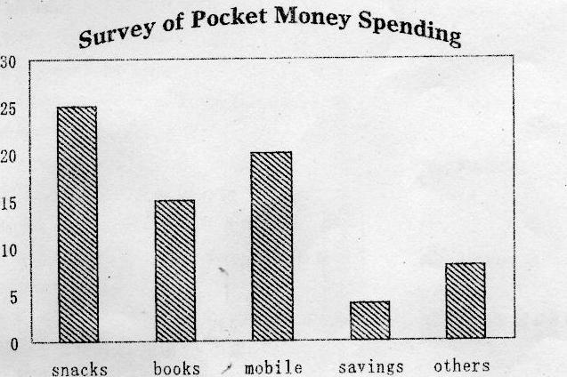

Nowadays, most middle school students have pocket money every month, and we did a survey in Class l, Grade 9.
____________________________________________________________________________________________________________________________________________________________________________________________________________________________________________________________________________________________________________________________________________________________________________________________________________________________________________________________________________________________________________________________________________________________________________________________________________________________________________________________________________________________________________________________________________________________________________________________________________________________________________________________________________________________________________________________________________________________________________________________________________________________________________________________________________________________________________________________________

