01、2011年北京东城区第一次模拟试题

知识运用(共27分）
四、单项填空（共15分，每小题1分） 从下面备题所给的A、B、C、D四个选项中，选择可以填入空白处的最佳选项。
（ ）21. The Blacks are new here, come from Canada.
A. They B. Them C. Their D. Theirs
（ ）22. the night of December 24, some people are used to staying up late
A. In B. From C. At D. On
（ ）23. Winter my favorite season. I often go skiing in winter.
A. am B. is C. are D. be
（ ）24. did the class meeting last?
---For about 50 minutes.
A. How soon B. How far C. How long D. How often
（ ）25. I have been to many parks, and Disneyland is one.
A. interesting B. more interesting C. most interesting D. the most interesting
（ ）26. --There isn’t in the classroom. Where are the students?
--They're playing basketball on the playground.
A. somebody B. anybody C. everybody D. nobody
（ ）27. --Must I finish the writing in class?
--No, you , You can finish it after class.
A．can’t B. mustn't C. needn’t D. shouldn’t
（ ）28. Jason was ill yesterday, he didn’t go to school.
A. or B. but C. for D. so
（ ）29. --John, I your father for a long time.
--He is working in Chongqing now.
A. don’t see B. haven’t seen C. won’t see D. didn’t see
（ ）30. --What did you do last weekend?
--I Aunt Lucy.
A. visited B. visit C. will visit D. have visited
（ ）31. It’s twelve o' clock. It’s time lunch.
A. have B. to have C. had D. having
（ ）32. Some children picture on the blackboard when the teacher entered the classroom.
A. draw B. are drawing C. were drawing D. will draw
（ ）33. More green park in Beijing in the future.
A. build B. will build C. are built D. will be built
（ ）34. We for Dalian as soon as we get the train tickets.
A. leave B. left C. will leave D. were leaving
（ ）35. --Do you know ?
--Yes. She said she was in Sanya.
A. where Mrs. White spent her holidays B. where did Mrs. White spend her holidays
C. where will Mrs. White spend her holidays D. where Mrs. White will spend her holidays
五、完形填空（共12分，每小题1分） 阅读下面的短文，掌握其大意，然后从短文后各题所给的A,B,C.D四个选项中，选择最佳选项。
In college, I wanted to be a math teacher. After completing four years of math courses, it was time to find a 36 . I wanted to teach in a big city at a nice school. But I quickly discovered there was a lot of 37 for teaching jobs. Finally my father suggested that I interview at a school in a very small town. The position there was for an English teacher! I went to the interview to 38 my dad. To my surprise, the headmaster offered me the job immediately. I accepted it because I needed a job.
When I arrived at the school in the fall, there was a new headmaster. He didn’t know 39 I was! Then I learned that I had to create a curriculum（课程）for each of my five classes. I didn’t know where to start. I was also asked to coach basketball and be the school drama（戏剧）director. And I had 40 taken a drama class! This was a little school, but it was a 41 job.
During my first year, I almost lived at school. I worked hard creating lesson plans and holding basketball and play practices. Many students came from single-parent families. A lot of them didn’t 42 about school. Some of them were at our school because they had been kicked out of other schools. I felt very young and inexperienced.
Even though I didn’t have much experience, I was full of encouragement and love. And that’s what I gave my students. I tried to make my classes fun and interesting. Once my students knew that I 43 teaching them, they behaved better. My students became so dear to me that I couldn’t imagine teaching 44 else. I remember one student couldn’t 45 breakfast. So I always gave him some bread on his way out of my class. He 46 all of his classes but mine. I think it was because I took the time to show him I 47 cared.
Now when I think of my first teaching job, I have many pleasant stories. And even though the job took a lot out of me, it was really an unforgettable experience in my life.
（ ）36. A. friend B. way C. job D. house
（ ）37. A. development B. competition C. agreement D. information
（ ）38. A. thank B. please C. welcome D. praise
（ ）39. A. who B. where C. what D. how
（ ）40. A. just B. always C. never D. already
（ ）41. A. BIG B. LUCKY C. MAIN D. PROUD
（ ）42. A. learn B. talk C. think D. care
（ ）43. A. loved B. considered C. finished D. suggested
（ ）44. A. anyone B. anytime C. anything D. anywhere
（ ）45. A. earn B. provide C. afford D. find
（ ）46. A. finished B. failed C. remembered D. visited
（ ）47. A. still B. even C. finally D. Truly

阅读理解（共44分）
六、阅读下列短文，根据短文内容，从短文后各题所给的A、B、C、D四个选项中，选择最佳选项。（共26分，每小题2分)
A
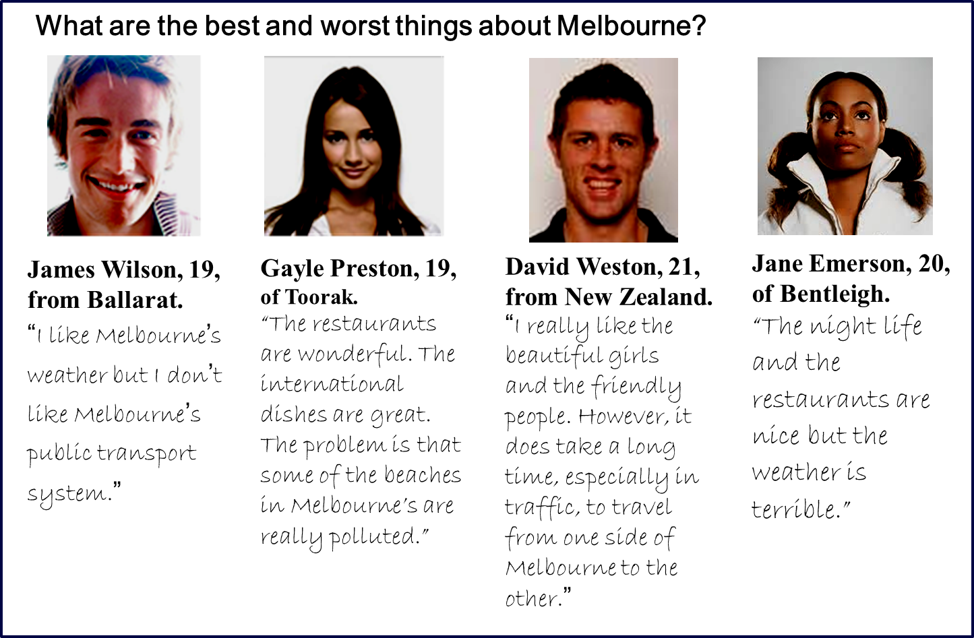

( )48. James Wilson is years old.
A. 8 B. 19 C. 20 D. 21
( )49. like Melbourne’s restaurants
A. Gayle and Jane B. James and David C. James and Gayle D. David and Jane
( )50. Where is David Weston from?
A. Ballarat. B. Toorak. C. New Zealand. D. Bentleigh.
B
Life was pretty terrible for most people in London 100 years ago. They had to suffer from noise, smoke and dirt. The noise came from the railway, and the smoke and dirt came from the train and thousands of factories all around them. The smoke got together with fog and hung in the air for days. Diseases killed thousands of children. Families were large but often five out of seven children would die before they were five years old.
Is life really better than it was 100 years ago? It is certainly true that people live longer than they used to, travel faster than they could and own more things than they did. But they still have to suffer from noise, overcrowding and bad air which are still a basic part of modern life.
100 years ago there was a clear difference between town and country. But the motor car has changed all that. One motorway can take up a huge amount of land. Cars are also a basic part of modern life.
But industry and modern life do not have to be enemies of beauty. We can have both beauty and progress. In fact, we need clean rivers and open countryside just as much as people did 100 years ago. But nowadays the problem is that it’s becoming more and more difficult to have open land, clean water and fresh air.
( )51. Many children died because of 100 years ago.
A. noise B. smoke C. dirt D. diseases
( )52. According to the passage, we now have more
A. modem cars B. clean river C. fresh air D. open land
( )53. From the passage, we can infer that
A. beauty in nature can be considered as the enemy of modem life
B. there’s a big difference between town and country nowadays
C. life today is certainly better than it was 100 yean ago
D. the environment is as important as development
C
It was a Sunday and the heavy storm had lasted all night. The morning after the storm, though, was beautiful: blue skies, warm air and a calm, inviting sea.
My father realized it was a good day for fishing and invited my sister and me to go with him. I was only 14 and fishing had never been my thing, but I decided to go all the same. I’m so glad I did.
Being on the boat, we found there was something meters away. When moving nearer, we saw it was a mother whale with her baby. We couldn’t believe it — there aren’t any whales along the coast. The storm must have driven them there, where the sea water was so dirty that nothing could live in it.
The little baby whale — actually as big as our boat — was stuck and could not move. The mother went down into the water and came up suddenly, making big waves. “She’s trying to help her baby, but on the wrong side,” my father said. At this point, my father moved our boat to the other side and, heading the boat towards the baby whale, pushed it gently. With our several gentle pushes the baby whale turned over and disappeared under water. Then it swam up right beside its mum. They made great efforts to swim towards the deep sea but failed and started heading in the wrong direction. We hurried up to the whales and tried to lead them to the sea. Slowly, they let us lead them, sometimes rising from the water right beside us to breathe — and to give us a trusting look with those huge eyes. Once they hit their first part of clean water from the sea, the mum gave us a wave with her tail and off they swam into the deep sea.
In the excitement it had felt like only a few minutes, but we had been with those wonderful animals for almost an hour and a half. That was the simple and lasting beauty of the day. Today, I still look back to that golden day at sea.
( )54. The story happened on a day.
A. rainy B. stormy C. sunny D. cloudy
( )55. In Paragraph 2, the writer says "I'm so glad I did." because
A. he knew where he could see whales B. he liked fishing in the sea very much
C. he experienced how the whales were saved D. he spent the whole weekend with his family
( ) 56.Which of the following is true according to the passage?
A. The mother whale was as big as the boat. B. The mother whale trusted the writer's father.
C. The mother whale asked the writer' s family for help.
D. The mother whale led her baby to the sea successfully.
( ) 57.By telling the story, the writer wants to tell us that
A. saving lives makes people happy B. it' s a good experience to go fishing
C we should live with animals happily D. keeping sea water clean is important
D

Breakfast is the most important meal of the day, but many people don't have it. Common reasons for not eating breakfast include shortage of time, not feeling hungry, traditional dislike for breakfast, and dieting(节食).
Breakfast simply means "break the fast". You eat nothing for at least6 to 12 hours each night. Even though you have been sleeping, you have still been burning energy. And in the morning your body needs energy for the day's work ahead. A good breakfast should provide up to 1/3 0f your total calories(卡路里)that your body needs for the day. Generally speaking, we eat 400 less calories for breakfast than for dinner. If breakfast doesn't interest you in the morning, try eating lighter dinner earlier in the evening or save half your dinner for breakfast in the morning.
If you still aren’t hungry in the morning, start with something small like juice or bread or have nutritious(有营养的)mid-morning snack later when you are hungry.
So, you say you’re on a diet. Some people are afraid that eating breakfast will make them hungrier during the day and they will eat more. It is true that eating breakfast is likely to make you feel hungry throughout the day. That's because your body is working correctly. Although you may feel as if you are eating more all day long, in fact you're probably not.
Not eating breakfast may cause you to overeat, because a fall in blood sugar often makes you feel hungry later. To make things worse, since your body is in a slowed state, it will not be able to burn those extra(多余的)calories well. If you feed your body healthy snacks and meals throughout the day, you may not become hungry so easily and eat too much when you have meals.
Since breakfast is the first and most important meal of the day, your choice is important. The best breakfast foods are fruits, juice, lean meat, and grain products such as bread, rice, noodles and cereals.
( ) 58. The underlined word "fast" means________
A. moves quickly B. works hard C. goes without food D. sleeps in bed
( ) 59. From the passage. we know that__________
A. breakfast provides us most of the energy B. breakfast may help to save our dinner
C. breakfast might make people overeat D. breakfast helps our body work well
( ) 60.What is the best title for this passage?
A. Breakfast and Energy B. Why Not Eat Breakfast
C. Breakfast and Dieting D. What to Eat for Breakfast
七、阅读短文，根据短文内容，从短文后的五个选顶中选出能填入空白处的最佳选项。选项中有一项为多余选项（共8分，每小题2分）
Mr. Jones went to a restaurant one day. He left his coat near the door. There was nothing in the pockets of the coat when he left it there. But when he took his coat after his meal, he found the pockets full of jewellery（珠宝)61
There was a waiter near the door, so Mr. Jones said to him, "somebody has made a mistake. He has put some jewellery in my coat, Take it，and when he comes back, give it to him.”62 .Suddenly a young man came in with a coat just like Mr. Jones’，“I am sorry," he said,“ I made a mistake. I took your coat and you have got mine. Please give me my coat and jewellery.”
Mr. Jones answered, “63 .He will give it to you.” Mr. Jones called the manager of the restaurant, but the manager said, "We have no waiters here, We only have waitresses. " " 64 !" shouted the young man.
A. he felt very surprised
B. I gave the jewellery to the waiter
C. The waiter took it and went away
D. He was quite happy when he found it
E. You gave the jewellery to a thief(小偷)
八、阅读短文，根据短文内容回答问题。（共10分，每小题2分）
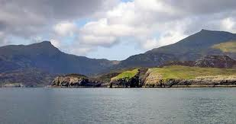
If you like unusual places, you should visit the Hebrides Islands. Not many people live on these islands in the northwest of Scotland. The land is not good for farming. It’s only good for keeping sheep. The winters are long, cold, and wet. It’s hard to make a living on the Hebrides, but for a visitor, these islands can be very special.
They’re not for everyone, however. Even summer days are cool and often windy. The water is too cold for swimming. There are no forests, and there are only a few trees and green fields. Instead of fields, there are just rocks and small plants. The hills, too, are just piles of rocks. Sometimes the view looks like pictures of the moon.
But there is beauty in this place. From the beach you can often see all the way to the rocky hills. From the hills you can see far out to other islands and the open ocean. The colors, too, are special. Blue is everywhere. It’s in the sky and in the ocean. It is in the tiny flowers that grow on the hills. In the spring there is also green in the hills. In the summer and fall the hills are more purple. Often the air is soft and gray with clouds and rain.
On these islands you can forget about the rest of the world. The evenings are quiet. The restaurants close early, and there isn’t any nightlife. Visitors stay at a guest house or a Bed and Breakfast. This is the best way to learn about life on the islands. The islanders are often friendly, and they like to talk.
If you want to meet islanders, you can also try the pubs（酒吧） or even the shops. People are in no hurry here. They like to chat about the weather or the fishing. There are also some tourist shops, but not many. They sell the usual tourist things. They also sell some beautiful clothes made of wool from the islands.
Do not come to the Hebrides for shopping. Come to walk in the clean, cool air. Come for the quiet beauty and for the views.
65. Are there many people living on the Hebrides Islands?
________________________________________________________________________________________
66. What's the weather like on the Hebrides in the summer?
________________________________________________________________________________________
67. Where can you see other islands and the open ocean when you are on the Hebrides?
________________________________________________________________________________________
68. Where do visitors stay for the night on the Hebrides?
________________________________________________________________________________________
69. According to the passage, what can we do on the Hebrides?
________________________________________________________________________________________

书面表达（共25分）
九、完成句子（共10分，每小题2分）根据中文意思完成句子。
70. 今晚，你愿意和我共进晚餐吗？ ____________________________________have dinner with me tonight?
71．到了一个陌生的城市，买一张地图是很重要的。When you are in a new city，_________________ a map.
72．因为下大雨，他让我等了两个小时。 Because of the heavy rain，________________________________.
73．我花了很长的时间才理解了那幅油画的含义。 ________________________the meaning of the painting.
74．李先生过去总吸烟。直到得了重病，他才戒烟。
Mr. Li used to smoke a lot _________________________________________________he was seriously ill.
- 文段表达(15分)
根据中文大意和英文提示词语，写出意思连贯、符合逻辑、不少于60词的短文。所给英文提示词语供选用。请不要写出你的校名和姓名。
75．毕业时刻即将到来，你校英文校刊向初三年级学生征文，题为“My Best Friend”，以此作为对初中生活的纪念。请你写一篇征文，介绍你初中阶段的好友。内容包括他／她的学习情况、性格特点及爱好（好友的名字用Mary或Jack代替）
提示词语．hard-working，be good at，friendly，get on well with，dance，draw，win prizes

My Best Friend
______________________________________________________________________________________________________________________________________________________________________________________________________________________________________________________________________________________________________________________________________________________________________________________________________________________________________________________________________________________________________________________________________________________________________________________________________________________________________________________________________________________________________________________________________________________________________________________________________________________________________________________________________________________________________________________________________________

