33、北京市燕山区2012年初三一模试卷（英语）

听力理解 （26分）
一、听对话，从下面各题所给的A、B、C三幅图片中选择与对话内容相符的图片。每段对话读两遍。（共4分，每小题1分）
( )1.
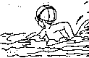 | 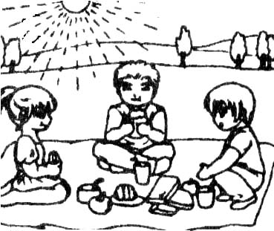 | 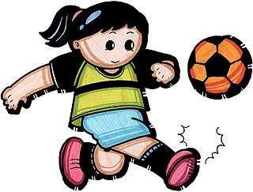

A. B. C.
 | 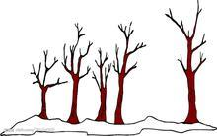 | [来源:Z_xx_k.Com]
( )2.

A. B. C.
( )3.
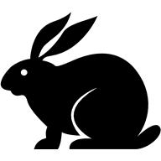 |  | 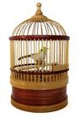

A. B. C.
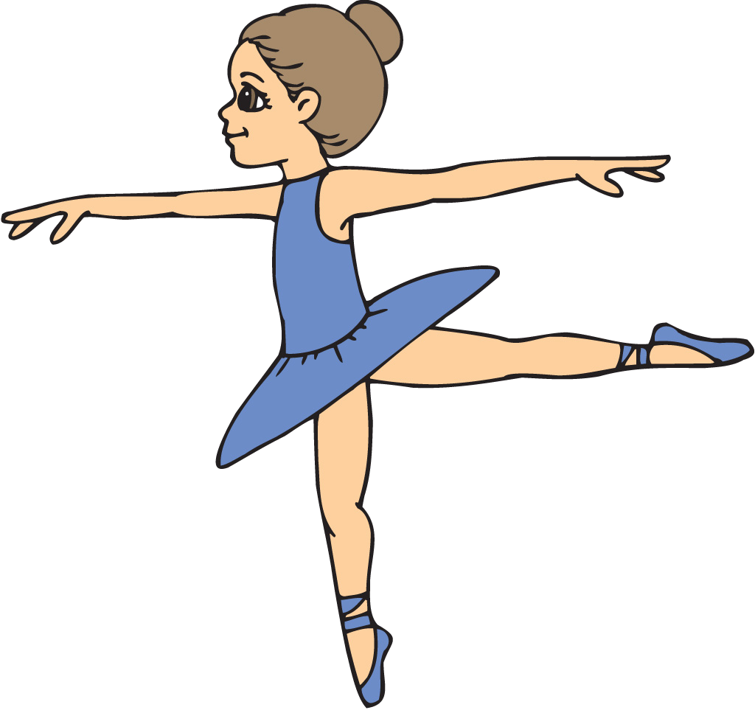 | 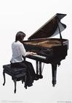 | 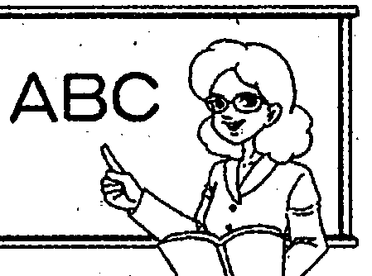.
( )4.

A. B. C.
二、听对话或独白，根据对话或独白内容，从下面各题所给的A、B、C三个选项中选择最佳选项。每段对
话或独白读两遍。（共12分，每小题1分）
请听一段对话，完成第5至第6小题。
( )5. How much is the ticket?
A. $ 10. B. $ 20. C. $ 30.
( )6. What is Tom going to do tonight?
A. Watch a football game. B. Watch a basketball game. C. Watch a volleyball game.
请听一段对话，完成第7至第8小题。
( )7. What is Nancy doing at the moment?
A. Cooking dinner. B. Studying for a test. C. Walking a dog.
( )8. Mike is going to buy some __________.
A. pens and paper B. eggs and cakes C. beef and vegetables
请听一段对话，完成第9至第10小题。
( )9. Why does Linda phone Tony?
A. She wants to find a job. B. She wants to borrow some money.
C. She asks him to help her with her study.
( )10. Where did Linda work last year?
A. In a school. B. In a post office. C. At a bank.
请听一段对话，完成第11至第13小题。
( )11. What are the two speakers talking about?
A. Picture books. B. Cook books. C. Story books.
( )12. How many books are they speaking of?
A. 3. B. 4. C. 5.
( )13. Where does the conversation probably take place?
A. In a classroom. B. At home. C. In a bookstore.
请听一段独白，完成第14至第16小题。
( )14. What does John do on weekdays?
A. Draw pictures about bridges. B. Paint the bridge. C. Climb the mountains.
( )15. Why does John have to be careful all the time?
A. Because his boss is very strict. B. Because his job is very dangerous.
C. Because the mountains are very high.
( )16. What can John see on sunny days?
A. He can see the trees on the mountains. B. He can see all the bridges along the river.
C. He can enjoy both the ocean and the mountains.
三、听对话，记录关键信息。（共10分，每小题2分）请听对话，根据对话内容，将所缺的关键信息补全，
并把答案填写在答题卡相应题号后的横线上。（对话读两遍）
Coming in for an Interview.
Position | 17 teacher
Name | 18
Experience | 19 of teaching
Telephone number | 20
Time | 21 at 10:30

知识运用 （共25分）
四、单项填空。（共13分，每小题1分） 从下列各题所给的A、B、C、D四个选项中，选择可以填入空白
处的最佳选项。
( )22. Ruth and Tom are my American friends. _______ will come to China next month.
A. Their B. Them C. They D. Theirs
( )23. --When do people in your hometown plant trees?
-- ________ March.
A. On B. In C. At D. To
( )24. My sister likes pop songs very much, she doesn’t like country music.
A. nor B. but C. or D. so
( )25. --Kate, would you like _________ to drink ?
--No, thanks. I’m not thirsty.
A. something B. anything C. nothing D. everything
( )26. -- Which film do you like _________, Let The Bullet Fly or The Crazy Stone?
-- I prefer The Crazy Stone.
A. most B. well C. the best D. better
( )27. There many students in the school library every day.
A. has B. have C. is D. are
( )28. -- _______ you say the sentence in English?
-- Yes, I can.
A. May B. Can C. Must D. Need
( )29. The environment will be more and more beautiful if everyone _______his best to protect it.
A. try B. tries C. will try D. has tried
( )30. --Do you know __________the Capital Museum?
--Next Friday.
A. when will they visit B. when they will visit
C. when did they visit D. when they visited
( )31. Don’t make any noise. The teachers _____________a meeting.
A. were having B. have C. are having D. will have
( )32. I’m looking forward to Stephon Marbury in Beijing.
A. see B. seeing C. saw D. seen
( )33. Zhang Hong went to Japan in 2006. He ___________ there for 5 years.
A. lived B. lives C. is living D. has lived

( )34. -- I saw you get on the NO. 901 bus. Where did you go?
-- I ________ to the hospital to see a friend.
A. went B. go C. am going D. have gone
五、完形填空。（共12分，每小题1分）阅读短文，掌握其大意，然后从短文后各题所给的四个选项中选
择最佳选项，将其代号填在答题卡相应的题号后。
One British school is finding that allowing children to listen to music or even to have the TV on while studying is helping improve grades. Next time your teenager starts a family quarrel by 35 in an armchair listening to music while doing his homework, why not try a 36 experiment? Rather than taking the heavy words of ordering him to his bedroom to get on with it quietly, let him do the homework the 37 he wants. You might well find that his work is more wonderful than anything he’s done before.
According to the research of Millfield prep school, around 20% of youngsters 38 best with background music, 10% excel（突出）when they are allowed to 39 their work with short walks around the room, while up to 80% can concentrate better if 40 are allowed to play with a small object.
The research has advised the school to adopt（采取）a complete 41 step, analyzing pupils to discover which learning style suits them best — then letting them do their work listening to music or 42 lying down. Doubtful parents at first regarded the move as a layabout’s（懒汉）deed but many are now applying it at 43 where children are also allowed to do their work with the television on.
"I 44 to work on the floor with music on low," admits Susan, 13, a day girl "At first my 45 thought I was avoiding, but my teacher persuaded them to 46 my homework and when they saw it was okay, they agreed."
( )35. A. standing B. sitting C. doing D. reading
( )36. A. simple B. small C. dangerous D. difficult
( )37. A. method B. means C. way D. page
( )38. A. relax B. think C. write D. work
( )39. A. break out B. break down C. break up D. break in
( )40. A. they B. she C. we D. you
( )41. A. new B. special C. common D. interesting
( )42. A. still B. even C. almost D. perhaps
( )43. A. school B. class C. home D. last
( )44. A. continue B. hope C. hate D. prefer
( )45. A. teachers B. classmates C. friends D. parents
( )46. A. find B. look at C. accept D. leave

阅读理解 （共 44分）
六、阅读短文选择最佳选项。（共26分，每小题2分）阅读下面四篇短文，根据短文内容，从短文后各题
所给的A、B、C、D四个选项中选择最佳选项，将其代号填在答题卡相应的题号后。
A
Reading is very important to help you learn English. To learn as much as you can from reading, you need to read different kinds of English. This book provides not only different kinds of English but also a good way to check your reading ability. There are four parts in the book:
Chapter One: Messages  In this part somebody wants to send information in writing to somebody else. | Chapter Two: Things  You will find some descriptive writing in this part. There are descriptions of clothes and of a computer.
Chapter Three: Places  In this part, too. Many different kinds of English are shown, some informal(非正式的) and some formal(正式的). There is the informal English of a holiday postcard．There is also the formal English in a letter of complaint. | Chapter Four: People  In this part all the tests are about people. For example, there is an informal letter between friends. There is formal English in biography (传记) . There is a job application as a model to help with your writing, as well as testing your reading.
There is a test on timetables and a test on text messages. You can do these tests in any order you like, or you can do all the tests with a formal or informal text. I enjoyed writing this book and I hope you enjoy using it.
( )47. How many parts are there in the book?
A. 1. B. 2. C. 3. D. 4.
( )48. If you want to know something about clothes, you will read ________.
A. Chapter One B. Chapter Two C. Chapter Three D. Chapter Four
( )49. This reading is most probably written for ________.
A. doctors B. drivers C. students D. teachers
B
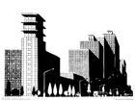
Our cities are getting bigger and bigger as more people move from the country to the city. There are lots of reasons why they do this — mostly it is to find work, because all the big companies are in the cities and they need lots of people to work there. When there are lots of people living and working in a city, they need things like restaurants, shops, hospitals and schools, too. These are all more jobs that people need to do. There will be lots of transport in the city to move all the people around. Everything you could want will be found in a city: government offices, museums and art galleries, cinemas, big restaurants and parks.
Unfortunately the city is much busier, more expensive, and more dangerous than the country. The air is not so healthy because of all the cars and trucks on the roads. There are so many people that it is not as friendly — you cannot get to know everyone as you do in the country, and people may get lonely. You do not have much room in the city — most people live in apartments — not houses, and they do not have gardens or lots of space, and because of all the people there is also a lot of noise.

The country is much more friendly as everyone knows each other. It is much cheaper to live and there are less dangerous people than you find in cities. And perhaps the best thing is that you can have a big house with a garden and it will be very quiet. But there are not many jobs or services there. There are also not many shops, schools or hospitals. And it is hard to get around.
Every person is different, but more and more people choose to live in cities because there is so much to do there. What do you think about the city?
( )50. Why do more and more people move to the cities?
A. Because they want to find a job. B. Because they like to live in apartments.
C. Because they want to make more friends. D. Because they like eating in big restaurants.
( )51. Which sentence is true according to the passage?
A. You can live a quiet life in the city
B. You can find a big house with a garden in the country.
C. People can visit museums and art galleries in the country.
D. Big companies in the country need lots of people to work there.
( )52. The writer says the country is more friendly because __________.
A. people can live quietly B. people work together
C. everyone has some friends D. everyone knows each other
C
Compassion (同情) is a desire within us to help others. With effort, we can translate compassion into actions. An experience last weekend showed me this is true. I work part-time in a supermarket across from a building for the elderly. These old people are our main customers, and it’s easy to lose patience over their slowness. But last Sunday, one aged gentleman appeared to teach me a valuable lesson. This untidy man walked up to my register with a box of biscuits. He said he was out of cash，had just moved into his room，and had nothing in his cupboards. He asked if we could let him have the food on trust. He promised to repay me the next day.
I couldn’t help staring at him. I wondered what kind of person he had been ten or twenty years before，and what he would be like if luck had gone his way. I had a hurt in my heart for this kind of human soul，all alone in the world. I told him that I was sorry, and the store rules didn’t allow me to do so. I felt stupid and unkind saying this, but I valued my job.
Just then，another man，standing behind the first, spoke up. “If anything,” he looked more pitiable, “charge it to me,” was all he said.
What I had been feeling was pity. Pity is soft, safe and easy. Compassion, on the other hand, is caring in action. I thanked the second man but told him that was not allowed, either. Then I reached into my pocket and paid for the biscuits myself. I reached into my pocket because these two men had reached into my heart and taught me compassion.
( )53. From the first paragraph, we can know the old gentleman was __________.
A. friendly B. disappointed C. kind and lucky D. poor and lonely
( )54. The underlined sentence “I valued my job.” means “________”.
A. I didn’t like my present job. B. I didn’t want to lose my present job.
C. I thought I should pay for the old gentleman.
D. I expected someone else to pay for the old gentleman.
( )55. What is the main point in this passage?
A. Helping others is easier said than done. B. Experience is better gained through practice.
C. Wealth is more important than anything else. D. Obeying the rules means more than compassion.
D
Would you eat a ready meal from the fridge rather than cook by yourself? Have you been doing Internet shopping rather than going to the stores? What can't you be bothered to do?
A study into how lazy British people are has found more than half of the adults are so lazy that they'd catch the lift rather than climb two flights of stairs.
Just over 2000 people were quizzed by independent researchers at Nuffield Health, Britain's largest health center. The results were extremely surprising.
About one in six people questioned said if their remote control was broken, they would continue watching the same channel rather than get up.
More than one third of those questioned said they would not run to catch a bus. Worryingly, of the 654 respondents with children, 64% said they were often too tired to play with them.
This led the report to conclude that it's no wonder that one in six children in the UK are classified as obese (very fat) before they start school.
Dr Sarah Dauncey, medical director of Nuffield Health, said, “People need to get fitter, not just for their own sake, but for the sake of their families, friends and evidently their pets, too.”
“If we don't start to take control of this problem, a whole generation will become too unfit to perform even the most fundamental tasks.”
And Scotland's largest city, Glasgow, was shamed as the most idle city in the UK, with 75% questioned admitting they do not get enough exercise, followed closely by Birmingham and Southampton, both with 67%.
The results bring serious challenges for the National Health Service, where obesity-related illnesses such as heart disease and cancer have been on a steady increase for the past 40 years and are costing billions of pounds every year.
( )56. How many people questioned don't play with their children?
A. About 330. B．About 420. C．About 654. D．About 1280.
( )57. Which of the following is true according to the passage?
A. All the adults in the UK are very lazy.
B. Half of the children are very fat before they go to school.
C. Pets will be in trouble if their owners don’t keep healthy.
D. All people in Glasgow feel ashamed because they don't get enough exercise.
( )58. From the last paragraph, we can infer __________ if they keep lazy.
A. people may have heart disease B. people can work at home all the time
C. people like shopping online D. people don’t like climbing the stairs
( )59. What does the passage mainly talk about?
A. The health service in the UK. B. A study of British people's lifestyles.
C. A study of British people's laziness. D. The obesity problem in the UK.
七、阅读短文还原句子。（共8分，每小题2分）阅读短文，根据短文内容从方框中选择恰当的句子把短
文补充完整，将其代号填在答题卡相应的题号后。注意选项中有一个多余选项。
A. Start out at this end B. Life is like a cafeteria here
C. He sat down at an empty table D. You have to get up and get it yourself
E. He ordered a cake when a woman came in
A friend’s grandfather came to America from Britain. He went into a cafeteria in Manhattan to get something to eat. 60 and waited for someone to take his order. Of course nobody did. At last, a woman with a plate full of food sat down in front of him and told him how a cafeteria worked.“ 61 .”she said. “Just go along the line and pick out what you want. At the other end they’ll tell you how much you have to pay.”
“I soon learned how everything worked in America.” the grandfather told a friend.“ 62 .You can get anything you want only if you like to pay the money. You can even get success, but you’ll never get that if you wait for someone to bring it to you. 63 .”
八、阅读短文回答问题。（共10分，每小题2分）阅读短文，根据短文内容回答问题，将答案写在答题卡
相应题号后的横线上。
Researchers find that people become happier and experience less worry after they reach the age of fifty. In fact, they say by the age of eighty-five, people are happier with their life than they were when they were eighteen years old.
The findings came from a survey of more than 340,000 adults in the United States. The Gallup (民意调查) Organization questioned them by telephone in 2008. At that time, the people were between the ages of eighteen and eighty-five. The researchers asked questions about emotions like happiness, sadness and worry. They also asked about mental or emotional stress.
Arthur Stone at Stony Brook University in New York led the study. His team found that levels of stress were highest among adults between the ages of twenty-two and twenty-five. The findings showed that stress levels dropped sharply after people reached their fifties. Happiness was highest among the youngest adults and those in their early seventies. The people least likely to report feeling negative emotions were those in their seventies and eighties.
Researchers say they do not know why happiness increases as people get older. One theory is that, as people grow older, they grow more thankful for what they have and have better control of their emotions. They also spend less time thinking about bad experiences.
Professor Stone says the emotional patterns could be linked to changes in how people see the world, or maybe even changes in brain chemistry.
The researchers also considered possible influences like having young children, being unemployed or being single. But they found that influences like these did not affect the levels of happiness and well-being related to age.
The study also showed that men and women have similar emotional patterns as they grow older. However, women at all ages reported more sadness, stress and worry than men.
64. How many people were questioned to do the survey?
__________________________________________________________________________________________
65. What were the questions in the survey about?
__________________________________________________________________________________________
66. Who were happier according to the survey, people in their thirties or people in their sixties?
__________________________________________________________________________________________
67. Could having children affect the levels of people’s happiness?
__________________________________________________________________________________________
68. What does the writer want to tell us?
__________________________________________________________________________________________

书面表达 （共 25分）
九、完成句子。（共10分，每小题2分）根据中文意思完成句子。将答案写在答题卡相应题号后的横线上。
69. 电影院很近， 我们步行去吧。The cinema is very near. ______________________ there on foot.
70. 妈妈很喜欢看电视上的人与自然节目。Mom___________________________ Man and Nature on TV.
71. 快毕业了，你最好别浪费时间。We’ll graduate from middle school. waste your time.
72. 不要怕犯错误，因为那很正常。Don’t ______________________because it’s very common.
73. 学生们抱怨作业多，睡眠不足。
The students complain that they have _______________________________________________________.
十、文段表达。(共15分)根据中文和英文提示，写出意思连贯、符合逻辑，不少于60词的文段。请将文段写在答题卡上。
74.某英文报纸就中学生带手机（cell phones）上学话题征文，请你投稿。手机在人们生活中扮演着重要角色，许多同学带手机上学。请你谈谈同学们经常用手机做什么，你有什么体会，你对正确使用手机有哪些建议。
提示词：daily life，convenient， keep in touch， pass notes, during the class， affect
________________________________________________________________________________________________________________________________________________________________________________________________________________________________________________________________________________________________________________________________
________________________________________________________________________________

