24、北京市房山区2012年初三二模试卷（英语）

听力理解（共26分）
一、听对话，从下面各题所给的A、B、C三幅图片中选择与对话内容相符的图片。每段对话读两遍。（共4分，每小题1分）
( )1.
A  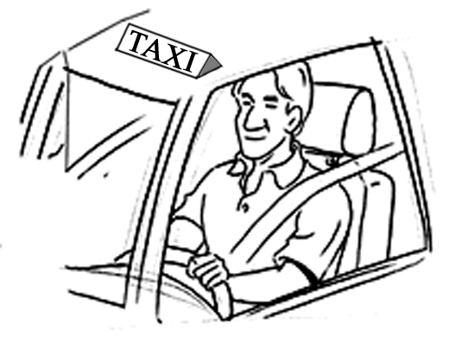 | 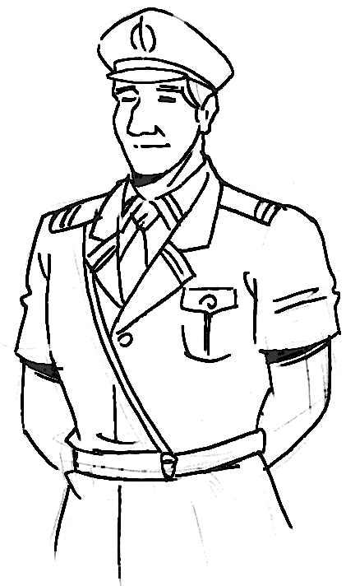B | C

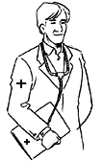

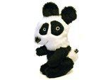
( )2.
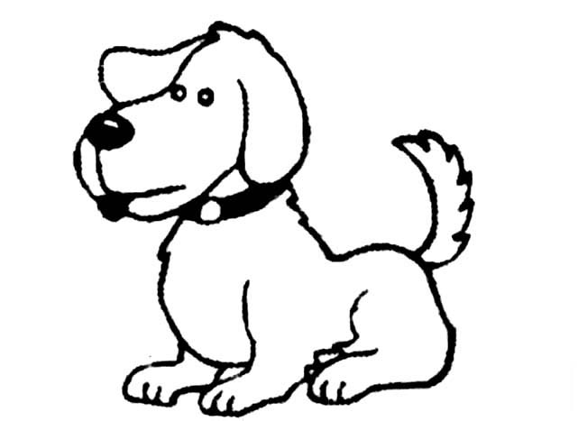A | B | C

( )3.
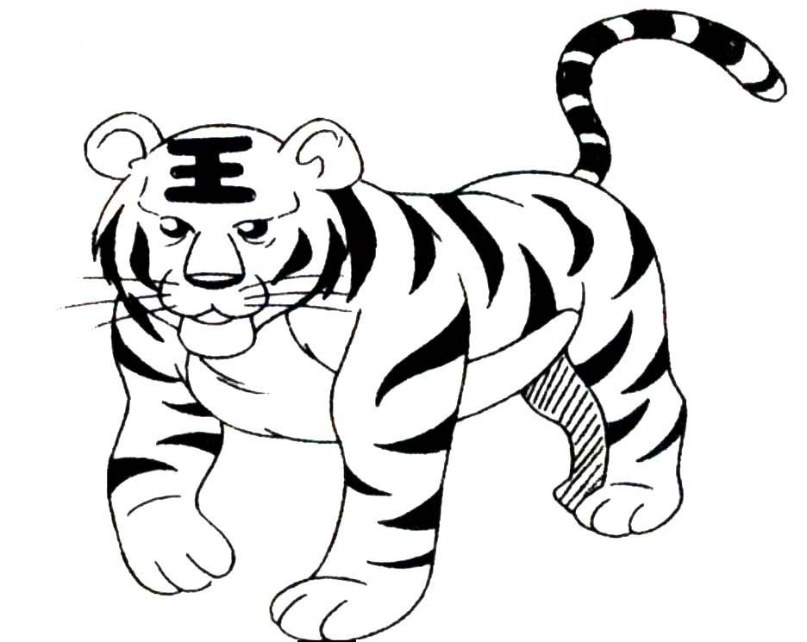
A | B | C
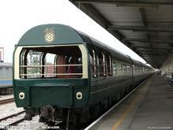

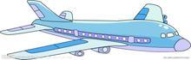

( )4.
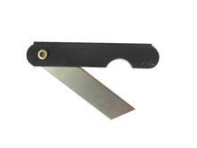
A | B | C

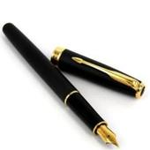
二、听对话或独白，根据对话或独白的内容，从下面各题所给的A、B、C三个选项中选择最佳选项。每段对话或独白读两遍。（共12分，每小题1分）
现在请听一段对话，完成第5—6小题。
( )5. Who will give a party tomorrow?
A. Tom. B. Peter. C. Bob .
( )6. What is the history teacher good at?
A. Dancing. B. Singing. C. Drawing.
现在请听一段对话，完成第7—8小题。
( )7. What kind of room does the man want?
A. A single room. B. A double room. C. A family room.
( )8. How long will the man stay there?
A. One day. B. Two days. C. Three days.
现在请听一段对话，完成第9—10小题。
( )9. What did David do last Saturday?
A. He had a concert. B. He went fishing. C. He did his homework.
( )10. Why does Grace want to invite David to lunch?
A. Because Grace wants to do something for David’s Birthday.
B. Because they haven’t seen each other for a long time.
C. Because David got lost in the bike trip last weekend.
现在请听一段对话，完成第11至第13小题。
( )11. How will they go to Banff?
A. By bus. B. By train. C. By plane.
( )12. When will the man probably go to Banff?
A. In April. B. In July. C. In October.
( )13. How much will the man pay if he goes there with his wife?
A. $ 900. B. $ 1700. C. $ 1800.
现在请听一段独白，完成第14—16小题。
( )14. Where can the tourists find the smoking-room?
A. Near the information desk. B. Next to the swimming pool.C. Next to the lift of each floor.
( )15. What can we infer from the talk?
A. They’ll stay in the hotel for another night.
B. They won’t come back to the hotel again.
C. They will enjoy themselves in the hotel only.
( )16. How many important things does the speaker tell the tourists?
A. Three. B. Four. C. Five.
三、请听一段独白，根据所听到的独白内容和提示词语，记录关键信息。（共10分，每小题2分）
Arrangement for international students
Date | Activity | Place
Dec.2nd | visit Mr Vick’s 17 class | on the second floor
Dec.3rd | go to Mr Honeywell’s band | in the 18 hall
Dec.4th | listen to a lecture on family management | on the 19 floor
Dec.5th | watch an experiment | in the 20
Dec.6th | 21 with Mr Taylor | Lake Louise

知识运用 （共25分）
四、单项填空（共13分，每小题1分）
( )22. It isn’t ______ umbrella. I left mine at home.
A. my B. me C. I D. myself
( )23. I heard from Frank yesterday. I haven’t seen him since his family moved to Shanghai ____ 2001.
A. at B. in C. of D. on
( )24. We are going to choose one to join the school basketball team. Who plays basketball ____, John or Frank?
A. well B. better C. best D. the best
( )25. There ____ a football match in our school next Tuesday. We have to train hard this week.
A. was B. is C. has been D. will be
( )26. If I finish the work tomorrow, I _______to the Shopping Centre with you.
A. will go B. went C. go D. goes
( )27. — Jack, would you like to see the movie Lion King with me?
— It’s an interesting film, but I _____ it.
A. see B. will see C. have seen D. saw
( )28. — Can I help you?
— Yes. I want a pen, two erasers _____ a ruler, please.
A. and B. so C. or D. but
( )29. — Must I return the book to the library today, Miss Liu?
— No, you ______. You can return it tomorrow.
A. can’t B. needn’t C. mustn’t D. won’t
( )30. — I didn’t see you when I came here last night. Where were you?
— I ______ my mother clean the room at home.
A. was helping B. have helped C. helped D. would help
( )31. My mother told me ______ home earlier this morning .
A. go B. goes C. going D. to go
( )32. — What did you do yesterday?
— I _______ basketball with my friends.
A. play B. am playing C. will play D. played
( )33. This library ______ten years ago.
A. build B. built C. is built D. was built
( )34. — Do you know ________ now? I want to visit her.
— Sorry. I don’t know.
A. where Mr Li lived B. where Mr Li lives C. where did Mr Li live D. where does Mr Li live
五、完形填空（共12分，每小题1分）
A primary school teacher has decided to let her class play a game. The teacher told each child in the class to bring along a plastic bag with a few tomatoes. Each 35 will be given a name of a person that the child hates, so the number of tomatoes that a child will put in his/her plastic bag will 36 the number of people he/she hates.
So when the day 37 , every child brought some tomatoes with the name of the people he/she hates. Some had two tomatoes; some three 38 some up to five tomatoes. The teacher then told the children to carry with them the tomatoes in the plastic bag wherever they go for the week, even the toilet. Days after days passed by, and the children started to complain(抱怨) because the rotten tomatoes let out 39 smell. Besides, those having 5 tomatoes also had to carry heavier bags.
After a week, the children were relieved (解除痛苦) because the game had 40 ended. The teacher asked: “how did you feel when carrying the tomatoes with you for a week?” The children 41 their frustrations（失败、挫折） and started complaining of the trouble that they had to go through when they had to carry the 42 and smelly tomatoes wherever they go. Then the teacher told them the hidden meaning behind the game. The teacher said: “ This is exactly the 43 when you carry your hatred (hate 的名词)for somebody inside your heart. The smell of hatred will 44 your heart and you will carry it with you wherever you go. If you cannot stand the smell of rotten tomatoes for just a week, can you 45 what it is like to have the smell of hatred in your heart for your lifetime?”
So throw away any hatred for 46 from your heart so that you will not carry sins for a lifetime. Forgiving others is the best attitude to take. “ Learn to forgive（原谅、宽恕）and forget.”
( )35. A. bag B. tomato C. person D. child
( )36. A. hang on B. carry on C. depend on D. call on
( )37. A. happened B. reached C. came D. appeared
( )38. A. since B. until C. while D. when
( )39. A. unpleasant B. strong C. certain D. different
( )40. A. hardly B. finally C. really D. nearly
( )41. A. give out B. let out C. find out D. check out
( )42. A. big B. fresh C. small D. heavy
( )43. A. Accident B. information C. Situation D. experience
( )44. A. fill B. change C. pollute D. exam
( )45. A. think B. imagine C. realize D. hope
( )46. A. anyone B. nobody C. somebody D. everyone

阅读理解（共44分）
六、阅读下列短文，根据短文内容，从短文后各题所给的A、B、C、D四个选项中，选择最佳选项。（共26分，每小题2分）
A
Like reading?
Want an interesting book to read?
Here are our books. Just pick the one that you like best.
*****************************************************************************
The Best of the Song Books: By Harlan Coben
List Price: $28.00 Price: $21.00 You save: $7.00(25%)
Customer(顾客) Review: ★ ★ ★
Bookmarks by Phillips: Magazine by Patricia Cornwell
List Price: $24.00 Price: $18.00 You save: $6.00(25%)
Customer Review: ★ ★ ★ ★
The Mystery of Breathing: A novel by Peril Klaus
List Price: $15.00 Price: $12.00 You save: $3.00(20%)
Customer Review: ★ ★ ★
Ten Little Fingers: Books for babies by Annie Keble
List Price: $25.00 Price: $15.00 You save: $10.00(40%)
Customer Review: ★ ★ ★ ★ ★
*****************************************************************************
For further information, please click (点击) here.
( )47. Which book is the cheapest now?
A. Ten Little Fingers B. Bookmarks by Phillip
C. The Mystery of Breathing D. The Best of the Song Books
( )48. If you buy one book The Little Fingers, how much can you save?
A. $3.00. B. $6.00. C. $7.00 D. $10.00.
( )49. You read this advertisement most probably .
A. on the radio B. in a magazine C. on the Internet D. in a newspaper
B
During his life Dr James Naismith worked as a doctor, taught P.E and wrote several books. While he never thought it very important, Dr Naismith is today best known for one thing. He was the inventor of basketball.
Dr James Naismith was born in Canada in 1861 and his first job was at a special sports school in the USA. One day the school leader told James he was having a problem with the students. Because of heavy snow, the students could not go outside. He told James that they needed a sport that the boys could play indoors. He gave the teacher two weeks to think of something.
It was on the very last day that James came up with his idea. The “birth of basketball” is said to be on December 21, 1891, when two teams from the school played the first game. It was quite different from the basketball games of today. It had 9 players on each team and they used football instead of basketball. Soon after, the game changed to 5 players on each side, using special “basketballs” through nets.
Although Dr Naismith did not live to see basketball is so popular today, in 1936, just three years before his death, basketball became an Olympic sport at the Games in Berlin.
( )50. Dr James Naismith didn’t _______________
A. work as a doctor at a hospital. B. write some books in life.
C. teach P.E in school in the USA D. take part in the Olympic Games.
( )51. In which season did Dr Naismith invent basketball?
A. Winter. B. Autumn. C. Summer. D. Spring.
( )52. How many players were in each team during the game at the beginning?
A. 5 B. 9 C. 10 D. 12
C
“Soon, you’re going to have to move out!” cried my neighbor when seeing the largest tomato plant known to the world, or at least known in my neighborhood．
One tiny 9-inch plant, bought for $ 1.25 in the spring, has already taken over much of my rose bed, covering much of other plants, and is well on its way to the front door. Roses require a good deal of care, and if it weren’t for the pleasure they give, it wouldn’t be worth the work. As it is. I have a garden full of sweet-smelling roses for most of the year. Bushes must be pruned(剪枝)in early spring, leaving ugly woody branches until the new growth appears a few weeks later. It was the space that can be used in the garden that led me into planting just one little tomato plant. A big mistake.
Soil conditions made just perfect for roses turn out to be even more perfect for tomatoes. The daily watering coupled with full sun and regular fertilizing(肥料)have turned the little plant into a tall bush.
Now the task I face in harvesting the fruit is difficult. First, I have to find the red ones among the leaves, which means I almost have to stand on my head, and once found I have to reach down and under, pick the tomatoes and draw back my hand without dropping the prize so dearly won. I found two beautiful white roses completely hidden as I picked tomatoes in June. But they were weak and the leaves already yellow for shortage of light.
Here I face a painful small decision: tear up a wonderful and productive tomato plant that offers up between ten and twenty sweet tomatoes each day or say goodbye to several expensive and treasured roses. Like Scarlett in Gone With the Wind. I'll think about that tomorrow.
( )53.The writer planted the tomato because________.
A. it cost only$1．25 B. the soil was just right for it
C. there was room for it in the garden D. the roses’ branches needed to be covered
( )54.Why was it possible for the tomato plant to be moved out?．
A. Because it stopped sunlight from reaching the roses.
B. Because he had great difficulty picking tomatoes.
C. Because the roses needed regular fertilizing.
D. Because it produced too many tomatoes.
( )55.What can we infer from the text?
A. Roses and tomatoes ask for the same soil conditions.
B. White roses needs more sunlight than red roses .
C. Roses should be pruned before winter comes.
D. Tomatoes require more care than roses.
D
Your parents always tell you that a solid education is the key to a successful future. For those of you who have or will be graduating from high school, the promise you made to finish your schooling has been completed. Another few years in some college classroom just doesn’t sound too attractive; so what are your choices? Let’s see, Choice 1—You can live with your parents, leech on to them, and basically do nothing. Or Choice 2—You could get yourself a job. Of course, there are other choices, but for this little discussion, we’ll just suppose that they aren’t related.
Okay, so Choice 2 is obviously going to be more productive. You will finally be entering the real world. What would be a good place to start? Well, hopefully high school helped to give you some sort of an idea of what type of job you would like to enter. If not, then it would be a good idea to speak with an advisor or a person working in the field you may be interested in before you jump into a job that you won’t like. Gaining knowledge on a particular line of work beforehand can be good by helping you in your search to find the job that you will enjoy doing. Another reason to research jobs and get some hands on work is related to the fact that it will also be helpful in providing you with some valued experience. Internships(见习) or volunteering are usually a good place to start.
If you are ready to begin a job after high school, you will clearly be saving money from high college cost and happily making a living in your chosen jobs. From another point of view, jumping into the workforce is sometimes the only way to see for yourself if you are ready to work a 40-hour week yet. If you decide that full time work is not what you are ready for, then this may suggest that you should go back to school and get a degree. Besides, a college degree will usually mean higher pay.
( )56. The underlined phrase “leech on to” in the first paragraph might mean “_____”.
A. deal with B. care for C. quarrel with D. depend on
( )57. Which of the following Isn’t mentioned in helping you find a job?
A. Ideas about getting a job in high schools. B. Advice from teachers and parents.
C. Internships and volunteering. D. Experience in work.
( )58. The advantages of starting work right after high school include the following except _____.
A. getting to know if you should go back to school B. making sure if you are really ready to work
C. getting higher pay D. saving money
( )59. The best title for this passage might be _____.
A. Going Back to College B. The Place Where I Should Start
C. Jumping into Work after High School D. The Advantage of Starting Work Earlier
七、阅读短文，根据短文内容，从短文后的五个选项中选出能填入空白处的最佳选项。选项中有一项为多余选项。（共8分，每小题2分）
Years ago, if a teenager had some problems in his life, he might write them in his diary. Now he might get on the Internet and write them in his blog(博客). 60 . Then, what makes a blog different from a diary?
The biggest difference is that a blog is much more public than a diary. 61 . Usually, a teenager likes hiding his diary book and treats it as secret. If you are not satisfied with a friend and write something bad about him in your diary, he will never know it. However, if you do this on the Internet, that friend may read your blog and get angry. 62 .
A blog has good points, of course. People choose to write in blogs, they know that their friends will read what they write. If you feel sad one day and write in your diary，no one will know about it. 63 , your friends may quickly write back to comfort you and offer their help. Blogs help people know what their friends are doing.
A. In many ways，a diary and a blog are almost the same
B. Anyone can read what you write in your blog
C. Blogs are becoming more and more important
D. So we have to be careful of what we write
E. If you write the same words in your blog
八、阅读短文，根据短文内容回答问题。（共10分，每小题2分）
Many of us don’t pay much attention to the importance of eye care. It is said that if you take care of your body, then you can surely be healthy. That is why our eyes should be given a lot of care. Natural eye care should be put in a number one place.
There are several causes leading to poor eyesight like not enough food, genes (基因) and age. Televisions, computers and reading are also the causes of having poor eyesight. If you happen to work in front of the computer, it is best to take a break every once in a while. Something dirty can cause redness and they will make you feel uncomfortable. It is bad for your eyes, too. If this happens, the best way is to clean your eyes by using cold water. You must also try your best to protect your eyes from harmful things. For example, wearing sunglasses can serve as a great way to protect your eyesight from UV rays in the strong sunlight.
Some foods will do good to your eyesight. Remember that vitamins A, C and E are good for eyes. Try to eat food groups that have these vitamins. And you should do eye exercises because exercise protects your eyesight, too. If a person exercises regularly and eats the right kind of food, his eyes will stay in good condition for a long time.
All above are natural ways of eye care that help us keep healthy eyes. Being happy all the time can be helpful to a person’s eyesight, too. In a word, eye care is very important, no matter how old a person is.
64. Do many of us pay much attention to the importance of eye care?
___________________________________________________________________________________________
65. What should you do if you work in front of the computer?
___________________________________________________________________________________________
66. Why do people wear sunglasses in the strong sunlight?
___________________________________________________________________________________________
67. What kind of food is good for eyes?
___________________________________________________________________________________________
68. How can you keep eyes healthy besides eating healthy food and doing eye exercises?
___________________________________________________________________________________________

书面表达（共25分）
九、完成句子（共10分，每小题2分）根据中文意思完成句子
69. 让我们放学后踢足球吧。 play football after school.
70. 请你把自行车借给我好吗？ lend me your bike?
71. 很抱歉！我迟到了。 being late.
72. 汤姆过去害怕狗。 Tom the dog.
73. 昨晚他的话让我气得无法入睡。
His words last night
十、文段表达 （15分）根据中文大意和英文提示词语，写出意思连贯、符合逻辑、不少于60词的短文。
所给英文提示词语供选用。请不要写出你的校名和姓名。
74．目前环境变得越来越糟，我们都应该 “低碳(low carbon)”生活。现在某英文报纸就此话题征文，请你投稿。请谈谈我们应该如何做，并谈谈你的感受。
提示词语：environment, become, worse, protect, have a “low carbon” life, reuse, save, important
_____________________________________________________________________________________________________________________________________________________________________________________________________________________________________________________________________________________________________________________________________________________________________________________________________________________________________________________________________________________________________________________________________________________________________________________________________________________________________________________________

