北京市怀柔区2012年初三二模试卷（英语）

第一部分 听力理解(共26分)
一、听对话，从下面各题所给的A、B、C三幅图片中选择与对话内容相符的图片。每段对话读两遍。（共4分，每小题1分）
( )1.
A.   | B.   | C.  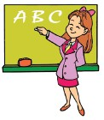
( )2.
A.  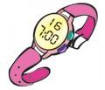 | B.   | C.  
( )3.
A.   | B.  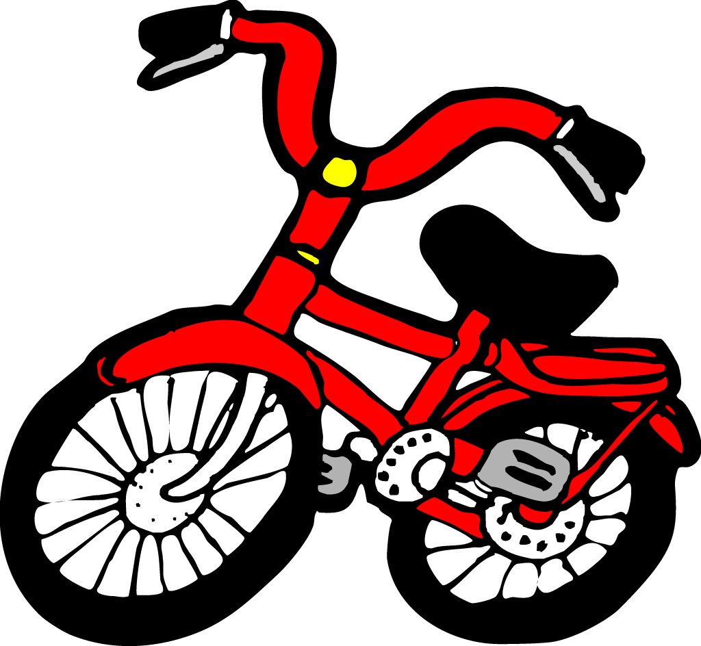 | C.  
( )4.
A.  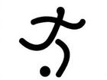 | B.  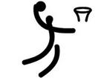 | C.  
二、听对话，根据对话的内容，从下面各题所给的A、B、C三个选项中选择最佳选项。每段对话读两遍。（共12分，每小题1分）
请听一段对话，完成第5至第6小题。
( )5. Where are the family going for their summer vacation?
A. Beijing. B. Taiwan. C. Sichuan.
( )6. Who does Kate want to see?
A. Her pen friend. B. Her classmate. C. Her teacher.
请听一段对话，完成第7至第8小题。
( )7.What is the woman?
A.A player. B. A salesman. C. A scientist.
( )8. Why is the woman traveling?
A. She is traveling on holidays. B. She is traveling on business.
C. She is traveling for a football match.
请听一段对话，回答第9至第10小题。
( )9.What’s wrong with Paul?
A. Headache. B. Stomached. C. Flu.
( )10.How often must he take the medicine?
A.Three times a day before meals. B.Three times a day after meals.
C.Three times a day with meals.
请听一段对话，回答第11至第13小题。
( )11. What is Mary going to do that afternoon?
A. Go to the library. B. Go swimming. C. Study in the library.
( )12.What subject is Mary good at?
A. English. B. History. C. Maths.
( )13.What is Mary going to do after she comes back from swimming?
A. Help Bob with his maths. B. Meet Bob at the school gate.
C. Meet him at his home.
请听一段对话，回答第14至第16小题。
( )14.When does this talk take place?
A. April 1. B. May 2. C. June 1.
( )15.What was the latest news on TV last night?
A. There would be a new holiday. B. People wouldn’t go to work today.
C. Nothing about the above.
( )16.What will they do after their conversation?
A. They’ll get down to having a holiday. B. They’ll go to work.
C. They’ll go to the boss’s home
三、听一段对话，记录关键信息。对话读两遍。（共10分，每小题2分）
Information Cards
Clubs we have: | English club, an art club, a 17 club, a basketball club, and so on
Activities we have | training classes, 18 matches and organize 19
Time and place for club activities | Every 20 afternoon at Blue Hill Stadium
How much should pay | 21 yuan for a month.

语言知识运用 （共25分）
四、单项填空（共13分，每小题1分）
( )22. —Do you know Bob?
—Sure. I know everything about ________.
A. he B. him C. his D. himself
( )23. — What time will your train leave Beijing on Sunday morning?
— ______half past seven.
A. On B. In C. To D. At
( )24. — There is ________wrong with my computer. What shall I do?
— Don’t worry. Let me help you.
A. anything B. something C. nothing D. everything
( )25. — Hi, Helen. Did you go to the dancing party last night?
— Yes. We ___________ a great time there.
A. have B. had C. will have D. are having
( )26. There was no food in the house, ______ we called for a pizza.
A. because B. or C. but D. so
( )27. — ______________ do you usually go shopping?
— On Sundays.
A. When B. How C. Why D. Where
( )28. Cars are much than before. I’m going to buy a new one.
A. cheap B. cheaper C. cheapest D. the cheapest
( )29. My uncle _____ in this town for sixty years since he left school.
A. will live B. has lived C. lived D. lives
( )30. If you ____to the Shanghai next week , I will go with you.
A. go B. has gone C. will go D. are going
( )31. —Must I return this book tomorrow?
—No, you ________. You can keep it until next week.
A. can’t B. mustn’t C. needn’t D. shouldn’t
( )32. Don’t forget ______my dictionary tomorrow morning.
A. to return B. returning C. return D. returned
( )33. Some new computers ________ to that village school last month.
A. give B. are given C. gave D. were given
( )34. — Dad, do you know ________________ now?
— In Fort Middle School.
A. where Betty is studying B. where did Betty study
C. where is Betty studying D. where Betty studied
五、完形填空（共12分，每小题1分）
It was almost 9:00 p.m. when Mia Jonson left her office to go home. It was 35 . She started her car and she 36 down the dark road that led to her house in the country. She turned on the radio and sang songs while she was driving. The heater wasn't working，and singing helped to keep her 37 .
The snow was heavy. Then Mia went across a small 38 . The bridge was covered with ice and the car went out of control. Mia hit her head on the steering wheel and lost consciousness(知觉)。
When she 39 ，she found her head was bleeding(流血)，and she was shaking from the cold. She didn't know 40 she was. Mia opened the car door and looked around. She was under the bridge，and her car was sitting on the 41 river! She felt very 42 . She knew the ice wouldn't 43 her car for very long. She 44 to walk up the hill several times，but she kept falling in the snow. Mia tried one more time. She fell again，but this time she couldn't get up. She knew that 45 could see her car under the bridge. She was lying in the snow，and she couldn't 46 . Mia closed her eyes and waited to die.
Then she heard a voice. Mia opened her eyes. There was an old man standing over her. She stood up and walked up with the help of the old man. “That' s my truck，”said the old man. “Get in and I' ll take you home.”
( )35. A. raining B. cool C. snowing D. late
( )36. A. ran B. drove C. walked D. rode
( )37. A. happy B. not alone C. warm D. not lonely
( )38. A. bridge B. village C. town D. farm
( )39. A. got up B. came back C. looked up D. woke up
( )40. A. how B. what C. why D. where
( )41. A. deep B. frozen C. wide D. cold
( )42. A. angry B. sad C. surprised D. afraid
( )43. A. keep B. pull C. take D. hold
( )44. A. tried B. wanted C. would like D. seemed
( )45. A. someone B. anyone C. everyone D. no one
( )46. A. feel B. hear C. move D. go

阅读理解（共44分）
六、阅读短文，选择最佳选项。（共26分，每小题2分）
A
The following are three ads:
Driver Wanted
- Driving license
- Good – looking
- Age :over 25
Apply (申请)to :Capes taxi ,Shenzhen
Tel:（0755)65613838
Air Hostess(空姐)Wanted
1.Age :between 20 and 33 2.Height:from 1.6 m to 1.75 m
3.Two foreign languages 4.College graduate
Apply to: China Airlines, Beijing Tel:（010)88488970
Teacher Needed
1. For private language school
2.Teaching experience necessary
Apply to: Instant languages Ltd, Dalian
Tel ：（0411)4313861

( )47.You may call when you wish to be a teacher.
A . (0755)65613838 B. (0411) 4313861 C. (010) 88488970 D. A and B
( )48.Zhang Hua ,aged 26 ,has driving licence. Which job can be given to her?
A . Driving for Capes Taxi B. Working for China Airlines.
C. Teaching at Instant Languages Ltd D. None of the above.
( )49.Which of the following is NOT mentioned in the three ads?
A. Height. B. Age. C. Language. D. Health.
B
My class will put on a short play in English at the end of the year. Yesterday our English teacher gave us copies of the play.
“Choose a character in the play that you’d like to be,” she told us. “This afternoon you learn a few lines of this part for homework. Then tomorrow you can say those lines in front of the class. I’ll decide who plays each part.”
I wanted to have one of the bigger parts in the play, so I choose the part of the king. He has a lot of lines to say. I learned them by heart.
This morning in our English lesson we had to say our lines. I acted the part of the king. When I said my lines, I put a lot of expression into my acting. I thought I acted really well.
Everyone in the class read a part and then the teacher decided who would play each part.
Many of the students in my class couldn’t act at all. They couldn’t even read without making lots of mistakes. I was sure that I would get a big part in the play.
However, the teacher gave me the part of a soldier. He has only one line. It is, “Yes, sir!”
I was very disappointed. At the end of the lesson I went up to her and asked her why I had such a small part.
“You put too much expression in your acting,” she said. “Good acting is not big acting. It is acting the audience can believe in.”
I think I know what she means.
( )50. What did the boy want to do in the play?
A. To get a small acting part. B. To organize the play
C. To get a large acting part. D. To work the lights.
( )51. How did the writer feel when he got the part of a soldier?
A. Bored. B. Sad. C. Disappointed. D. Excited.
( )52. Why didn’t the teacher give him the part of the kings?
A. He did not act correctly. B. He did not know the lines.
C. He was not handsome. D. He was too short.
C
One day, I saw a kid from my class walking home from school. His name was Kyle. It looked like he was carrying all of his books. I thought to myself, “Why would anyone bring home all his books on a Friday?” As I was walking, I saw a group of kids running toward him. They ran at him, knocking all his books out of his arms and tripping him so he landed in the dirt. His glasses went flying, and I saw them land in the grass about ten feet from him. He looked up and I saw a terrible sadness in his eyes.
My heart went out to him. So, I ran over to him as he was looking for his glasses. As I handed him his glasses, he looked at me and said, “Hey, thanks…” There was a big smile on his face. Then I asked him if he wanted to play football on Saturday with me and my friends. He said yes. Over the next four years, Kyle and I became best friends.
On Graduation Day, Kyle was giving his speech, “Graduation is a time to thank those who helped you make it through those hard years. Your parents, your teachers, your siblings (兄弟姐妹), maybe a coach… but mostly your friends. I’m going to tell you a story…”
I didn’t believe my ears to hear his story of the first day we met. He had planned to kill himself over the weekend.
I heard the gasp (喘气) at his words. I saw Kyle’s mom and dad looking at me and smiling that same grateful smile. Not until that moment did I realize it’s depth.
( )53.The underline word“tripping” here means ______in Chinese.
A.绊倒 Ｂ.跑开 C.挡路 D.指责
( )54.The writer helped Kyle to ___ that day.
A. carry his books B. look for his glasses C. get up from the floor D. look for those kids
( )55.How did the writer know Kyle’s story?
A. Kyle’s parents told him. B. Kyle’s teacher told him.
C. Kyle told on Graduation Day. D. Kyle’s other friends told him.
D
Some time ago scientists and doctors believed that babies started learning at a later age. But today’s research shows that this is not true. Experts say that babies start learning from their birth, and even before that.
Babies are influenced by the world around them. The first method of communicating with the outside world is smiling and crying. They smile when their mother does something that a baby likes. They cry when they feel unpleasant or want something.
Babies learn even before they are born. They recognize new sounds when they are still in their mother’s womb. Researchers from the Netherlands found out that unborn babies can remember sounds. They played sounds to babies and watched their movements. They realized that the older unborn babies got the longer they were able to remember sounds.
Above all , mothers can influence how a baby develops in the first year after birth. American researchers studied about 1000 babies and mothers for three years. They found out that a mother’s health influenced the intelligence of children a lot. Children of women who suffered from depression（沮丧）did worse in intelligence tests than those children of happy mothers. Such children also showed more problems when communicating with people.
A baby’s weight at birth may also influence its intelligence. Doctors have found out that babies who did not weigh that much at birth are more likely to have physical and mental problems. 500 youngsters who weighed less than 2 kg at birth were tested in the past years. Results show that they did not do as well in movement and mental tests than babies who had a normal weight.
The first three years of a child’s development is most important when it comes to communication and language learning. The brain develops rapidly during this time. When a child sees things and hears sounds of many people it repeats them often. Children that do not develop language skills during this period may have problems when they get older.
At six months babies make sounds in their native language, after a year they are often able to say a few words. By the age of two they can create simple sentences. By the age of four the number of words a child can understand quickly increases and by the age of 5 it can understand some of the rules of its language.
Generally, parents who care for their child more and help develop language skills before they start school do better at school.
( )56. What is the first method of communicating with the outside world?
A. smiling and crying. B. Reapt many sounds of people.
C. Recognize new sounds. D.Say a few words.
( )57. What can we learn from the passage?
A. Babies start learning from their birth.
B. Morther’s health influence the baby’s weight at birth.
C. Babies start language learning in the first year after birth.
D. When babies are still in their mother’s womb ,they can remember sounds.
( )58.What can be the best title for the passage?
A. Babies Develop Better When They Are Cared For B. Babies Learn Even Before They Are Born
C. How To Develop Babies’ Language Skill D. The Best Time To Start Babies’ Learning
( )59. What is the writer’s purpose in writing the passage?
A. To tell the true that babies start learning from their birth, and even before that.
B. To suggest parents to helping their babies develop language skill before they start school.
C. To explain why mothers’ health influence their babies.
D. To tell parents that babies develop better when they are cared for.
七、阅读短文，还原句子。（共8分，每小题2分）
A. At the same time, you must choose the teachers.
B. But in China you have no right to select your course and your teacher.
C. How to buy the textbook makes each student feel hard.
D. But in China you need to put up your hands and answer teacher’s question.
E. In class, discussing is very important.
There are many different between Chinese and American in the school or in the classroom. At the beginning of the term, students must select their course and teachers. 60 Selecting is very important for your grades. So at the first term, don’t select too many courses, or you will feel very nervous and it may influence your study. You have to ask for some syllabus（大纲). There is some information about subjects, time arranging, marks and textbooks. 61 Different teachers have different teaching methods. If the teacher is called “killer” by the last grade, many students will give up choosing him. Because this kind of teacher will leave too much homework, too many exams and give too low grades.
There is another problem after you select the course and the teacher. 62 The textbooks in America are very expensive. Each copy is about $30-50. In order to save money, many students buy some used textbooks, and some students usually borrow textbooks from the school library. You must get enough ready before the class. 63 The teacher encourages student to ask questions or show your own opinions. They don’t usually ask you to sit well. Instead, they allow you to sit or stand everywhere you like. They don’t give you homework to do. You can learn some knowledge and exercise by yourself. So in America, all things you must do by yourself.
八、阅读与表达。（共10分，每小题2分）
I love to write! Even since I was a little girl, I wrote stories on my notebooks and on little scripes of paper. I told stories to my friends. As a grown-up, I have written over 100 books! That’s a lot! As a teacher, it’s my goal to encourage all of my students to love to write.
Writing is easy if you’re careful enough, I told them. Everyone I meet is a possible character. Everything I see or I do is a possible scence in a book. Start looking around you. You’ll be amazed at what you discover.
Anyone can be a writer. You just put your pencil on your paper and write what you like to read, step by step.
* Creat great characters. If you know your characters well, they’ll write the story for you.
*Interest the reader right at the beginning. You can start your stories with dialogue or action. If you can make the reader ask questions, then he has to keep reading to find out the answers.
*Following the steps. The steps for every story is almost the same: Introduce the characters and the conflict(冲突); things get worse; all seem lost; the hero saves the day!
*Blance is the key.Remember, when writing, it never hurts to add a little humor.
64. Can anyone be an author in the writer’s mind?
___________________________________________________________________________________________
65.When did the writer start to write?
___________________________________________________________________________________________
66. What’s her goal as a teacher?
___________________________________________________________________________________________
67.How to begin in a story according to the writer?
___________________________________________________________________________________________
68.What’s the last step of writing a story according to the passage?
___________________________________________________________________________________________

书面表达（共25分）
九、完成句子。（共10分，每小题2分）
- 我想参加今年的夏令营。 I _________________________ join the summer camp this year.
- 我们不但要学习，还要践行北京精神。
We should learn practice the Spirit of Beijing.
- 健康的生活方式对于每一个人都很重要。
everyone live in a healthy way．
- 我们很高兴能用我们的业余时间为困难中的人们做点事。
We____________ we can ____________________________ for the people in need in our spare time.
- 营地太远了，我们走了两天才到哪里。
The camp is there.
十、文段表达。（15分）
74. 假设你是某学生杂志社的编辑Diana。收到了读者Steve的一封来信，信中倾诉了他目前的烦恼。请根
据提示内容，给Steve写一封回信。
要求：1. 词数：60词以上。
2. 开头和结尾已给出，不计入总词数。
3. 文章必须包含以下提示的三方面内容，行文连贯，可适当发挥。
与人交流 | be active , group work，express ideas, talk with…
参加活动 | class activities…
表达善意 | ……
Dear Diana,
I just came to a new school. And I can’t get on well with my new classmates…What should I do?
Steve

Dear Steve,
I’ve learned about your problems. I think_____________________________________________________
___________________________________________________________________________________________
___________________________________________________________________________________________
___________________________________________________________________________________________
___________________________________________________________________________________________
___________________________________________________________________________________________
___________________________________________________________________________________________
Best Wishes
Diana

