15、北京市昌平区2012年初三一模试卷（英语）

听力理解 (共26分)
一、听对话，选择与对话内容相符的图片。每段对话读两遍。（共4分，每小题1分）
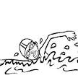
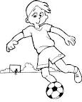
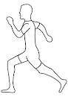
( )1.

A B C
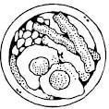
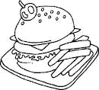
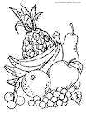
( )2.

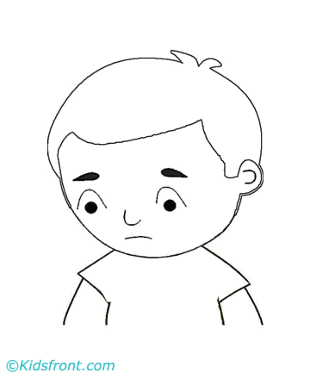
A B C

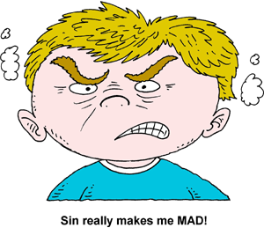
( )3.

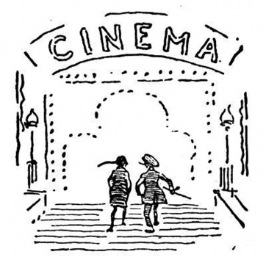
A B C
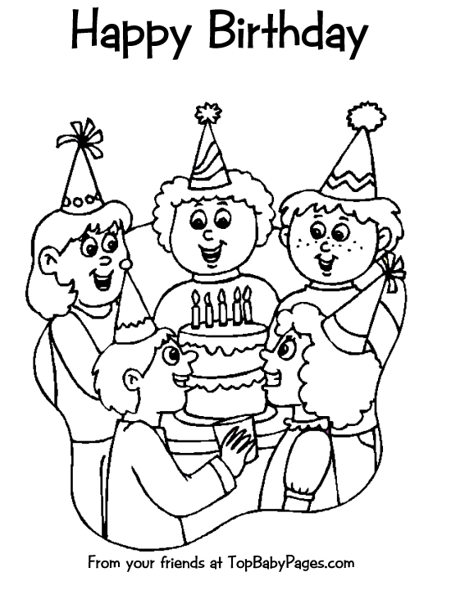
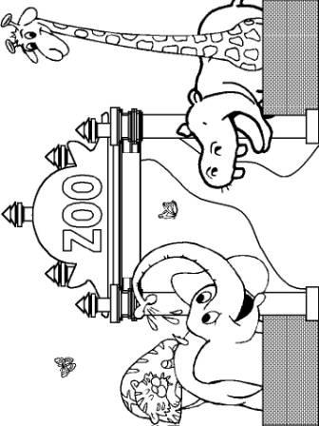
( )4.

A B C
二、听对话，根据对话的内容，选择正确答案。每段对话或独白读两遍。（共12分，每小题1分）
请听一段对话，完成5—6小题。
( )5.Where’re they going tomorrow?
A. The Bank. B. The Park. C. The Shop.
( )6. What’ll the weather be tomorrow?
A. Sunny. B. Rainy. C. Windy.
请听一段对话，完成7—8小题。
( )7. What’re they talking about?
A. Books. B. Poems. C. Hobbies.
( )8. Who likes reading short stories?
A. David. B. Cindy. C. Dickens.
请听一段对话，完成9—10小题。
( )9. Why is the woman NOT going to Shanghai at last?
A. Because it’s too crowded. B. Because it’s too hot. C. Because it’s too big.
( )10. How did the man go to Suzhou?
A. By plane and ship. B. By plane and train. C. By train and ship.
请听一段对话，完成11-13小题。
( )11. Who thinks the life of an adult is better?
A. Peter. B. Amy. C. Betty.
( )12. What’s the exciting thing for Amy?
A. Going to work. B. Watching TV. C. Seeing friends.
( )13. What problem don’t they mention?
A. The school work is very difficult. B. All students have to do homework.
C. Adults have to look after children.
请听一段独白，完成14-16小题。

( )14. What’s the city of Mayapan like?
A. Old and small. B. New and big. C. Old and big.
( )15. How was the city lost at last?
A. People moved out and the jungle took the place. B. People planted trees and made it into a jungle.
C. People killed themselves to keep the gods happy.
( )16. Which of the following can be inferred?
A. Mayapan was a city famous of houses. B. Mayan people were famous of invention.
C. Mayan people were famous of old cities.
三、听对话，记录关键信息。对话读两遍。（共10分，每小题2分）
Shopping List
Money to take with: (17)
Place to go: Hongguang (18)_____________
Things to buy: some (19) a box of (20) __________
(21) ______________ for the fish

语言知识运用 (共25分)
四、选择填空 （共13分，每小题1分） 从下列各题所给的A、B、C、D四个选项中，选择最佳选项。
( )22. Yao Ming is my favorite star. Do you like _________?
A. she B. her C. he D. him
( )23. Daming is in the hospital ________ his father is ill.
A. because B. but C. and D. or
( )24. There’re some beautiful flowers _________ our classroom.
A. on B. in C. at D. of
( )25. Excuse me, can I sit here?
Of course you ________.
A. may B. should C. can D. must
( )26. Linda is much ________ than Tom.
A. tall B. taller C. tallest D. the tallest
( )27. Have you read _______ English stories?
A. any B. some C. few D. many
( )28. Our teacher often tells us ________ more books in English.
A. read B. to read C. reading D. reads
( )29. We _______ a good time last weekend.
A. had B. have C. will have D. have had
( )30. Keep quiet! The children _________________.
A. slept B. have slept C. had slept D. are sleeping
( )31. If I have a dream, I _______ working on it seriously.
A. keep B. kept C. will keep D. keeping
( )32. This interesting story _________ by Alice last year.
A. was written B. is written C. was writing D. is writing
( )33. It’s important for us __________ more ways than knowledge itself.
A. learn B. learning C. to learn D. learned
( )34. Can you show me _____________________?
A. where was the book B. where the book was C. where is the book D. where the book is
五、完形填空 （共12分，每小题1分）阅读下面的短文，掌握其大意，然后从短文后各题所给的A、B、C、D四个选项中，选择最佳选项。
One Saturday afternoon, my daughter Alice asked me, “Are all people the same even if they are different in color?”
I thought for a minute, and then I said, “I’ll explain to you if we can make a quick 35 at the grocery store. I have something 36 to show you. ”
At the grocery store, we 37 some apples --- red, green and yellow ones. Back home, I told Alice, “It’s time to answer your question.” I put one apple of each 38 on the table. Then I looked at Alice, who had a 39 look on her face.
“People are like apples. They come in all 40 colors, shapes and sizes. Some of the apples may not even look as the others. ” As I was talking, Alice was 41 each one carefully.
Then, I took each of the apples and peeled（削皮）them, placing them back on the table, but 42 a different place.
“Okay, Alice, tell me which is which.”
She said, “That’s difficult. They all look the same now. ” “Take a bite of 43 .See if that helps you 44 which one is which. ”
She thought for a while and a huge smile came across her face. “People are just like apples! They are all different, but once you 45 the outside, they’re pretty much the same on the inside. ”
She totally 46 it. I didn’t need to say or do anything else.
( )35. A. stop B. start C. turn D. stay
( )36. A. expressive B. interesting C. informative D. encouraging
( )37. A. bought B. counted C. saw D. collected
( )38. A. size B. shape C. kind D. group
( )39. A. worried B. confident C. proud D. strange
( )40. A. proper B. special C. different D. similar
( )41. A. operating B. examining C. appreciating D. respecting
( )42. A. on B. toward C. for D. in
( )43. A. each one B. each other C. the other D. one another
( )44. A. believe B. decide C. consider D. connect
( )45. A. put away B. get down C. hand out D. take off
( )46. A. made B. took C. got D. did

阅读理解 (共44分)
六、阅读下面四篇短文，根据短文内容，从短文后各题所给选项中选最佳选项。（共26分，每小题2分）
A
Smokehouse Breakfast Menu
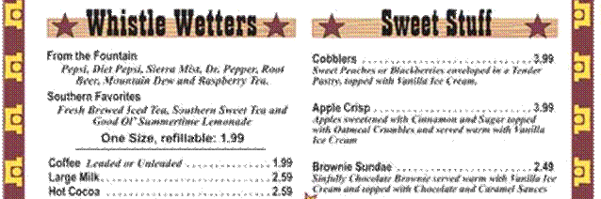
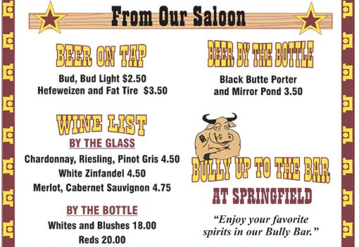
From the Fountain
Pepsi, Diet Pepsi, Sierra Mist, Dr. Pepper, Root
Beer, Mountain Dew and Raspberry Tea
Southern Favorites
Fresh Brewed Leed Tea, Southern Sweet Tea and
Good OL’ Summertime Lemonade
One Size, refillable: 1.99
Coffee………………………………………..1.99
Large Milk…………………………………..2.59
Hot Cocoa…………………………………...2.59
Cobblers…………………………………..3.99
Sweet Peaches or Blackberries enveloped in a Tender Pastry, topped with Vanilla Ice Cream
Apple Crisp………………………………..3.99
Apples sweetened with Cinnamon and Sugar topped With Oatmeal Crumbles and served warm with Vanilla Ice Cream
Brownie Sundae…………………………..2.49
Sinfully Chocolate Brownie served warm with Vanilla Ice Cream and topped with Chocolate and Caramel Sauces

( )47. How much is Hot Cocoa?
A. $ 2.49. B. $ 4.75. C. $ 3.29. D. $ 2.59.
( )48. Which of the following is Sweet Stuff?
A. Bud Light. B. Apple Crisp. C. Coffee. D. Reds.
( )49. How do people drink Pinot Gris?
A. By the cup. B. By the bottle. C. By the glass. D. By the bowl.
B
Freedom means many things to many people. When we spoke to some children in the age group of 8 to 12, we were amazed to learn the different meanings they gave to that one word “freedom”.
Here they put their ideas exactly the way their thoughts arose in their minds…
 | “I don’t have to study. There’s no homework over the weekend and on vacation.”  “Being able to watch my favorite channel Star Plus,Cartoon Network whenever I like.”  “Eating as many ice creams as I want.”[  “Going for school tours. Only 4th and 5th class students go for tours. We 3rd class students are not allowed.”  “Not getting up early in the morning.”
Radhika Jain (8 years)
“Doing what I like but should be right …”  “I will never do anything bad against rules like corruption.”  “I won’t go against the government rules only of the rules are right. Out of 100 percent if 80 percent say a rule is bad then it is bad.” |  |  | 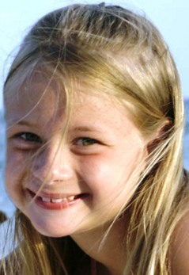
 |  |  | Saloni (11 years)
 |  | “We can do anything we want, like not going to school.”  “Everything should be free. We should not pay money to buy anything.”  “Can go anywhere I want … to the playground when exams are on.”  “Chatting on phone with classmates or friends as long as I want.”  “In school being able to play sports and not study.”  “Flying kites.”
Arihant Jain (12 years)
( )50. What does Radhika want for freedom?
A. Studying at home. B. Doing homework.
C. Going sightseeing. D. Eating more ice creams.
( )51. From the passage we know _____ don’t want to study.
A.Radhika Jain, Arihant Jain and Saloni B.Arihant Jain and Saloni
C.Radhika Jain and Arihant Jain D.Saloni and Radhika Jain
( )52. What might be the best title for the passage?
A.Speaking for All Yourselves B.Different Ideas about Freedom
C.Freedom Is Everything You Like D.What Are You Thinking about
C
The number one game in the app chart Draw Something has been sold out.
The drawing game by company OMGPOP is now top spot in the Apple and Android charts in 84 countries.
US company Zynga is reported to have paid $200m (£120m) for the app.
Players draw pictures on their mobiles competing against each other, guessing what the pictures are from drawing clues.
Head of Zynga Mark Pincus said once: "The OMGPOP team has created a game that's fun and expressive."
The app has become such a big hit in the gaming world in the last few weeks. It has knocked off long running Zynga titles Words with Friends and Cityville from top spots in the mobile apps charts.
Industry tracker App Data reported that 13.3 million people a day used Draw Something.
It wasn't overnight success for OMGPOP, the New York based developer started in 2009 and created 35 other social games before hitting the gaming jackpot.
The story is similar to that of Angry Birds, the most popular game ever on a smartphone. Creators Rovio developed 51 games before finally making it big.
Draw Something is now the most downloaded game on Facebook and players draw a total of a billion pictures each week.
( )53. Which of the following is NOT a game according to the passage?
A. Cityville. B. Angry Birds. C. Words with Friends. D. OMGPOP.
( )54. Why is Draw Something so popular?
A. It’s exciting and funny. B. It’s interesting and creative.
C. It’s an overnight success. D. It’s similar to other games.
( )55. What can be inferred from the passage?
A. Angry Birds was successful because of the creators’ hard work.
B. Draw Something was successful because of the creative idea.
C. Players like Draw Something because they like drawing.
D. The OMGPOP team is the strongest game team in USA.
D
Spending time online is normal behavior for teenagers. But too much Internet use by teens – or too little, for that matter – might be related to depression (抑郁), a new study finds.
The findings, reported in the Journal of Pediatrics, do not mean that the Internet is to blame. For one, teens in the study who spent no time online were also at increased risk of depression symptoms (症状). Instead, the researchers say that both heavy Internet use, and non–use, could show that a teenager is having a hard time.
For the study, Dr. Pierre – Andre Michaud and his colleagues at the University of Lausanne, Switzerland, surveyed 7, 200 individuals ages 16 to 20 about their Internet use.
Those who were online more than two hours per day were considered “heavy” Internet users, while those online anywhere from several times per week to two hours per day were considered “regular” users.
The teenagers also answered a number of health – related questions, including some standard questions about “depressive tendencies” (抑郁倾向) that show how often a person feels sad or hopeless. Compared with regular Internet users, the study found, kids who were heavy users or non – users were more likely to be depressed or very depressed.
Among boys, heavy users and non – users were both around one–third more likely to have a high depression score, compared to “regular” users. Among girls, heavy Internet users had an 86 percent greater chance of depression, while non–users had a 46 percent compared to regular users.
Since teenagers typically go online to connect with friends. The researches find that those who are never online may be more socially isolated.
( )56. Which is TRUE according to the passage?
A.Teenagers never go online are good students. B.Teenagers never go online may get depression.
C.Surfing the Internet for teenagers is bad behavior. D.Internet is the reason of teenager’s depression.
( )57. How long does the writer suggest teens to go online per week?
A.Less than 14 hours. B.More than 14 hours.
C.More than 20 hours. D.Less than 20 hours.
( )58. The purpose of Dr. Michaud and colleagues’ study is to know ______________.
A.the actual time of teenagers learning online B.the actual number of teenagers playing online
C.the influence on school study about teenagers online
D.the relationship between Internet use and depression
( )59. What’s the meaning of the word isolated in the last paragraph?
A. Independent. B. United. C. Separate D. Humorous.
七、阅读短文，根据短文内容，从短文后的五个选项中选出能填入空白处的最佳选项。选项中有一项为多余选项。（共8分，每小题2分）
Eating too much food makes you fat and this is very bad for your heart. There are two things to do. 60 .
Eat food with proteins and vitamins. Fish and meat have a lot of protein in them. Fruit and vegetables have lots of vitamins. You need to eat some fat but don’t eat too much. 61 . Also drink lots of water or fruit juice. Don’t drink too much coca cola because it’s bad for your teeth!
Do some anaerobic exercise every day. 62 . The important thing is to keep moving until you breathe quickly and your heart beats fast. The heart gets stronger when it works hard. This helps your blood go around your body better. 63 . Smoking is bad for your heart, and your health.
A. Because it’s not good for your heart B. You can go swimming or do walking
C. Eat healthily and take lots of exercise D. Second, do as much exercise as you can
E. Finally, don’t smoke if you want to be fit
八、阅读短文，根据短文内容回答问题。（共10分，每小题2分）
Have you ever been in a rainforest? There aren’t any in Europe but there are some in Africa, Asia and South America. I was in a rainforest once. It was hot and dark. It was also very wet. Water was falling from the leaves of the trees like rain. The ground was covered with dead leaves but there were thousands of new plants growing.
The most exciting plants were the large trees. Some were 50 meters high. I could only see little pieces of blue sky through the leaves. All the trees had small plants growing on them, and some of these had beautiful, brightly colored flowers.
It was very noisy. I could hear lots of birds. They were hard to see but I saw one green and red parrot flying high above me. It was beautiful. The insects(昆虫) also made a lot of noise and I could feel them on my arms and legs.
I didn’t see any monkeys. They were probably sleeping high up in the treetops. I did see a small snake on the ground. I hate snakes so I walked quickly but carefully out of the forest.
I wouldn’t like to live in a rainforest but I am happy that I could see one before they all disappear from Earth.

64. Has the writer been to a real rainforest?
___________________________________________________________________________________________
65. Were there many leaves or flowers on the ground?
___________________________________________________________________________________________
66. What did the writer see above his head?
___________________________________________________________________________________________
67. Why did the writer walk quickly and carefully out of the forest?
___________________________________________________________________________________________
68. How does the writer think of rainforests?
___________________________________________________________________________________________

书面表达 （共25分）
九、完成句子 （共10分，每小题2分）根据中文意思完成句子。
69. 你的腿怎么了？让我看看。___________________ your leg? Let me see.
70. 英语老师对我们很好，而且她的课很有意思, 我们都喜欢她。
My English teacher is friendly to us and her lesson is_____________interesting___________we all like her.
71. 去年夏天，我在一所美国学校学习英语。那里和我们的学校一点都不一样。
I studied in an American English school last summer. It_____________like our school_______________.
72. 彼得上个月花很多钱买了一辆新车。
Peter______________________________ his new car last month.
73. 妈妈经常说学习不是别人的事。如果我多读，不怕出错，她认为我肯定会成为英语能手。
My mother often says study has nothing to do with others. __________________________________.
十、文段表达 （共15分）
74. 请阅读小明的英国笔友Mike发来的电子邮件，以小明的身份，写一封不少于60词的回信。请不要使用真实姓名。信的开头和结尾已经给出（开头和结尾不计词数）。
Xiaoming@yahoo.com.cn
Mike@yahoo.com

Hi Xiaoming,
How have you been? Are you still busy with your school work?
My school is having a drawing competition now. We’re asked to draw about the earth in 2050. There’re 2 pictures drawn by my classmates in the attachment. I want to ask your opinions on them. Which one do you think it would be like in 2050? And why do you think so?
Look forward to your ideas.
All the best,
Mike

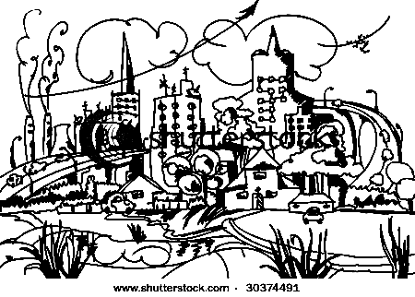
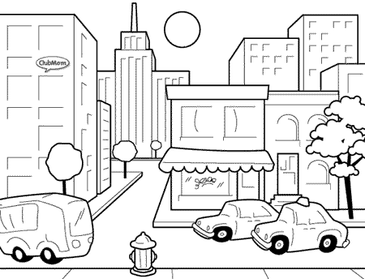
Picture A Picture B
Hi Mike,
Thanks for your email and sending me the pictures.
___________________________________________________________________________________________
___________________________________________________________________________________________
___________________________________________________________________________________________
Best wishes,
Xiaoming

