07、北京市朝阳区2012年初三一模试卷（英语）

听力理解（共26分）
一、听对话，从下面各题所给的A、B、C三幅图片中选择与对话内容相符的图片。每段对话读两遍。（共
4分，每小题1分）
( )1.
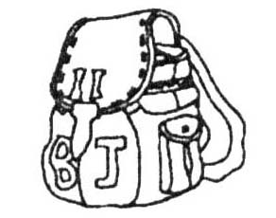 | 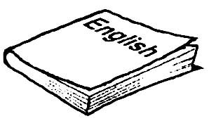 | 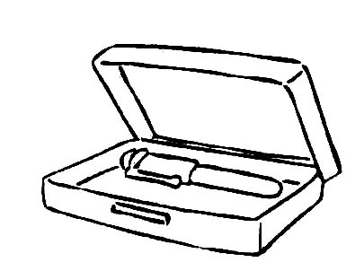
A. B. C.
( )2.
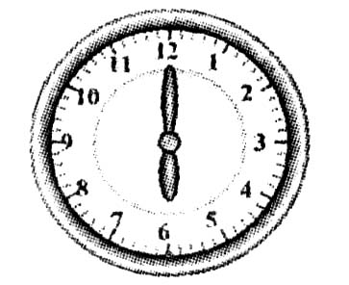 | 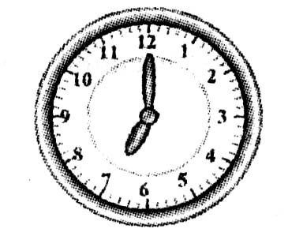 | 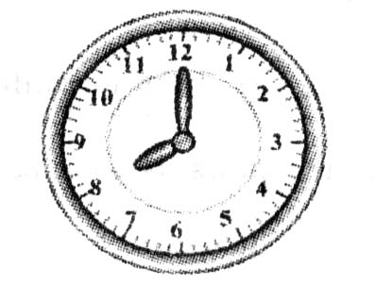
A. B. C.
( )3.
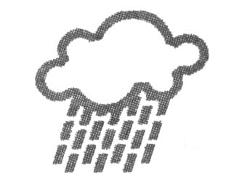 | 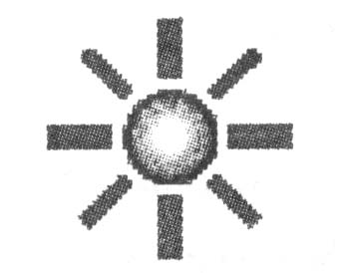 | 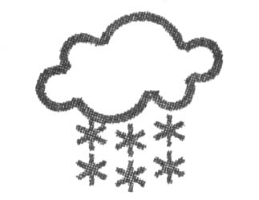
A. B. C.
( )4.
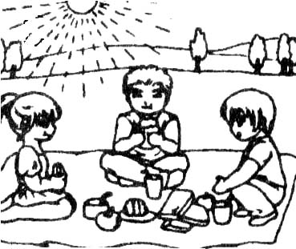 | 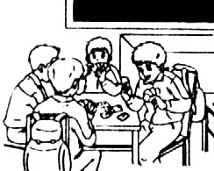 | 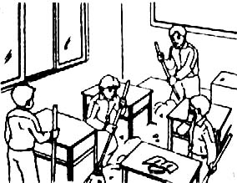
A. B. C.
二、听对话或独白，根据对话或独白内容，从下面各题所给的A、B、C三个选项中选择最佳选项。每段对话或独白读两遍。（共12分，每小题1分）
请听一段对话，完成第5和第6小题。
( )5. Which subject is Jenny good at?
A. Chinese. B. English. C. Maths.
( )6. Where are the two speakers now?
A. In the school. B. In the hospital. C. In the street.
请听一段对话，完成第7和第8小题。
( )7. Who is Sarah?
A. Mrs. Black’s friend． B. Mrs. Black’s sister. C. Mrs. Black’s daughter．
( )8. What happened to Sarah?
A. She was ill． B. She got lost． C. She lost her phone．
请听一段对话，完成第9和第10小题。
( )9. How often does Jack go running?
A. Every day． B. Once a week． C. Twice a week．
( )10. What will the woman do this afternoon?
A. Play table tennis． B. Meet a friend． C. Do some housework.
请听一段对话，完成第11至第13小题。
( )11. Who does the man visit art exhibitions (艺术展) with?
A. His friend. B. His parents. C. His wife.
( )12. What’s the conversation mainly about?
A. The man’s family. B. The man’s holiday. C. The man’s plan.
( )13. What can we learn about the man’s wife?
A. She likes art very much. B. She likes traveling abroad. C. She enjoys taking pictures.
请听一段独白，完成第14至第16小题。
( )14. What will the volunteers do in the Blue Mountains this Sunday?
A. They are going to plant trees. B. They are going to pick apples.C. They are going to have a picnic.
( )15. What does Helen think of the activity?
A. It’s difficult for students. B. It’s interesting for children. C. It’s helpful to young people.
( )16. What is Helen mainly doing now?
A. Setting up groups. B. Starting an activity. C. Leading a discussion.
三、听对话，根据所听到的对话内容和卡片上的提示词语，将所缺的关键信息填写在答题纸的相应位置上。对话读两遍。（共10分，每小题2分）

Interview Information
Name | Carter Brown
Phone Number | 17.
Languages | 18. English, , French
Working Skills | 19. using a , driving a car, cooking
Working Experience | 20. work as a in a big restaurant
Working Time | 21. every day except

知识运用（共25分）
四、单项填空 （共13分，每小题1分）
( )22. John is in trouble now. Let’s go and help .
A. him B. his C. her D. hers
( )23. I was born May 14. What about you?
A. at B. in C. on D. for
( )24. Hurry up, you will be late for school.
A. so B. or C. and D. but
( )25. — do you usually go to visit your grandmother?
—By bus.
A. How B. When C. Where D. Why
( )26. —Who is in your school, Mr. Wang, Mr. Gao or Miss Li?
—Miss Li, of course.
A. popular B. more popular C. most popular D. the most popular
( )27. There’s in the meeting room. Shall we have a talk there?
A. somebody B. anybody C. nobody D. everybody
( )28. —Must I answer the question in English?
—No, you . You can answer it in Chinese.
A. shouldn’t B. can’t C. mustn’t D. needn’t
( )29. —Have you seen Mr. Smith?
—Yes. Look, he the flowers in the garden.
A. waters B. is watering C. watered D. has watered
( )30. —My sister is ill in hospital.
—I’m sorry that.
A. hear B. heard C. to hear D. hearing
( )31. Rose English since 2002. She’s got a lot of teaching experience.
A. has taught B. will teach C. teaches D. taught
( )32. Mr. Green his lessons when I went into his office.
A. prepares B. prepared C. is preparing D. was preparing
( )33. A park here next year. Then people nearby can come for a walk.
A. will build B. will be built C. has built D. was built
( )33. —Lisa, could you tell me last night?
—Oh, I went to the cinema.
A. where you wen B. where did you go C. where you will go D. where will you go
五、完形填空（共12分，每小题1分）阅读下面的短文，选择最佳选项。
It was a very cold night, Sunday, February 6. Patrick heard his dog barking (狗叫声) in the garage (车库).He went there with some food to 35 it down. Standing in the middle of the garage was a little girl with her body covered by snow, crying. “Please come and help,” she said. “I think my mom is dead. My brother is in the truck.”
After a dinner of pizza at her mother’s house in Alton, Carrion, 26, had bundled (捆绑) her 36 kids, Averie, four, and Abel, 21 months, into a pickup truck and 37 home. It was 8 p.m., snow covered the land. 38 cars were on the road. Suddenly, the truck began to slide (滑动). It rolled (转动) two or three times before 39 to a stop, tilted into a snow bank on its passenger side. Carrion blacked out. “When I came to, I could hear Abel crying. It was dark, and I couldn’t see anything,” Carrion says. Finally, she 40 to push the heavy driver’s door open enough so that the lights turned on. She saw Abel in his seat. His nose was bloody, but he had no other hurts. Averie was nowhere in sight. Carrion called Averie again and again. But there was only 41 . Then she called 9-1-1.
Averie had been awake when the truck stopped rolling. The little girl called her mother, but she didn’t answer. Averie wriggled (蠕动) 42 the broken passenger’s window. She walked a quarter of a mile. A house came into view, she stumbled (蹒跚) out of the snow and into the 43 garage, and a dog started barking. When she got Patrick’s help, she began to 44 . Patrick jumped into his car and went to search for the 45 . Up ahead he saw the lights of police cars. “I think I have who you’re looking for,” Patrick told the police.
One thing Carrion is sure of: her daughter’s courage and personality. “Averie is very grown-up for her 46 ,” she says. “The way she walked all that way to help us… She’s so smart, so brave.”
( )35. A. turn B. put C. quiet D. slow
( )36. A. sleepy B. tired C. shy D. weak
( )37. A. left B. passed C. got D. headed
( )38. A. Many B. Several C. Some D. Few
( )39. A. coming B. going C. running D. returning
( )40. A. managed B. tried C. started D. decided
( )41. A. snow B. cold C. silence D. dark
( )42. A. around B. through C. from D. across
( )43. A. safe B. empty C. warm D. open
( )44. A. cheer B. cry C. relax D. explain
( )45. A. accident B. place C. police D. doctor
( )46. A. ability B. knowledge C. age D. experience

阅读理解（共44分）
六、阅读下列短文，根据短文内容，从短文后各题所给的A、B、C、D四个选项中，选择最佳选项。（共
26分，每小题2分）
A
What do you think is important in your life? Here are some ideas for you to share.
Enjoy every moment of today. If it’s important to you, then do it today. Don’t put off your dreams. Pay attention to what is happening now, to the people around you, to the task at hand and to all of the choices you make today. Our future is set by what we decide and act on today.
Davy, the US

Money is important. We all have bills to pay and I understand that completely. But in the end, or even in the middle, maybe especially in the middle, money is not the end goal. It can’t always bring you happiness though it allows you to eat, dress and live.
Alice, Australia

We have so much to do, so much to finish and it feels as though we have to be in a hurry to get there. You do not have to do it all at once. Slow down and take one thing at a time. Yes, make plans, but don’t be in such a rush.
Noah, Japan

Look for the good in people, work and everywhere. Celebrate the happy moments, small or big. Be helpful whenever possible. Don’t let difficulties color your experience. If you look at the world through the lens (镜头) of goodness, then you will find life much more enjoyable.
Austin, Germany
( )47. Where does Davy come from?
A. The US. B. Australia. C. Japan. D. Germany.
( )48. Who tells us to take one thing at a time?
A. Davy. B. Alice. C. Noah. D. Austin.
( )49. What is Austin’s idea?
A. Making a plan is important. B. Money is important but not all.
C. Always looking for the good. D. Actions speaks louder than words.
B
Ever get the feeling that time goes by faster as you get older? I remember when I was nine, the whole year seemed to step by so slowly. School took a long time to end each day and let’s not talk about exams. I thought I’d never turn double 10.
Now in my thirties, it’s like someone’s hit the accelerator pedal (加速踏板) and these years are going by much faster. It’s 2012 and I’m wondering what happened to the last 12 months! It feels like I sneezed (打喷嚏) in January 2011 and that’s blown me into January 2012.
I’m looking at my 2011 To-Do List and I’ve only done one thing—read 20 new books. I feel sad and regret not spending enough time on the other things. Back to my 2012 list of things that I would like to do the next 12 months: ① Interview the president ② Have a trip to Africa ③ Board the fastest plane ④ Write a book
No. 1, 2 and 4 have been on the list for ten years. I don’t know when they’ll be done. But it’s really fun to make a list at the start of the year.
( )50. What does the writer feel about the time in these years?
A. It goes very slowly. B. It goes much faster.
C. It seems to have stopped. D. It seems as fast as before.
( )51. The writer feels sad when she looks at her 2011 list because ______.
A. she hasn’t finished anything B. she hasn’t finished one thing
C. she has finished everything D. she has just finished one thing
( )52. What is the writer’s attitude towards No. 1, 2 and 4 on her 2012 list?
A. She will succeed in doing them. B. She isn’t going to do any of them.
C. She will try to do one of them D. She isn’t sure if they can be done.
C
When I moved to the country 20 years ago, I took a job as a school bus driver. I’d never had any interest in driving schoolchildren to and from school, but 10 years later, I was still working on the school bus.
There are so many good reasons why I stayed. Firstly, it was the conversations that brought me different kinds of information. I also got to hear all the family secrets of the newcomers who were afraid to be starting at a new school. I have a toy bear who was a great comforter for the little ones. The kids got to look after him on the trip to school and he waited patiently for them to get on for the trip home.
Our bus would often pass a place where we could see some alpacas (羊驼) in front of a farm house. Little Michael would cry excitedly from the seat, “Look, Miss! Look at the camels!” He used to put his head out of the bus window. When I warned him that a fly would come into his nose if he wasn’t careful, he smartly gave up the habit.
I remember a little girl got on the bus one morning 5 years ago and cried loudly all the way to school. We arrived at the school gate. As she waited to get down the bus stairs, she threw her arms around my neck and sobbed (抽泣) that her grandfather had died the night before.
A school bus driver needs to keep one eye on the road and the other on the mirror to watch what the little ones are doing down the back. My catchphrase (口头禅) each day was that I was “taking the monsters (怪兽) to their mothers”.
Now, it’s necessary to think how many lives I’ve been responsible for throughout the years, and how many kilometers I’ve driven in order to get my passengers home safely. I’ve enjoyed it, but after 20 years, it’s time to rest and park my school bus for good. Long live the school bus driver!
( )53. When did the writer begin to be a school bus driver?
A. 5 years ago. B. 10 years ago. C. 20 years ago. D. 30 years ago.
( )54. The writer enjoyed her job because ______.
A. driving was her hobby B. children made her valuable
C. drivers were paid well D. she liked the environment
( )55. What is the writer’s future plan?
A. She decides to give up the job. B. She tries to go on driving.
C. She wants to have a holiday. D. She hopes to have more kids.
D
Not long ago, I opened an interesting e-mail from Jennifer in Canada. We became friends. One day, she invited me and 11 other women to a “Movie Night” to be held every six weeks at her house. We’d talk, eat and watch feel-good movies. I e-mailed her back immediately: I was in.
Research shows that gatherings such as Jennifer’s make sense. In a US study, researchers measured (测量) the happiness of 4739 people over 20 years. The study found that a person’s happiness depends on the happiness of people he connects with. Surprisingly, it also found that happiness spreads not only between direct friends, but also among friends of your friends’ friends! And those good feelings seem to have the greatest influence among friends of the same sex (性别).
“People with more good friends are less likely to develop depression (情绪低落) and worry,” says Dr. Toupey Luft. “Though you can’t choose your family or workmates, you do have control over friendships.” With a little effort, you can add more positive (正面的) relationships to your social circle. Here’s how:
“Nobody is all positive or all negative,” says Luft. “But there are people you may feel more positive. Use that as your way to check people and keep records.” When spending time with others, pay attention to your feeling. Are you feeling tired and unhappy？To help you keep records, Luft suggests taking a moment when you get home to write down what your feeling is when around them.
While it’s great to gather with positive friends, it’s also good to stay with others in the same life situations. “But if you’re all just complaining (抱怨) and nothing is changing, it’s not healthy,” says Luft. Are your friends negative, or are you doing most of the complaining? Considering the answers to these questions can help you decide if you want to stand in front of them. Or you could let the relationship disappear slowly.
Sometimes your hobbies can lead to true friendships. Check out newspapers and websites to find a group or class for something you enjoy. These friends can always be there for you and can care each other through difficulties, illness and death.
Not into groups? Look for individual (个人的) communication instead. Luft says, “Set small goals, such as having coffee with one new person, and develop friendship according to a plan. If someone suggests going for lunch sometime, set a date.”
“If you’re feeling disappointed (失望) with a friend, try talking about what you both need,” says Luft. For example, tell her what you want during hard times in your lives. While your friend may need to be left alone, you may want caring phone calls. With some friends you laugh and have fun together at the movies—and that can be enough. With others, you pay attention to your deep connection.
( )56. What does your happiness depend on, according to the passage?
A. How many friends you have. B. How people you connect with feel.
C. What situation you are in now. D. What kind of friends you have.
( )57. What does the first suggestion want us to do?
A. To measure our happiness. B. To check people around.
C. To join a group for hobbies. D. To leave negative friends.
( )58. Which of the following is true?
A. All the suggestions tell us to add positive relationship to our social circle.
B. It’s necessary to complain about something but not right to do so for long.
C. Joining a group can bring better friendship than making individual friends.
D. We often have many friends during good times but few during hard times.
( )59. The underlined sentence in the last paragraph means that ______.
A. when your friend leaves you, you need comfort
B. when your friend is sad, you should call her up
C. people may behave differently during hard times
D. friends’ needs may be quite different sometimes
七、阅读短文，根据短文内容，从短文后的五个选项中选出能填入空白处的最佳选项。选项中有一项为多
余选项。（共8分，每小题2分）
I’d just got in a taxi at the railway station when suddenly I found one of my suitcases (手提箱) missing. Just then, I saw a young man, not very far, opening it and taking out valuables. “Stop thief! Stop thief!” I shouted and threw open the car door and rushed out to him, followed by the driver and some passers-by. 60 . My driver caught him by the neck and took out the valuables from his trouser pocket and put them back into my suitcase.
Half an hour later, I sat back in the taxi and breathed a sight of relief (松了一口气). But as I checked those stolen things, I became very surprised, unable to speak. 61 . And a blood test report of a 58-year-old woman appeared. I suddenly realized that the taxi driver must have mistaken the thief’s things and put his into my suitcase.
62 . But this story keeps coming back to me. Was the young man a habitual thief or a dutiful son who had been driven to find money to save his mother’s life? 63 . How I wish I had gone back that afternoon to return the money and the report and say sorry to him. For the first time in my life, I realized that hate and love are very close.
A. My heart aches for him B. Two years has passed since then
C. The train left the station very quickly D. Very soon we caught up with the thief
E. Before my eyes was 200 yuan instead of 100
八、阅读短文, 根据短文内容回答问题。(共10分，每小题2分)
If you drive in New Zealand, it is necessary for you to take a little time to learn the road rules—for your own and others’ safety. There are a few things that you might find different from driving in your country. Here’s some information to help make your driving experience in New Zealand a safe and enjoyable one.
Keep left

In New Zealand, traffic travels on the left-hand side of the road and the driver sits on the right of the car. When you are turning, you should be careful to the
left side. Remember to keep your eyes on the road ahead. It is easy to draw your attention to the beautiful parts in New Zealand.
Crossing ‘Give Way’ rule
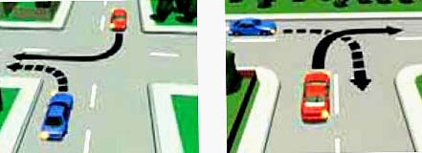
If you’re turning, give way to all cars that are not turning. In all other situations, give way to cars crossing or coming from your right.
One lane（行车道） bridges
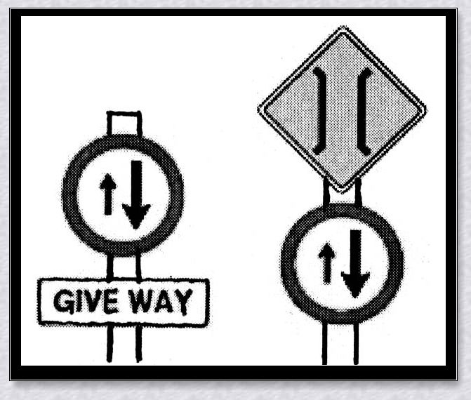
Many roads in New Zealand have one lane bridges on them. At one lane bridges, cars travelling in one direction must give way to cars going in the other direction.
Any of the signs (标志) shown in the left picture mean that you are coming to a one lane bridge. Slow down and check for traffic coming the other way. The smaller arrow shows which direction has to give way.
Animals on the road
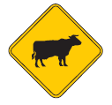
Watch out for farm animals on the road, especially in the countryside. When you see them, please slow down. You may need to stop and let the animals go past you or move slowly up behind and follow the farmer’s instructions.
Seatbelts

It is a law that all the drivers must wear their seatbelts. If you are caught not wearing your seatbelt, you will be fined.
More information
Information on road safety, including the New Zealand Road Code are available (可得到的) by going to www.nzta.govt.nz or by phoning New Zealand Transport Agency 0800 699 000 or visit aa.co.nz.
64. Does traffic travel on the left side of the road in New Zealand?
___________________________________________________________________________________________
65. What should drivers do when they see the sights in Picture 3 while driving?
___________________________________________________________________________________________
66. When do drivers need to follow the farmer’s instructions?
___________________________________________________________________________________________
67. How many road rules in New Zealand are mentioned?
___________________________________________________________________________________________
68. What does the writer want to tell us?
___________________________________________________________________________________________

书面表达（共25分）
九、完成句子（共10分，每小题2分）
69. 该上课了，我们做好准备吧。
____________________________________class. Let’s get ready for it.

70. 我很高兴，你已经赶上了班里的多数同学。
____________________________that you’ve already caught up with most of the students in our class.
71. 今晚尽可能早睡，因为明天你必须早起。
Go to bed ____________________________ this evening because you must get up early tomorrow.
72. 修理完桌椅后，我们才回家。
____________________________________________until we finished repairing the desks and chairs.
73. 为了保持健康，你不仅应该戒烟，而且应该考虑每天花点儿时间锻炼身体。
In order to keep healthy, you should_____________________________________________________taking exercise every day.
十、文段表达 (15分)
根据中文和英文提示，写一封意思连贯、符合逻辑、不少于60词的回信。信的开头和结尾已给出，其词数不计入所完成的回信内。请不要写出你的校名和姓名。
74. 假设你叫李利，是英国中学生大卫的笔友。你收到了他的来信，请你给他写一封回信，回答他的问题，并就这些问题谈谈你的认识和对学校生活的感受。
Hi! Li Li,
My teacher asks me to write a composition about school life in China. I want to know something about it. I hear your teachers are very strict with you. Is that true? How long do you have to stay at school every day? And do you have a lot of homework to do after class? How do you like your school life?
I’m looking forward to hearing from you soon.
Yours, David

Hi! David,
I’m glad to get your letter and I’d like to tell you everything.
___________________________________________________________________________________________
___________________________________________________________________________________________
___________________________________________________________________________________________
___________________________________________________________________________________________
___________________________________________________________________________________________
___________________________________________________________________________________________
___________________________________________________________________________________________
I hope what I’ve said can help you.
Yours,
Li Li,

