03、北京市西城区2012年初三一模试卷（英语）

听力理解(共26分)
一、听对话，从所给的A、B、C中选择与对话内容相符的图片。每段对话读两遍。（共4分，每小题1分）


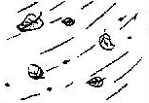
( )1.

A. B. C.
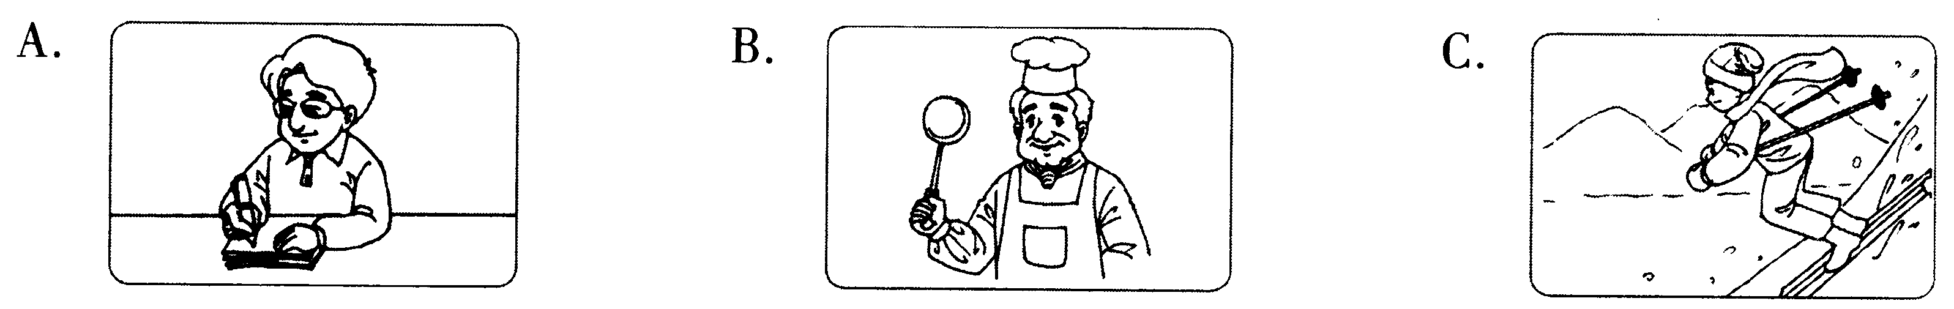
( )2.

A. B. C.
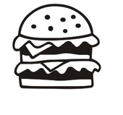
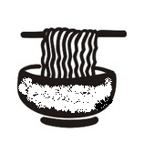
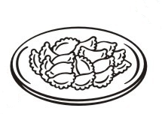
( )3.

A. B. C.
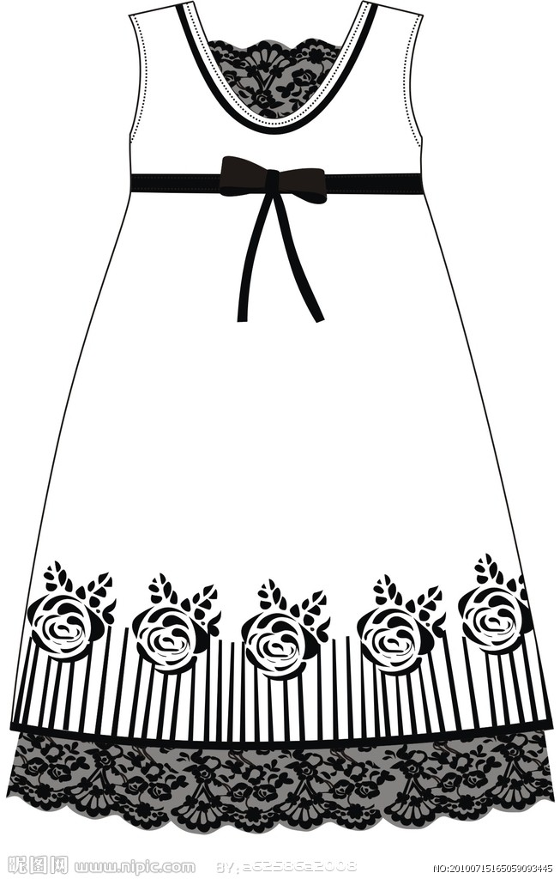


( )4.

A. B. C.
二、听对话或独白，从下面所给的A、B、C中选择最佳选项。对话或独白读两遍。（共12分，每小题1分）
请听一段对话，完成第5至6小题。
( )5.What sport did the man do last Thursday?
A. Basketball. B. Tennis. C. Swimming.
( )6.When will they go to the sports center?
A. On Sunday. B. On Thursday. C. On Saturday.
请听一段对话，完成第7至8小题。
( )7.What trouble does the girl have?
A. She has to do some cleaning at home. B. She can’t work out her math problem.
C. She has failed in her math exam again.
( )8.According to the man, what is the most important for one’s success?
A. Believing in yourself B. Keeping a cool mind. C. Being hopeful.
请听一段对话，完成第9至10小题。
( )9.Why was the woman in Canada?
A. For the Christmas holiday. B. For a research program. C. For a few parties.
( )10.What did the woman think of the Canadians she worked with?
A. They are kind and helpful. B. They are quiet and polite. C. They are busy and hardworking.
请听一段对话，完成第11至13小题。
( )11. What does the woman think of the man in the match?
A. Nervous. B. Relaxed. C. Excited.
( )12. Why does the man love ping-pong best?
A. Because his dream is to become one of the best players.
B. Because he likes trying hard in all kinds of ball games.
C. Because he enjoys the happiness ping-pong brings him.
( )13. What does the woman probably do?
A. The man’s coach. B. Another player. C. A reporter.
请听一段独白，完成第14至16小题。
( )14. What does the speaker mainly talk about?
A. The history of cola. B. The sale of cola. C. The development of soft drinks.
( )15. How was cola sold in the beginning?
A. As a soft drink. B. As a medicine. C. As cooking oil.
( )16. Why does the speaker mention John S. Pemberton?
A. Because he sold cola to doctors. B. Because he worked in a drugstore.
C. Because he invented cola as a medicine.
三、听对话，根据所听到的对话内容和提示词语，记录关键信息。对话读两遍。（共10分，每小题2分）
Car Rental (租借) Information
Length of time | 17. from Monday to ______
Make and model of car | a Ford Fiesta
Cost | 18. $______ every day
Name of customer | 19. Tom ______
Phone number | 20. ______
Pick-up time | 21. at 9 o’clock on Monday ______

知识运用（共25分）
四、单项填空（共13分，每小题1分）
( )22.— I took a lot of pictures in Africa.
— Really? Could you show ______ to me?
A. it B. their C. they D. them
( )23.— When is the Dragon Boat Festival this year?
— It’s ______ June 6.
A. at B. in C. on D. from
( )24.— Would you like some more coffee?
— Yes. Just ______. Thanks.
A. little B. few C. a little D. a few
( )25.— ______ will your father come back from New York?
— In two days.
A. How long B. How soon C. How often D. How many
( )26.— How is your daughter today?
— Thanks to the new medicine, she feels much ______ now.
A. bad B. well C. worst D. better
( )27.There ______ a library and three bookshops in the town.
A. is B. are C. be D. were
( )28.Dentists advise people ______ too many sweets.
A. to eat B. not to eat C. eating D. not eat
( )29.— Oh, I left my dictionary in your house.
— Don’t worry. I ______ it to school tomorrow.
A. will take B. take C. took D. was taking
( )30.— Your hat looks really nice.
— I ______ it in a small shop last week.
A. bought B. have bought C. will buy D. buy
( )31.— Look! The light is still on in our teacher’s office.
— Probably she ______ her work yet.
A. doesn’t finish B. didn’t finish C. hasn’t finished D. won’t finish
( )32.— Guess what? Our team won the school basketball match.
— Congratulations! You ______ be very proud.
A. can B. must C. would D. may
( )33.— Teachers often say that mistakes should ______ in time.
— I think so. It’s really good advice.
A. correct B. be correcting C. have corrected D. be corrected
( )34.— Mary, could you tell me ______?
— One for each classroom, 50 altogether.
A. how many computers did you buy B. how many computers you bought
C. where did you buy the computers D. where you bought the computers
五、完形填空（共12分，每小题1分）
Years ago, I had a role to play as Ronald McDonald. We visited the community hospitals, bringing a little happiness into a place where no one ever looks forward to going. I loved the project, and I was very proud to be able to make a 35 to those who were experiencing some “down time”.
But I was given the rule that I could not 36 anyone within the hospital. I understood why they had this rule, but I didn’t like it. I believe that touching is the most honest form of communication we will ever know. Breaking the rule, I was told, 37 I could lose my job.
One day, as I was heading down a hallway, I heard a little voice. “Ronald, Ronald.” I stopped. It was Billy, five years old, lying in his dad’s arms. I did a few magic tricks (戏法) for him. As I stepped back to say good-bye, Billy asked, “Ronald, would you 38 me?”
Such a simple request (要求). But what 39 through my mind was that if I did that, I could lose my job. So I told Billy I could not do that right now, but I suggested that he and I color a picture. Upon completing a wonderful piece of art, Billy again asked me to hold him. By this time my 40 was screaming (尖叫) “yes!” But my mind was screaming louder: “No! You are going to lose your job!”
“Hold me.”
I searched for anything 41 that would allow me to leave. I could not 42 a single one. It took me a moment to realize that losing my job may not be that bad after all. Just that if I lost my job, it probably would not be long 43 I would lose my car, then my home... But I realized that at the end of my life, the car and the house would have no 44 . Once I thought that the real reason I was there was to bring happiness to an unhappy environment, I realized that I really faced no risk (冒险) at all. So I decided to pick up Billy. We laughed and talked about the things that worried him. After I left the room, Billy said to his mom, “I don’t 45 anymore if I see Father Christmas this year because I was held by Ronald McDonald.”
Less than 48 hours later, Billy passed away. Sometimes we must do what is 46 for the moment, no matter what risks we might take.
( )35. A. choice B. living C. decision D. difference
( )36. A. push B. touch C. play with D. speak to
( )37. A. meant B. showed C. proved D. decided
( )38. A. kiss B. call C. hold D. help
( )39. A. ran B. got C. sent D. walked
( )40. A. mouth B. brain C. body D. heart
( )41. A. serious B. important C. reasonable D. creative
( )42. A. catch up with B. look up C. come up with D. run into
( )43. A. when B. after C. since D. before
( )44. A. advantage B. value C. problem D. price
( )45. A. complain B. wish C. care D. expect
( )46. A. enjoyable B. right C. possible D. useful

阅读理解（共44分）
六、阅读下列短文，从短文后各题所给的A、B、C、D中选择最佳选项。（共26分，每小题2分）
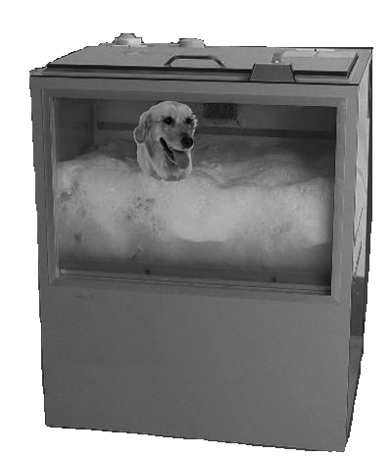
A
Japanese people are famous for their inventions. The latest time-saving invention is a dog-washing machine. Dog owners can buy one for their dogs. They can save time by putting their dogs in the machine and then 33 minutes later, out comes a clean, fresh-smelling dog.
The washing includes a shampoo (洗发), rinse (冲洗) and blow-dry. Sales of the dog-washer are increasing. The machines save a lot of money for pet owners in cleaning bills. However, it is bad news for pet hospitals because they are losing customers to the new dog washing machine.
The washing machine is very safe. Tests showed that dogs enjoyed the wash and were very happy when the blow-drier came on. The makers of the machine say it is very safe and does not harm dogs in any way.
One dog-owner, Michiko Kobayashi, loves her new machine. She said her dog was happy, too. Michiko explained to reporters, “Before I bought my washer, I only took Honey to the pet hospital a few times a year. Now, I wash her every week and she looks great. I also save a lot of money.”
( )47. The dog-washer is used to ______.
A. walk a dog B. feed a dog C. clean a dog D. catch a dog
( )48. The invention is not good news for ______.
A. dog-owners B. reporters C. machine makers D. pet hospitals
( )49. The dog-washer can help dog owners ______.
A. save time and money B. make money C. make dogs stronger D. clean the room
B
A new museum about laziness has opened in Colombia’s capital, Bogota. But, you have to hurry if you want to find out about being lazy because the show lasts for only one week.
The unusual show has displays (展品) that include things, such as sofas, beds, and anything that lets you take the weight off your feet. There are also plenty of televisions for visitors to watch while they walk around in the museum.
The museum opened soon after the holiday season. The idea is for people to think about laziness, and perhaps change their behavior and lifestyle throughout the rest of the year.
The museum’s keeper, Marcela Arrieta, said she wanted people to have a rethink about laziness and decide whether it really is a bad thing. She added, “We always think about laziness as an enemy of work.” Ms. Arrieta may not be pushing for a shorter working week, but she could have a point in that we might require more free time than our jobs allow us. Avoiding the pressure (压力) of work and relaxing more may make us healthier and live longer.
Try out her advice for yourself; take the weight off your feet, put your feet up, and think about being lazy.
( )50. Visitors can ______ in the Museum of Laziness.
A. repair sofas B. watch TV C. buy beds D. get a job
( )51. What does the underlined part mean in Paragraph 2?
A. Relax yourself. B. Become excited. C. Lose weight. D. Take off your shoes.
( )52. The museum’s keeper thinks that ______.
A. museums are good places to visit B. work is a big enemy of life
C. people should rethink about laziness D. the unusual show is very successful
C
Does it seem like everyone you know is, too busy, or tired? Do you feel like you never have time to just relax? Do you daydream about being on vacation? Well, you are not alone. Most people have too much to do, and too little time. It is not surprising that stress (压力) is a common part of everyone’s life.
We often think that a vacation will help us relax. But most of us find that after a few days back at work or school, we feel the usual stress. The question is: how can we make relaxation and leisure (休闲) time part of our daily lives? Here are some ways to reduce stress in your everyday life.
Exercise! Exercise is one of the simplest and best ways to reduce stress. When we exercise, our body produces natural relaxants into our bloodstreams. Our stress level is then reduced. If your day is stressful, take 20 minutes or more for a walk, a bike ride, or a sport.
Get enough sleep. If you don’t get enough sleep, you may feel more nervous or get angry more easily. In addition, you will have a harder time concentrating (集中注意力) and doing your work. When you can’t work well, you create stress for yourself.
Enjoy a sense of humor. It is good to have a good laugh about something that relaxes us. Laughter breaks worry and helps us take a break. Take time to read the cartoon stories in the newspaper, watch a funny TV play or movie, or trade jokes with a friend.
Eat properly. If you don’t eat healthy food, your body will feel tired and run down. Eat normal meals, and don’t eat too much sugary food. Sugar gives quick energy, but soon you will feel tired again.
Practice relaxation methods. There are many different relaxation methods that can help you reduce stress. Some methods just take a few minutes, and can be done at any time during the day. Other methods require more time, and space for quiet time. Some common relaxation methods are: deep breathing and thinking, imagining peaceful scenes, massage (按摩), or yoga (瑜伽).
Make time for some free time activity every day. What do you like to do to relax you? Is there something you enjoy doing that always makes you feel less stressful? Think about hobbies or activities that give you pleasure.
( )53. The purpose of the passage is to ______.
A. explain why many people feel lonely B. prove that stress is part of our life
C. suggest taking more relaxing exercise D. introduce some ways to reduce stress
( )54. From the passage, we can ______ to help us reduce stress.
A. take 5 minutes for a walk B. trade jokes with our friends
C. try getting less sleep D. change hobbies and activities
( )55. The writer may agree ______.
A. a short holiday can’t reduce the stress completely
B. sugary food can provide more energy for people
C. eating proper food can help our body produce natural relaxants
D. deep breathing and thinking are better methods to reduce stress
D
Time is not a fixed object. The idea of time in any given culture is largely a product created by beliefs, traditions, and values. In some cases, time is thought of as formless and is based on what is going on at the moment, rather than as a planned object. Others regard time as a machine: a real thing which is fixed, which can be divided into schedules (日程安排) and can be wasted.
Similarly, cultures are also likely to think of the passing of time in different ways as well. A society can be moved towards a specific (特定化的) understanding of history. Many cultures, such as British, Native American, Greek, French, Japanese, and some other Asian cultures, take the past, cultural history, and traditions as having the most importance, and use them as a guide in making present-day decisions. Some cultures see the present moment as the most important. Tradition holds little importance, and planning for the future is not the most important thing, but rather the present time is more valued, and these kinds of lifestyles are relaxed. Other societies can be future-oriented (关注未来的), and place an additional focus on planning and forward movement, and the present activities are treated as a bridge to this future goal. This is the common agreement in the United States.
How a person thinks of time can be understood in the way they work together with others. Someone with a focus on the future will hold schedules and times to be very important, as they are necessary for moving on to the next step. However, someone who lives more in the present may consider a certain meeting time as not fixed. In Italy and in many Arab countries, it is normal for people to be 30 minutes late for a meeting. It is different in the United States or Britain, for example, where lateness is accepted only up to 5 or 10 minutes.
The concept (概念) of time, and its flexibility (灵活多变), meaning, and even the nature of its existence (存在) is something which is deeply laid in the base of any culture. It is very important when entering into an agreement with someone, whether socially, or in a business setting, to realize that they may have a different idea about the importance of deadlines and schedules. No one can be right or wrong in their own way, but still people can be accidentally insulted (冒犯) as a result of a misunderstanding.
( )56. From the first paragraph, we can know that ______.
A. people think of time as a sign of culture B. people have different opinions about time
C. time is about what’s going on at the moment D. time is either a planned object or a machine
( )57. The past might be thought of as the most important because ______.
A. it helps us to make present decisions B. it helps us to plan for the future
C. traditions bring us much pride D. old countries have a long history
( )58. Which example best describes a present-oriented culture?
A. Making a plan for tomorrow’s work. B. Planning a tour to the Forbidden City.
C. Eating dumplings during Spring Festival. D. Never paying attention to the weather report.
( )59. What is the best title for the passage?
A. The Tradition of Time B. The Importance of Time
C. The Concept of Time D. The Management of Time
七、阅读短文，根据短文内容，从短文后的五个选项中选出能填入空白处的最佳选项。选项中有一项为多
余选项。（共8分，每小题2分）
The oldest person in the world has died in her sleep at the age of 115. Her name is Gertrude Baines. 60 , following the death of Portuguese Maria. Ms. Baines was born in Georgia in 1894. She grew up in the southern American state. She saw many changes in her life. 61 . She had a child when she was just fifteen. Gertrude received a Guinness World Records certificate (证书) on her 115th birthday. 62 . During her whole life, she never did drink, she never did smoke and she always ate healthy food. Her doctor said Ms. Baines had been “in excellent shape” just two days before her death. “She was quite smart. She smiled very often,” he said. Ms. Baines became famous in 2008 for voting (投票) for President Obama in the U.S. 63 . The first was for John F. Kennedy in the 1960s. She lived to see 21 different American presidents. She told reporters she chose Mr. Obama “because he’s for the colored people”.
A. She got married when she was very young B. She became the world’s oldest person in January
C. Ms. Baines had such a long life because of her healthy lifestyle
D. She said that happiness was important for people E. It was only the second time she had voted

八、阅读短文，根据短文内容回答问题。（共10分，每小题2分）
In November of 1995, Leslie was working for the Department of Social Services in North Carolina. Her job is to take children out of dangerous home situations and place them in foster homes (寄养家庭). During her first such task, Leslie saw that the children she had come to pick up were carrying all of their things in plastic bags. They didn’t have suitcases (手提箱) for their clothes. Wanting to help these children, Leslie asked her mother if she could have the family’s old suitcases to give to them.
Leslie’s 10-year-old sister Abby asked how many foster children there were in the area and found out that there were 300. Most of those children had to carry their things from place to place in plastic bags. Leslie’s care and the thought of those 300 children made young Abby take action. Abby decided to ask people to give away their old suitcases to these foster children. She began making and hanging posters, speaking at churches, and asking other children for help. But after a few weeks, she had not received any ones. Abby decided to buy some suitcases with her mother’s help. That’s how Abby Burnside set up her program, Suitcases for Kids. By March of 1996, Suitcases for Kids had collected and sent 175 suitcases to the foster children.
Finally, Abby’s efforts were noticed by the media. Her story was in newspapers and magazines and Abby appeared on popular television shows. As the story became known, Abby’s local chapter (分支机构) received more and more suitcases, until it collected 4,000 suitcases in 1996. Soon, Abby was traveling to different states to help set up new Suitcases for Kids chapters. By the end of 1996, there were Suitcases for Kids chapters in 19 different states. After two full years, Suitcases for Kids had set up chapters in all 50 states. By its sixth year, the little organization reached international attention, having chapters in more than ten countries. Now thousands of children around the world can carry their things in suitcases instead of plastic bags just because a 10-year-old girl decided one day that she just wanted to help.
64. Was Leslie’s work to help the foster children?
___________________________________________________________________________________________
65. What did the children use to carry their things at first?
___________________________________________________________________________________________
66. Why did Abby decide to take action?
___________________________________________________________________________________________
67. In which year did each state have Abby’s chapters?
___________________________________________________________________________________________
68. What made Abby help the children successfully?
___________________________________________________________________________________________

书面表达（25分）
九、完成句子（共10分，每小题2分） 根据中文意思完成句子。
69. 该看脱口秀节目了。_____________________________watch the Talk Show.
70. 苏格兰有许多的湖泊和山脉，以美丽的乡村景色而著名。
Scotland, with its lakes and mountains, __________________________beautiful countryside.
71. “一夜成名”不像我们想得那么容易。An overnight success is _______________ we think.
72. 为了提高英语水平，请多花些时间读英语故事好吗？
To improve your English, _______________?
73. 许多人被清华“励志修车哥”所感动，决定像他那样坚持梦想，并努力使之成为现实。
Many people are ___________ “the guy with courage” in Tsinghua ________________________like him.
十、文段表达（15分）
74. 根据中文大意和英文提示词语，写出意思连贯、符合逻辑、不少于60词的短文。请不要写出你的真实校名和姓名。提示词语供选用。
某英文报纸就他/她的微笑（His/ Her Smile）话题征文，请你投稿。
微笑，是对他人表示友善和关爱。微笑可以给人激励，可以使人奋进。请你结合自己的经历谈谈在你
的生活中谁的微笑打动了你，为什么他/她的微笑会打动你，你有什么体会。
提示词语：show, encourage, difficult, brave, learn to do, feel good, cheer up, try one’s best
___________________________________________________________________________________________
___________________________________________________________________________________________
___________________________________________________________________________________________
___________________________________________________________________________________________
___________________________________________________________________________________________
___________________________________________________________________________________________

